THE UNIVERSAL GRID
The Universal Grid is a grid throughout the Universe. It looks three-dimensional but includes no time and no space. At each juncture is a mathematical two-number set, acting as co-ordinates. (I found out later that this is called a vector matrix.)
Everything within the grid is thought.
Travel within the grid, within the Universe, is by thought. Therefore it is instantaneous, involving no time and no space. Travel is from one set or sequence of coordinates to another.
For example, to travel from A to B, you may think of a place or time, or both, but that thought equates to a mathematical thought energy. So you travel from point A to point B via the coordinates.

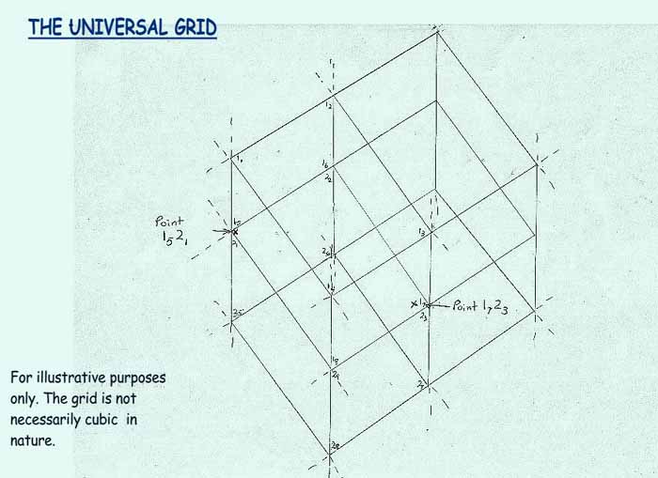

DISINTEGRATION
Travel by thought, with no space and no time involved, does not require movement as we know it. What is required is the matching of vibration of the thought to the vibration of the grid.
To travel to any planet as the vibration of that planet, and the resulting planet form, one must go through a series of portals in the grid for that particular planet. Though the travel is instantaneous, the particles do travel through a series of mathematical portals.
To travel to Earth becoming Earth's vibration with Earth physicality, the portal is the triangle created by the stars Alpheratz (Andromeda), Arcturus (Bootes), and Antares (Scorpio). As such, all souls coming to Earth at human birth, travel through this gateway. These matrix points create the mathematical sequence portal for this planet, and the planet sits at a further particular grid point.
As a human being, to travel via the grid has the following sequence:
- The thought occurs to travel to a point of space or time.
- This thought is a mathematical energy.
- The body disintegrates, into small pieces. These pieces are pure energy, and not visible.
- The thoughts of the being disintegrate into energy. The human can no longer create a thought.
- The thoughts re-integrate at the proposed thought grid point. The human can now think again.
- The body re-integrates at the proposed thought grid point as a physical entity.
If someone were observing this event from the original grid point, the person travelling would just seem to disappear!!

TRAVEL IN SHIPS
If the Universal Grid is a mathematical thought matrix, a vector matrix, then this can be used for travel in ships also, as long as the craft is the same mathematical vibration as the being wishing to travel. Therefore an organic being, such as a human being, must be in a craft of the same vibration.
In some crafts, this is done directly by thought, by the body of the being coming directly in contact with the ship, as in hand melding controls or body melding controls. The body of the being and the craft become one vibration and one thought.
In other crafts, this melding of vibration and thought does not occur, and the craft must be tuned to the vibration necessary. Therefore a navigational device may be used. One such device looks like a holographic crystal ball, in which you can see the grid as lines. By turning a vibrationally tuned sheath over the surface of the ball, the craft will reposition in the grid, reacting to the thought energy of the being touching the sheath.
Visions which occurred in relation to this information included a table on which were blueprints. These blueprints, with accompanying notes, were shown to me. These were various interstellar craft, of all shapes and sizes. However, these were shown so quickly to me that I could not retain any of the specific information on the blueprints. I think I was just being informed that this information is used throughout the Universe.

THE EARTH GRID/BLUE GRID
The Universal Grid surrounds everything in our Universe including our Earth, our Solar System, and the stars we see in our sky.
At various sectors of the grid, specific stars, galaxies and planets exist, by the combination of grid points that are in that sector. Everything in that sector will have a certain thought configuration, and be related to every other thing in that sector.
Therefore certain configurations in the stars surrounding our Solar System, will be found within our Solar System as well. And configurations in our Solar System are found on each planet in that system including Earth. The configuration of certain constellation and solar system patterns form a grid surrounding Earth. Therefore this Earth grid can be mapped over the earth's surface from point to point.
As this is a mathematical thought energy grid, this grid can be manipulated by thought energy, in the same manner as travel through the Universal Grid can occur. It basically is a matrix grid within the Universal matrix grid. This Earth Grid I have called the "Blue Grid", as it was shown to be as being a blue light grid surrounding Earth.
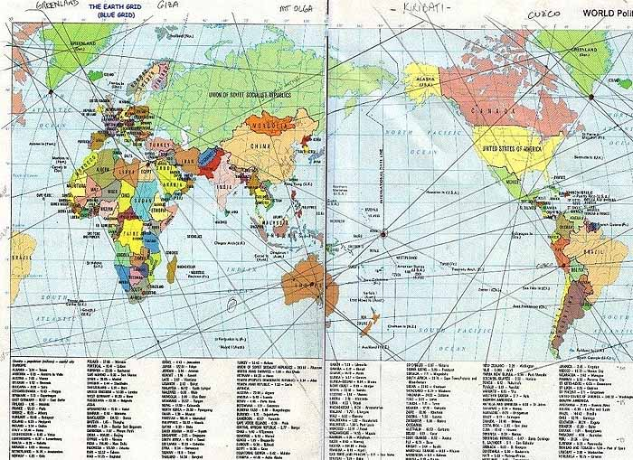
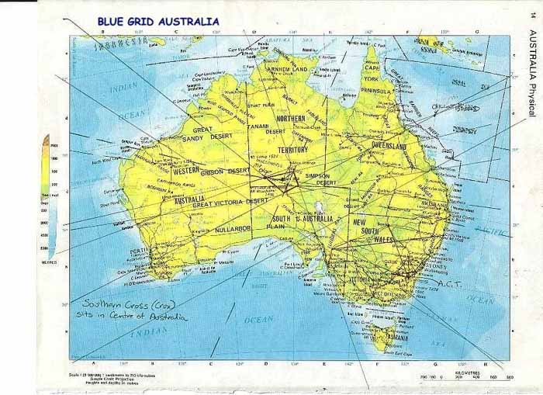

THE RED GRID
There is another grid which was shown to me which was shown as being red in colour. I have named this the "Red Grid".
The Red Grid is an electromagnetic grid placed around the Earth using alien technology. When I asked for more clarification, I was told that a contract occurred between those of Earth with a race called the Zeta Reticuli, and these were the ones who gave the technology for the Red Grid to be placed around the Earth. (I have since read various articles relating to such a contract, but I did not know of this prior to these visions.)
However, when the contract came to an end, the Zeta people could not leave Earth, for they had been trapped here. The way the technology was used was foreign to them.
However, thought energy can also affect the Red Grid, and vortices (holes) can be created in it. Due to this fact, the Zetas were given the opportunity of leaving in 1995. Many left at that time, in their crafts. Some stayed here to observe how the technology would be further used. These observers are on a suicidal mission, and are aware of that fact. This Zetal group is no longer a part of the contract.
The Red Grid is used for any technological manipulations, which are hidden from public view. If thought, directed using the Blue Grid, is used to create a vortex in the Red Grid (which requires a particular frequency sequence), airplanes will literally fall from the sky.
Any manipulations to the Blue Grid are publically obvious, though most people would not realize this unless they know the layout of the Blue Grid. For example, a created earthquake can be seen.
I purposely did not attempt to map the Red Grid, and coordinates were not given for it. Any manipulations can be done through the Blue Grid to counteract the Red Grid.

THE STAR MAPS
Once the grid coordinates had been given and I had mapped the Blue Grid, a series of star maps started to appear in the visions. Crux, also called the Southern Cross, was repeatedly shown to me. I would be woken at night to look out the window, and there would be Crux. I would look up at the stars when outside at night, and when looking at Crux, various things would happen. Visions would occur, or lights would physically appear and move within the constellation.
So, I went and bought a book on Astronomy, that showed the various constellations. When I did this, the visions returned to Latitude and Longitude calculations. A sequence was given which turned out to be geometrical angles. When mapped, the resulting picture looked like Crux with lines through the main star points.
From there, various sequences of numbers appeared again. A sequence overlayed on Australia gave a more detailed grid map there. The angles appeared also in the Blue Earth Grid (but not in the Red Grid). A vision was shown of our Solar System in a Crux configuration.
And then I was shown a huge pyramid. Coordinates were given which indicated this was Giza. The Crux configuration was shown overlayed on the Giza site. When I finally found a map of Giza I found that these lines fit various lines on the map. After doing some reading I found that these lines were ancient byways, and one was called the Bethlehem line, because it points to Bethlehem.
I was then shown the pyramid again as if on paper, and the Crux configuration was placed over the pyramid. I found certain chambers in the Great Pyramid correlated with the configuration shown.
Then I was given the coordinates of the first vision again, the ones that related to a date, and the Earth tilting on her side.
So began my pyramid visions in relation to Time being re-set.

THE GREAT PYRAMID
The Grand Gallery is the Timekeeper
Earth Time is set by the mechanism in the Grand Gallery.
Why is Earth Time important? Whilst Earth Time is only used on the planet Earth, it is important because it allows us reference to our physicality. If the Earth shifted on its axis to exactly horizontal, it would cease to exist physically. This is because tension is needed to keep the Earth physical, and this is provided by imbalance in the axis, and imbalance in the electromagnetic inner core. If the balance of the electromagnetism of earth became completely balanced, Earth would also become non-physical. The tension of these forces keeps us physical.
Earth Time used to be kept going by the "runners" as during the ancient Celtic ceremonies. People with drums would run the energy from territory to territory, thereby keeping the earth beating to Earth Time. Energy was kept going in the Earth by this method. Energy was run between ancient sites along the energy lines, territory to territory. The Earth thrived. The Native American drums today hold the heartbeat of Earth.
We have lost these important ceremonies in our modern world. And our Earth is dying. We are no longer in tune with the heartbeat, and we no longer help keep the energy in the Earth. We constantly take from Earth.
When the time comes for the Earth to shift, either on her axis, or balancing the inner core, we are to look to the ancient sites. These sites will be used to once again, to run the energy. And the Great Pyramid is a PROTOTYPE to show us how to reset Earth Time, so that Earth can once again live.
Why a prototype? The Great Pyramid has been altered significantly from its original form. It can no longer be used for its original purpose.
A set of 3 geared disks are the mechanism to make the Pyramid Time Machine work. One central disk sits in the floor, reaching from floor to roof, width is the width of the floor, (41.21" or 2 RC*), which is also the width of the tops of the walls and roof.
This main disk has two more disks sitting either side of it. These are geared to the main disk. They sit on the two ramps of the gallery, either side, and are the width of the ramps (20.61" or 1 RC). These sit in the spaces between the main disk and the walls, and are geared to the main disk. The main disk has a central axle reaching the walls, where the axle fits into the slot which runs the full length of the walls.
In each of the two ramps are holes bored down into the ramp. There are 28 holes in each ramp, giving a total of 56 holes. The ramp and walls are limestone. (cf Stonehenge)
Above these holes are stones of granite set into the walls. An incised depression occurs over each one at the floor/ramp angle of 26 deg 18' 9.7".
* RC = Royal Cubit
Each of the two outer disks contain a 'key'. As the disks move along the gallery, the keys hit the depressions and the granite stones, creating an energy frequency. It can be heard as music, in the notes of E and F.
As the sprung key on the side of the small disk hits the depression, another extended part of the key hits the corresponding hole below it. So there is a transfer of energy from the key into the limestone of the pyramid. These vibrations of E and F combine with the Earth's vibration to make a "Time Music".
56 holes and stones -- 52 for each week of the year. 4 extra for the 4 quarter days per year leading to leap year.
However, travel was over 13 revolutions/cycles per year, up and down the gallery. This gave the moons of each year. Every 3.15 (pi?) cycle was the solstice/equinox. Track of these revolutions was kept by the 3 and 4 sequence of grooves in the Kings chamber passage. That is 28 days per cycle. That is one key sequence per day for the 13 cycles.
The 40 ratchetwise slabs in the roof helped hold the central geared disk in place as it moved. I believe these 40 slabs somehow correspond to the number 40 in the Bible, as in 40 days and nights.
Entrance to the gallery is south. The Kings Chamber lies at the north end. South represents Fire/Sun, north represents Earth. The Sun/fire of life, entered the gallery (Time), and travelled north to Earth. The opposite direction, energy travelled north/Earth to fire/Sun. This was considered the connection of life, and physical life required Time to exist in balance. (cf Jesus life in Bible, and Osiris in Pyramid Texts) The south/north alignment may also have to do with the magnetic poles of Earth, and how they combine with the Pyramid energies.
Every 28 day cycle consists of 4 weeks of 7 days each. The walls of the chamber consist of 7 corbelled overlaps, and days were counted on these. Energy moved up the walls to each level.
At the top of the gallery is the Great Step, which was the endpoint of movement on each cycle. This leads to the Antechamber.
Antechamber
This chamber is built of a combination of granite and limestone. Energies are picked up from the gallery and the Kings Chamber, and combined in this area. The wall grooves on all walls help to keep track of Time sequence in the Gallery, and also serve to concentrate the frequency energies. In this chamber a combination of granite and limestone combined to concentrate the energies before sending them back to the Kings Chamber. (Note: It could be that the granite and limestone in the Great Pyramid represent a combination of some other composites.)
Kings Chamber
At the north end of the passage is the Kings Chamber.
A tunnel lies between the top corbelled wall section of the gallery and the first construction chamber above the Kings Chamber. Energy is transferred via this tunnel. Energy from the sun and stars is sent to the construction chambers and on to the Gallery. to combine with the Time energies to be sent to Earth. This makes the connection with the Universal Grid, placing Earth in the grid.
The vibration of Earth is sent up through the sides of the pyramid to the apex (now missing) and on to the Sun and other stars. This sets Earth's place (mathematical co-ordinates) in the Universal Grid.
There is a granite "coffer" at the centre of this chamber. The coffer should house a black shiny ball of stone, similar to a black crystal ball. This ball swirls the energy before it is sent out. It adds energy from space to the energy produced by the Time gallery, for use in the Queen's chamber. This stone ball is also a navigation device for travel. (see Queen's chamber) I believe this stone ball came from the planet of the people who built The Great Pyramid. It will appear at the appropriate time... when Time is to be reset.
The ball in the "coffer" would start spinning when the priest set a particular vibration (an incantation). Once the ball was spinning, an electromagnetic frequency from the ball would then cause the large disk in the Gallery to turn. The smaller disks would then create a frequency vibration which travelled on to the Antechamber and Kings Chamber.
Queens Chamber
Beneath the Kings Chamber lies the Queens Chamber. There is a corbelled indentation in the Queens Chamber wall, under the Kings Chamber.
The combined energies of Space and Earth accumulate in this chamber. It is a place for travel through Time and Space. A person standing in the tiered wall indentation can, by thought combining with the energies, travel physically through Time and Space, via the Universal Grid. The black stone ball concentrates the thought energies to navigate the grid.
The shafts in the Queens Chamber aligned with particular stars so that travel could occur. The energies of these stars, combined with the resonance in the Queens Chamber, allowed physical manifestation and disintegration.
The priests, or keepers of Time, entered the Kings Chamber via the travel mechanism in the Queens chamber. Only initiates could become priests, and only priests could enter the inner sanctum of the Kings chamber. This is because it requires trained thought process to be able to use the Queens Chamber travel mechanism. These trained thoughts could alter the priests vibration to be able to enter the chambers. This also protected the stone ball and energy mechanisms. I believe the priests were the original people of the home planet and their offspring, hence the 12 tribes, specific tribes being the priestly tribes. That is the keepers of the Merkabah (travel machine). (cf The Blue Star/Osiris)
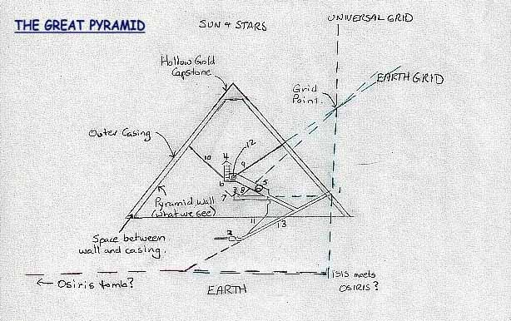
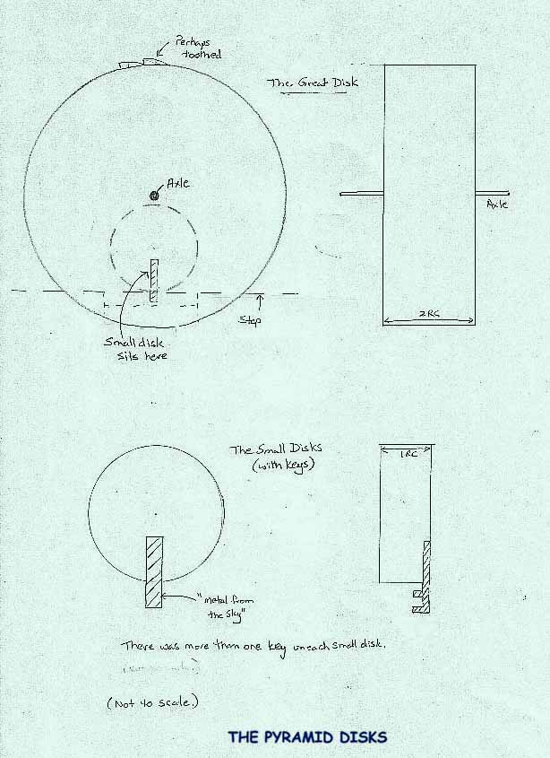

ANOTHER FUNCTION OF THE GREAT PYRAMID
A Particle Accelerator?
The original Great Pyramid had an outer casing over what we see today. Between the Pyramid walls and the casing was an air space.
The ball sits in the "coffer", and spins, creating an electromagnetic field. The air (gas) particles in the Kings Chamber become charged. These charged particles can then be sent out via the Kings north air (ventilation) shaft into the space between the walls and casing.
The vibrations from the disks in the Gallery mix with the vibrations in the Antechamber, and can be directed out to the Earth Grid (Blue Grid) via the Kings south air shaft.
Vibrations from the disks are also sent to the Queens Chamber via the Queens south air shaft. From here they are sent via the Queens north air shaft into the pyramid and on into the Earth.
The energy vibration of the sun and stars are also sent into the Pyramid via the hollow gold capstone, added to the energy in the air space between the walls and casing. The walls absorb this energy and send it also down into the Earth.
Vocal vibrations (incantations?) from the priest in the Subterranean Chamber could be sent via the "pit" shaft to the Gallery. In this chamber the music could be heard via this shaft, and the vibrations from the disks could be used for healing and visions. People entered this chamber from the Pyramid entrance on the south.
If the descending passage continues down and over to Osiris Tomb (which I believe is so), the vibrations can all be sent to the Tomb from the Subterranean Chamber shaft. It would also mean that Osiris, having "risen", could enter any of the Chambers without having to go outside the Pyramid or its passages. If god was not to be seen by mortal man, and Osiris could not go into sunlight, then this would be the ideal configuration.

THE ATLANTIS CONNECTION
As described in the previous section, The Great Pyramid, Earth's Time was kept on course by the ceremonies of the native peoples worldwide. As these ceremonies died, so did our connectedness to the Universe and all within it. These ceremonies were remembrances of an earlier time, embedded within our memory, of an Atlantean Age. In Atlantis, it is said, a Great Crystal kept Time.
The Great Crystal was the energy source for Time in relation to the Universal Grid. And through thought the crystal was used for many varied purposes.
One story says that an asteroid could be seen in those days heading towards Earth. The Atlantean Council debated what to do. Though there was some dissent, it was decided to use the Great Crystal to destroy the asteroid in fear that the asteroid would destroy Earth.
So the crystal was used to target the asteroid. This was done through thought projected through the crystal. The asteroid was destroyed, but a piece of it hit Earth anyway. And the Great Crystal broke into pieces. (cf Osiris/Seth stories) Atlantis was destroyed and the survivors travelled to other places on Earth, carrying pieces of the Great Crystal with them.
I was shown pieces of the Great Crystal, and where some of the pieces are. They still exist and could be brought back together. However, this would be of no use, as the Earth has a different balance and pole configuration now and the crystal would not work.
The pyramids at Giza are a remembrance of the technology of the Great Crystal, left for the time when another Pole Shift would occur.
Is it that the next Pole Shift will occur because of a negative, fear-based decision by mankind, as occurred in Atlantis?

THE MARS CONNECTION
Further questioning on the Solar System star maps brought more answers.
I was shown the Great Pyramid at Giza and a ladder leading to the top. Upon reaching the top, I looked up. Above me was another pyramid, upside down, and I reached out my hands to touch it. However I could not reach it. I was told it was too soon to reach it, but that we, the people of Earth, would eventually touch the pyramid in the sky. I was told that we are the "connectors".
It took me some years to realize the importance of the word "connectors". Connectors are used in an electrical circuit. We have lost our connectedness to all on Earth and the Universe. We are the connectors.
But the vision shown was of even more importance. There are pyramids in the sky and they point to the Great Pyramid.
Where are these most publically known? Mars.
At some point the Great Pyramid will connect, through us as connectors, to the pyramids on Mars.

THE SOLAR SYSTEM MAP
Towards the end of the series of visions, in 1994, I asked when would Time need to be re-set. I was again given a series of Latitudes and Longitudes, that when calculated, again gave the date June 21. This is the date of solstice, and in my mind corresponded well to the Giza connection.
But I was told this was incorrect, that I had made an error, and I should check my calculations. Indeed, I had made an error. The correct date was June 10.
This puzzled me, as I thought that solstice should have been a ideal point to re-set Time. But I was told "No, your calendar has been changed." It was a year after the visions finished, that I found details of the change of our calendar, which involved a change of 10 days.
I was again shown the Crux configuration of the Solar System. The Solar System would be configured in this manner, sometime in the future, on June 10. No year was given directly.
Until 12 months ago, I had no way of checking the accuracy of this data. Last year I was given as a gift, the software "Distant Suns". I have found recently that this configuration does occur on June 10, 1999.
It remains to be seen whether Time is actually re-set on this date, or whether it is the start of the chain of events which will require Time to be re-set.
With the time/technology events we have seen in recent times, and the knowledge of the history of Atlantis, ponder the following lesson, from a Native American friend of mine:
"Behold - The asteroid moves towards it's Source to become One with the Source. It accelerates and expands as it moves closer to the Source." (Night Eagle, 1994)

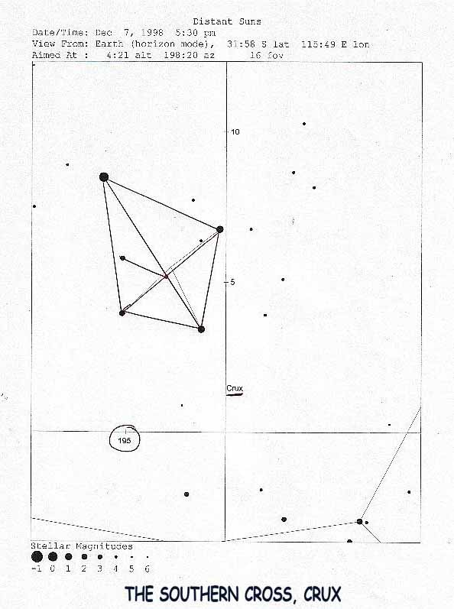
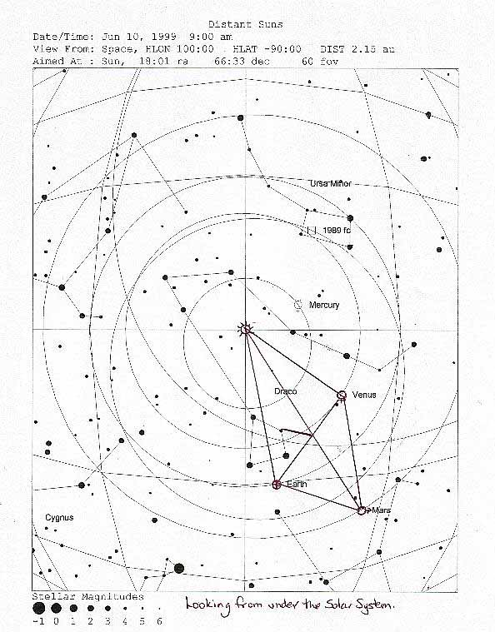
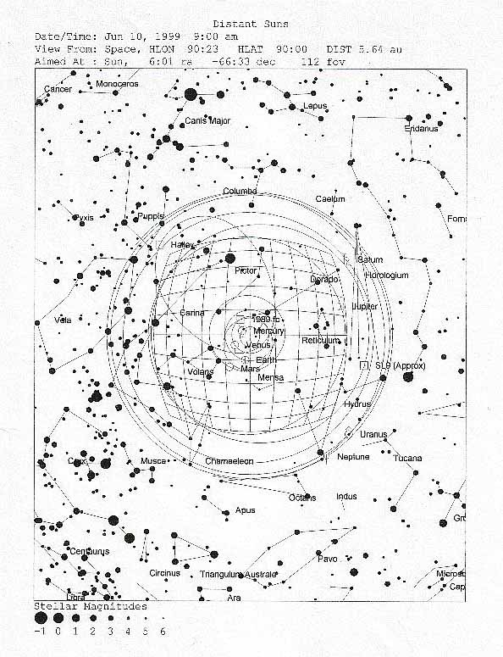

THE FINAL VISION
In early 1995, the visions seemed to be completed and I was returning to normality in my life.
Three days after Easter, I was woken up at 2 am. I went and checked the children and on my way back to bed, I looked out the laundry window at the stars. Obviously, being after Easter it was not a full moon, the moon was waning. Right next to the moon was a brilliant star, and I had not seen this before, a star being so close to the moon.
The sky suddenly started to change. The moon became full, the star became brighter, and between the star and moon a bright circular rainbow appeared. This rainbow had only four colours - yellow at the inside of the circle, then green, blue, and purple, in that order.
Then four 'moons' appeared at the four directions of this rainbow as part of the rainbow itself. They were brilliant white. The centre of the rainbow turned a most brilliant white, the central full moon remained, becoming so bright you could almost not look at it.
A voice then spoke to me. The voice was quite loud, gentle yet commanding. I turned away and looked at the washing machine. No, my sight had not been altered. I looked back. The voice did not come from inside me, because I covered my ears, and the voice became faint. The voice seemed to be coming from the sky.
The Voice said...
"Daughter of David of the tribe of Judah.
Prepare, prepare!
Behold the seals are broken!
The angels return to Earth, and
The souls are being released.
Woe be to the peoples of the Earth!
Woe be to those who do not see!
Woe be to those who do not hear!
For the Lord cometh!
Prepare! Prepare!
Prepare ye the way!
The Lord cometh and woe be to
Those who do not see or hear.
Prepare ye the way!
Tell them!"
Upon hearing my name, and my tribal affiliation, I fell to my knees with tears running down my cheeks. While the message was given, the sky kept changing further.
From the central brilliant moon came a beam of brilliant white light, which converged on a point above my neighbour's house. In this beam were angels, white angels, hundreds of them, coming down to earth. Floating gently.
Then from the earth another beam shot up to the moon, converging on a point at the centre of the moon. This beam was brilliant blue, and you could clearly see this blue beam transposed on the night sky. In this beam were greyish robed people, floating up towards the point on the moon. Thousands of them.
As this happened, the sky around the moon became dark blue, changing from the normal blackened night sky.
It was an awesome sight. It was an awesome voice. It gradually disappeared back to the normal moon and it's accompanying star.
On my way back to bed, I thought about knowing the 'fear' of God. I think I had just experienced it. Not fear. Just so awesome that unless you have experienced it, you cannot imagine it. I picked up my Bible and turned to Revelations to read about the seals. But I couldn't figure out "Tell them."
I had been told the visions were a history and manual for after the Pole Shift. I was given no information on how it was to be used or who would receive the information.
And I certainly now did not know how to "tell them" about this latest, and last, vision. Who was I to tell? And how, and when? And why?
It is being told now, right here, right now. I leave the answer of "why?" to you.

A CLUE
A man enters the Subterranean Chamber, the Pit. He sits and starts to recite the ancient words.
The black globe, suspended in its enclosure, slowly starts to spin. It spins, completely balanced within it’s void. It spins, a miniature replica of Earth. The Ark springs to life.
The Great Disk begins to turn. The Music of the spheres, created by the Great Disk, creates a resonance within the Antechamber. When the resonance reaches the Kings Chamber, the gaseous particles of the air become highly charged.
The stars outside are also sending highly charged particles to the Pyramid. The energies combine. The Great Pyramid begins to vibrate, and the energy of Heka, is received by Earth. As the golden apex appears, vibrations are sent into the sky, creating the mirror-like shield, the Firmament.
As the vibrations enter the Queens Chamber, a form begins to appear. Isis returns, forming from minute fragments of Universal thought.
Further away, deep in the protected chamber of old, Osiris awakens.
Osiris greets Isis, and says, "I return to create civilization". Isis replies, "And I return the Covenant".
Meanwhile Seth, brother of Osiris and Keeper of the Veils, hears the music. Knowing his plan for Earth is endangered, he concentrates on the Ark, and Osiris disintegrates into the Grid.
Isis recalls Osiris, by incanting his name that no man can understand. The globe starts to slow. As Osiris is gathered back into his coffer, now surrounded by water, the globe stops spinning. Osiris lies weakened, and slumbers.
A star appears in the sky, above the point where the Bethlehem causeway meets the horizon. A King is born, in the Subterranean Chamber, the womb cave of our memories. Horus, the son of Isis and Osiris, the Time Lord, the Keeper of Hours, has been born.
Three priests of the tribes arrive by way of the Bethlehem causeway. They ask entry to the Pyramid of the man waiting at the door. He tells them, "the lower way is open to all men." They reach the cave, bringing with them gold for the capstone, frankincense for the priestly cleansing, and myrrh for embalming, for this King is of Earth.
As Horus attempts to re-set the globe of the Ark, Seth appears. A battle ensues, and Seth smites Horus’ left eye, hoping that by doing this that Horus will not see Seth’s ancient plan. Horus still holds the black globe, and Seth’s own vibrations reflect in its lustre. Seth disintegrates and re-appears in the Underworld, a place of Death, by passing through the portals of Anubis, the great dog in the sky.
Horus re-sets the globe in it’s enclosure. He recites the ancient incantation. Time is re-set, and civilization re-birthed.
