Physical ufo-contact in the early 60ths after initial radio (amateur-) contact
the UFOcontacts of Bob Renaud from July 1961
(But as always in such contacts -"they" were not allowed to give too convincing proofs - the ripe one will recognize this INSIDE oneself when ready and ripe.
Her link til norsk OMTALE | Powerpoint on the case

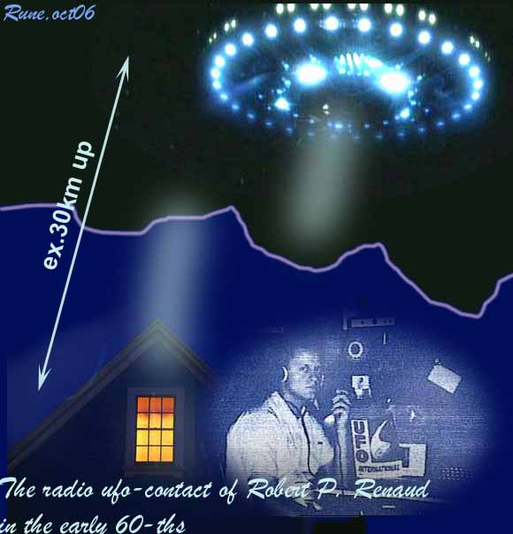

(TIP: this long article will be easier to read, at least on widescreens, with bigger txt - use CTRL + or by clicking on equivalent A upper right corner and adjust as shown on B below making txt width more narrow ) It may be txt/word-mistakes, not fixed in this doc.
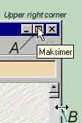

Introduction
The Korendians made contact with Bob Renaud in July 1961 as he was trying to pick up BBC Radio on his short wave set. Robert P. Renaud, an 18 year old Ham Radio Operator - working for General Electric - a electronics wizard and inventor, living in his parents home, in his basement bedroom converted to his studio-laboratory, picked up a strange beep high in the 25 meter band that overshadowed BBC. When he tuned in on the beep, it stopped and a clear soft feminine voice greeted him from a spaceship from Planet Korendor. She called him by his first name and said that they had been trying to get his attention before. The Korendians instructed him in how to modify his home built short wave radio set to receive them better. Then after a few radio contacts they helped him to modify his home built TV set to pick up their images on the vidicon tube while he spoke to them on radio.. Those contacts continued and developed into face-to-face meetings and even into going on trips with them, in their craft, for months and years. He kept careful notes on his contacts. This case is not well known in the USA.

The Case watched by the coverup-people
Like many other contactcases studied/investigated, also this case includes closely monitoring /surveillanc from the "hidden power behind" (the shadow government-people) – who obviously interrupted his mail. Same happened to the mail to Meier (the semjasecontacts) in Switzerland in the 70ths -where "they" had forced the local postoffice to let "them" filter his mail and such sanction the return-films from the development-laboratory and like. Once they disclosed it clearly seen by the film he got back – it was mirrored, seen by the filmlayer. So "they" had kept the originals and he got only copies back, but they had been careless to make mirrored ones. In the same way they changed the pictures of his contactwomen and used this systematic against him many years later.
In the case of Renaud here, they had as said, apparently looked through (scrutinized) his mail: when he later wrote and printed a book on his contacts by help of John Dean, they discovered, after it had been printed, that someone had changed astronomical information in it. This apparently done in the intention to disproving him later – to claim him a liar, and so ridiculing him as they use to do in such cases – with good help of the stupid, egoistic press-people – only seeking superficiality.
Ca.20 years ago FATE-magazine (march-86, p.52) had an article on this Korundor case written by Allen Griese. He thought when he heard about it - as most others, it all was pure science-fiction. But after meeting Renaud in –67, he didn’t longer believe he was a hoaxer as he wrote "..if Renaud was engaged in fraud, it was obviously an unrewarding task".
So Grise visited Renaud at his home and found, as the contactee's writings claimed, a basement room full of electronic equipment, including the television set and the shortwave radio over which the communications supposedly were effected.
Grise, an engineer by profession, and ham-radio buff by avocation, found that everything seemed to make sense. The circuits were all appropriate to extend the receiving range. "In other words, if he was getting messages from an aerial source, he had the equipment with which to receive them.
More remarkable, however, were the books Renaud was writing on Korendorian life and philosophy. There were a dozen or so of them, all single spaced an, each 500 to 600 pages long. There were, so far as Grise could discern from studying their contents, no typographical errors. But that was not all:
"When he wrote these books," Grise recalls, 'it was like his hands belonged to someone else: He'd sit there in front of his typewriter and pay no attention to what was coming out of him. He could be on the phone or talking with me, and all the while his hands are going, producing all this perfectly-typed, clearly-written stuff on alien philosophy. It was just unbelievable."
Grise was perplexed by Renaud's attitude: "He showed no signs whatever of wanting to promote himself", he says. "There was no show biz, no snake oil. He didn't even seem much interested in talking. He 'd answer questions, but he wouldn't offer anything. He was hesitant to entertain visitors and he sold nothing, made no money. He said the whole business was imposed on him; he hadn't gone after it".
"Renaud has a large collection of tapes allegedly on his space communications: Grise listened to some of them and heard what was supposed to be the voice of the primary contact-woman Lin-Erri. He recalls, "These were good-quality, reel-to-reel recordings. The womens voice had a kind of hesitancy in speech patterns suggesting a foreign person doing well in English. It had s a singsong, melodious quality ."
When Grise asked if he could meet the extraterrestrials in whom, despite a deep natural cynicism about such matters, he was almost ready to believe it: Renaud said he could request a meeting but could not guarantee that the Korendorians would agree to one...
Soon afterwards Renaud broke off their brief association and told him to not to call or visit anymore. He likely understood it was no meaning in trying to convince anyone not ready or spiritually ripe.

UFO CONTACT FROM KORENDOR - more details on the contacts and the information
Yes- soon half a century ago it apparently occurred some direct, physical contacts to our over-seers or "gardeners of earth". On of them were just these contacts of BOB RENAUD. He was a radio-amateur that some night in summer -61 got in a women's voice claming to be from a spaceship around earth. Apparent only a claim - but her further explanations was interesting, and it later evolved to physical contacts, which the common people could not fellow and believe if not having spiritual knowledge beforehand.
On this first radiocontact she said they discovered us about two years before. Their interest was aroused by our satellite activity, which they said, indicated an elevated technical level. So they wanted to learn all they could about us. They had tried many times on telepathic contacts as was their normal way- to various people - but in vain. They could not - in the beginning - stay on earth without breathing-help - because they were used to more oxygen in their home-air.
So they had to learn our language here -and found out that English was most used after monitoring radio/tv. So they placed a kind of small devices that could take up conversations etc and transfer them to the monitoring eq.on the ships, where advanced computers found the keys and interpretation. From those they learned the language quite easy. (Regarding this: Also from the Iarga-contact in the 60ths they told how they could "beam" such information as learning an unknown language directly into their brains with a special kind of radiation. And regarding spacepeople learning languages here: from the Semjase-contact (the 4th) in the 70ths, "they" - the Erra-pleiadians - told how to transfer this method of learning language on a hypnosis-like way - learning any language in ca 21days - then 9days for training)
But back to the Korundor-contact:
They told that they had learned English with a definite Southern California accent, due to the monitoring mostly in that area. They also claimed that there were bases on more of the planets here in our sunsystem -and that they also had co-operation with them. (There is also that possibility that they can adjust their frequency to visit other levels of planetary vibration, but that is not directlytold in these initial contacts.) They had monitored many and found Bob to be a developed kind of man - with interest in space, in world peace, and in the future of mankind. Seemingly he recorded some of the conversations like in the Koldas-contacts in South Africa in 1960- but those to another planetary group - but supposedly synchronised by a "higher federation".
And as mentioned above - already in the first contact they instructed him in how to convert his equipment for a better 2waycontact to them.

THE CONTACT-PLANET
The initial contactperson he talked with, was a lady - as many of the visitors seem to use in the beginning - we are not normally so afraid of women regarding ETs. Her name was Lin-Erri and her home-planets name " Korendor".
They said "Korena, our sun, is located at a point in the Constellation Bootes, about 3 degrees from Arcturus on a line between Arcturus and the centre of the M-3 cluster. It is roughly 400 light years distant, and is visible in the larger-aperture telescopes, although it has been given no specific name or number by your astronomers." It was 6x bigger than earth but had lower density that made gravity only 2x ours. Korendor was 3.of 12 in that sunsystem, having 4moons + an atmosphere with more oxygen.
They had developed space travel about 3,000 years ago in our time, and using craft as far ahead of ours as we were ahead of chariots. Gravity, magnetics, light, ions, etc powered their craft. These craft were brought from star to star in magnetically driven carriers or "mother-ships", which were literally travelling cities or worlds in themselves. Had learned to use the fourth-dimensional warp, but said it took some years learning to control the course once in this ‘warp’. "Of course there are still a few pilots with less than sufficient experience who start out for Sirius and end up in M-31. Eventually the control of craft will be entirely automatic, where the pilot sets the destination on a series of dials and pushes a button, to arrive there a second later."
One of their works here was to oversee the danger of atomweapons and said that earth must disarm or perish! And similar, red as warnings from many of the UFO-contacts through the years: "We have seen other planets follow the same route as you are now travelling. Always it has led to war and to the same racial suicide that you now face."
They also believed that many ufoships seen all around the world would cause us to consider as not alone in the Universe, but our governments have only made fear out of this through cover-ups and lies. But they wished that Bob Renaud would succeed in bringing some information through.
So 3 weeks later he had built the transmitter-radios ready and 5.aug 2at-night -he got them through again. They told him more on their translator-machine: "The machine is actually a specialized computer, with a memory console, input, output, and the relevant circuits. The input consists of the impulses relayed by our Robot Sensors, which we have planted in various places around your country."
"These impulses consist of two components --- the spoken sound and the corresponding mental impression. They are separated by the analyzers’ Discriminator, and fed to two circuits. The first receives the sound impulse and stores it for the moment. The other, the mental impulse section, instantly begins breaking down the image into basic components, and these components of the received telepathic signal are then compared with those in the Machine’s memory banks."
"Within a few micro-seconds, the analyzer has found an impulse exactly or nearly exactly like the received impulse. Their combined strength activates a semiconductor relay. This triggers another storage bank in which are all the words in Galingua-Korendian that correspond to the mental impulses in the first memory section. This releases the appropriate word and also the stored English word, and together they are recorded as the output, and are the translations of each other."
"The larger unit, received from Korendor, has no memory banks in itself, but is connected by direct SSR line to the Master Language Center’s half-billion word memory network. With this device, there is no word that cannot be translated."
"Once we learned the words, it was a simple matter to study your transmissions for proper placement, inflection, pauses, etc."

FELLOWING CONTACTS
In the 2.contact they also said contactpeople on earth… "who give accounts of tremendous ships, rides to the planets, and talks with the Masters are not average people. Each has been screened carefully, as you were, and chosen for their particular task on the basis of their abilities and belief in the cause of Universal Brotherhood. These people are the modern-day prophets, the media between you and ourselves. They give you information that we feel you must have."
They also spoke of the jealousy in the many ufogroups they had been monitoring - and about the religious ideas. And again they said that the governments had no right to conceal their enormous gathered UFO-information, which at one time had to come forward, and meant the feared panic was not the problem. They also claimed that United Nations, Dag Hammerskjold, was contacted three times by Venusians - as also many other world-leaders had been contacted from spacepeople. (Venus' life is not in our vibration/dimension but they can technically or mind-adjust to ours, as I have understood it-R.Ø.rem) They meant we should stand up against war and the weapon-race - and in retrospect one can speculate if all the antiwar/weapon demonstrations world-wide through the decades since this happened actual HAD a purpose.
They also gave him time for next radiocontact that happened 19aug2AM.
In that 3.contact they linked a speak from a "wiseman/master" on their homeplanet to Bob. He had himself been taken away from his own homeplanet by the Corundor-people, just before his homeplanet "Krystalina" had been ruined in a war with hydrogen-and kobolt-bombs. He said that the communism in the form of dictatorship would collapse in some time here. And…: "What makes a Master? To simplify it a bit too much, one becomes a Master by service to humanity."
In next contact they described how ideas are imprinted into selected people during sleep, which these subjects then credit to themselves. They called it Somnivision:
"In principle, as we will tell you in the next contact, the human mind is a form of energy. When in the body, each mind has a distinct frequency of operation depending on the particular characteristics of that brain which it inhabits. While we do not completely understand it, we know that it has to do with magnetic waves as you call it, electrical, circuit dimensions within the neurons of the brain."
"The instrument used to produce the Somnivision, the Omnifrequency Psychoprint Unit, is designed to register this characteristic frequency via a probe beam, which is trained on the mind from a unit in a small three-foot diameter scout ship." (The detailed technical data is omitted here. –Ed.)
"Whenever Somnivision is to be undertaken, a beam is set up from the scout hovering low over home of the person to be impressed, and a relay is begun through it to the mind. Since the frequencies are phased, any modulation on the beam would be considered by the brain as an impulse from the mind itself, and be treated as another thought."
"Depending on the strength of this beam, we can cause anything from merely a vague memory of the ‘dream’ to a verbatim recording in the brain. This can be compared to a radio feeding a tape recorder. When the incoming signal is weak and distorted, only occasional snatches of the program are intelligible. As the signal strength increases, more is recorded that can be understood, until, at a high strength, the tape is an exact duplicate of the program."
(example of scientist being loaded by this type of information - through what he call "dreams" is the super-rocket scientist David Adair - here link to googlevideo-Interview - he said he saw a "Living UFO-engine" at Area 51 when he was 17 years old.)
Then Bob remarked:
"Perhaps that’s the way I’m able to transcribe their entire conversations, as they told me I would be able to do. When I am ready to write them down, the words just seem to flow, afterwards blank! I can’t write it down accurately a second time. Normally, I might be able to remember portions of a conversation, but to relate an entire conversation from memory would be impossible unless I study it for hours before."
They also said that "The great inventions of your time --- radio, television, nuclear power, and the airplane, for example --- are for the most part a result of this imprinting."
In next contact, the contactwomen Lin-Erri again dived into the mind - saying it is a form of energy- and of our consciousness' composition. They outlined five separate levels of existence:
- Unconscious=here are "dreams" formed + memory.
- Subconscious= informationstore>>filed into unconscious+ collect information from the unconscious
- Conscious= information-gatherer for the whole mind- through it the five basic senses relay their impressions to the other levels. It is the control centre."
- Ultraconscious=center of parapsychic functions
- Unifying level. =All-Mind, Almighty, Creator, God.
About this last she said (extract) "All minds are as one, and the energies forming matter are a part of it likewise. The All-Mind controls the Universe to the limits possible. It does not know the future, and cannot cause predestination…| It can suggest, guide, and direct, but it cannot control."
She also said here that nr4 above/ill.down is accessible by both nr 3 and 5.
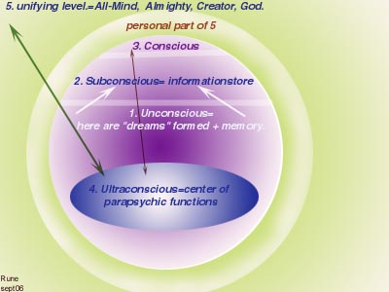
Illustrations is Rø- made out of interpretation of this 4.contact
They said mind is a form of energy with a set frequency, different from any other. "While this frequency cannot be changed, there is another, a universal frequency, which can be turned on and off at will by the individual. It is on this frequency that telepathy occurs".
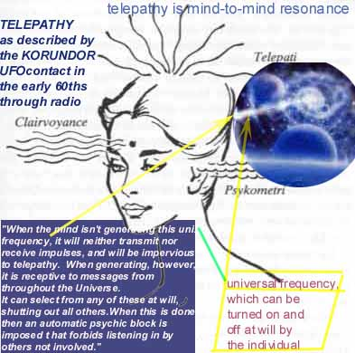
ill. not from this book - the line-drawing from a danish Lobsang Rampa book from the70ths

They also said that this universal telepathy on the universal freq.could not be tapped by any electronic means, and the callsignal used a form of mental paging -and many could be coupled together at the same time on this way.
Both are beyond the range of the normal senses and without electronic help. And by the All-Mind no limits to knowledge existed as it encompasses all, and is aware of everything that happens anywhere in the Universe. "If a conscious mind should therefore wish to see at a distance, it need only work through the ultraconscious, requesting a view of a scene, etc."
And on foreknowledge or prediction…"the All-Mind may project an image of what could very well occur if a certain pattern of events were to continue uninterrupted" - they told him through his radio at night 15September 1961.

They similar meant that by the same All-mind one could make teleportation possible either by technical or a direct mindcontrol - then by converting the body to energy and -back.

NUCLEAR TENSION CONCERN in -61
On the following radiocontacts they reported their observed increasing nuclear tension between USA and soviet, and they foresaw and warned of a crises, and also of supposed earthquakes around earth. They also said they would give much scientific information through him.
On contact late in-61 they instructed him on converting his TV to intuning their ET-ship so he could also see them such. They also said that they would begin a "Subconscious imprinting - a gradual process of changing basic personality traits for aggressive ones from January 1/63 on a select few people". Another int.thing was bases to be constructed underground, in strategic places:4 in the United States, 1 in the Swiss Alps, and 1 each in Asia and Siberia." (link to idea of basemaking + 2- on down on site - but not from this book) They said that they had planned 100+ such bases where humanlooking agents from the Alliance planets would be conditioned to the weather, gravity, temperature, and other factors. After receiving instruction in language, customs, beliefs, and emotional reactions of the populace of these areas, they were to be sent to their assigned areas to work undiscovered among the people to promote understanding, brotherhood and peace. And act as relays of information back concerning science, sociologistics, feelings, etc. "Under no circumstances will they reveal their true identity to your people."
(Comment - this fit good with the information from the Koldas people that also partly came by radio at the same timewindow, seemingly organized by a higher steering-group of benevolent ETs (+spiritual level of earth) but one of them DID reveal his "out there"-origin R.Ø.rem)
They also said they had planned few public landings in-62 or63 in remote places to test people's feelings and find out how to do the approaching - but book tells that this was later stopped cause of atomcrisis and the war-talk.. (But from today looking back - the non-sleeping know a lot of such landings/contacts have happened - but of course being officially coveruped. Beside that all the fear the frightET-movies and like have made regarding this -all deliberate done because the money/BIGbanks/military/powerhungry politicians/-hidden power behind all - try to keep their grip on the existing slave-society here.R.ø.rem)
They foresaw our (then) soon testflights to the moon, and had thus decided to move their existing/visible surface-moonbases underground. And they informed that world leaders was planned to be contacted in-65 as a test if they would admit the contact. And as also other ufocontacts have told, they said that they would boycott our spaceprograms as long as those were in the mind of war-thinking: "..until you have outgrown your bad warlike instincts, and are ready to live in Universal Brotherhood."

1962 and contact on modified TV
6.jan he got the first pictures through after some adjustments from "them above". He had followed the Korendian’s building instructions faithfully, on a frequency-doubler circuit in the vertical oscillator section, providing exceptionally sharp pictures as compared to normal TV then, and he first got in a picture transmitted by an unmanned TV disc-craft 160.000 km up.
Then he got in a picture from inside a ship, along with descriptions of the room which was midsection and roomdia of 200ft/60m + elevatorshaft on 20ft/6m= which was crew relaxing room. They had a special 5m-screen inside the room that he now saw. And then he saw the contact-space-girl he had spoken to unseen before:
Extract from book:
"At this point the camera swung directly on Lin-Erri. She was a breathtakingly beautiful blond who appeared to be about 18 or 20 years old. She stood there quietly for a few moments knowing, no doubt, that I wanted to drink in the details. Her hair was shoulder length and softly wavey. Her skin appeared to be light, and such a figure I’ve never seen! Talk about stacked! I had asked her earlier (in a radio contact) to describe herself and this is what she had said. "I am 5 feet 4 inches tall, 122 pounds, 37-22-26!!! Yes, 37-22-26! Then had come another shocker. "I am the equivalent of 74 of your years of age which, in our society, is the prime of life." (More in the book)
Then she again spoke of the danger of the mad rearmament, and said they were working undercover behind the iron-curtain. She also talked like to confirm that such contacts as ex. VAL-THOR (frequency-raised level of Venus- link) operated on earth. They ended with telling they would travel back to Korundor for a time, and planned to be back in august same year.

Idea of Lin-Erri…? Well- the picture was made on Rincons contacts in-73 (Columbia/south-America), when he was taken aboard a craft where he saw a girl so sexy that he really…..(So this is not a playboy-girl in a TV-shop as you may think….he,he | not from book)
On first of aug.62 they were heard again via his equipment and talked on overlooking our spaceprograms, to see if they were on military intentions and threats to the other planets here. Now the master also spoke of how they had made difficulties for U.S. high-altitude nuclear tests, after deep discussions on this on their home planet beforehand -on possibly breaking the non-intervention law.
They confirmed their bases were now ready here after advances, and that information from future spaceprobes "should not" reveal proofs for life out there, before earthpeople was ready for it.
They again warned of a very high level of radioactive junk they had found in our upper atmosphere that "could seriously affect life if it were to fall to Earth. Further testing will push that level past the critical point, so that it would be lethal to those passing through it, or to those in its fall area, if it should precipitate".
Again they said that this danger was not measured/known down here. And they commented on our religion that the miracles there, was just the product of a high level of scientific achievement. They said that we get very limited information through the controlled media, as they cover-up these (ufo)information. (Comment: this was said nearly half a century ago - showing now what an irongrip those powers have had as information-obstacles until internet appeared. rø)
After then the wiseman had given another warningtalk such, the beautiful spacelady came back reporting from the controlroom - that measured 17m dia.x5m up. On the walls were a lot of instruments and equipment:
" floor-to-ceiling panel of flashing lights, graphs, oscilloscopes, and screens of waving lines, changing patterns of light, and innumerable switches and knobs. Two girls were at a console to the left, apparently feeding information into it."
He was also allowed to see the central control board as a long, curving console at which four men and three girls were working.
They told him that the electronic apparatus on the entire ship was controlled from there - and more can be red in the cd-book.
They claimed late in-62 that they had infiltrated strategic positions in military and society else - acting as catalysts: "Their purpose will be to stimulate your own people to do things in their own behalf. According to Universal Law, they will not directly affect the destiny of your world, country or people. They will merely assist you. You must act by yourselves. By 1965, all countries will have received the same treatment."
They came with a very int.expl.on gravity/magnetism=the same force. "Investigate the properties of sub-atomic energies under the influence of the higher frequencies of radiation. At points, there will be resonance. This can be used either to generate or to negate gravitational flux, dependent on phasing. Experimentation will show how to control those angles of magnetism"
And they claimed this manipulation of the first Mars-Venus probes: the ETs manipulated the firstcoming data from them so that we could not reveal the LIFE there….but not later they claimed, and then it was up to our scientists here to find out!!? (But now - 40 years after this claim, Nasa talks about simple lifeforms on Mars for example, so THAT may be the predicted leakings..R.Ø.rem) And they said the air force had to admit the ufo-presence, or totally deny it. We know from history of last half of the century that the last won forth.
***
On 17nov62 he got information on this through radio and screen:

United Galaxy Alliance, also called the United Worlds Alliance, All-Worlds Federation, or Galactic Unison's 3meetings/conclaves:
1.happend in earthyear 1334
2. In earthyear 1784 to discuss planet "Khorellian" that was a problem in our galaxy as a piratlike planet.
3. In 1962 discussing EARTH!!-and then on how preventing atom catastrophe here.
They said: "Scientifically we feel that you are nearly ready for admission into the Alliance. We are watching your work on gravity and magnetics with much interest. When you have solved the riddles of these forces to the point of being able to use this knowledge in your daily lives, then we feel that your scientific status will be more than sufficient for admission."
"However, socially, culturally, and ethically, you are not sufficiently advanced. In fact, we note sadly that all your major progress in these fields seems to be away, rather than toward, the state of peace, love and brotherhood, which is the condition on all Alliance worlds."

First physical contact
He got a mail in dec62 on the planned physical contact which happened when 4 of them arrived in a magnetic "hover-car" as agreed, and took him to a more hidden place. The 4 men looked as ordinary white people, with various haircolor and about or some higher than Bob who was 183cm, and lighter in weight than he was.
One of the first things they demonstrated for him was an antigravity equipment that rose a big stone up in the air. They described the function of it and the technique behind gravitation as logic and scientific, so that alone is worth the price of the cd-book on the case. And not only that - they described in connection with this many technical problems of super high tech in a way that -I myself, as an engineer - intuitive feel is just exactly. Besides they demonstrated a very small laserlike "weapon"/device that melted big rocks, as a demonstration of the danger of this high-tech when misused.
on his first physical contact they also demonstrated how they could levitate a big stone - and they can also do so with people - also on some distances - as shown on video here and as the swedish contactperson Ante Jonsson told of in his book.

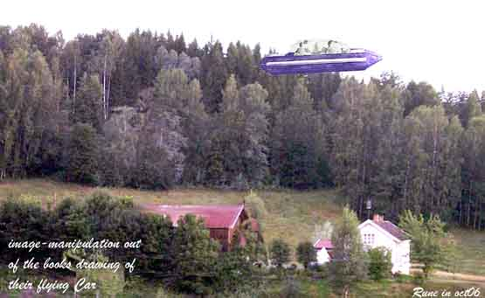
picture not from book - only made out of books drawing on the craft

The year 1963 -contacts of Bob
Radiocontact #18 from feb63 gave him their descriptions and ideas to make sketches on how they travel through 4th dimension as a shortcut for the long spacetravels - then "physical distances" are a minor problem. And they told "interstellar travel is really electronically controlled + "Interstellar communications signals are really transmitted in the Fourth Dimension to anywhere in the universe in 7.5sec".
But they could not reveal the method to enter the 4d spacetunnels, as also the Koldas-contacts told some about.(+ the Swedish contact-women channie west)
"With this type of communication, no corner of the universe is isolated. This type of quick messaging has led to a great under-standing among all people of the universe. Alliance or non-Alliance, since all are inhabited universes where there is SSR."
In the same contact they told that the military knows "they" are real, and the wordleaders had been contacted personally - but no mention of by which method. Did they just "beam down" or did they "rang presidents doorbell" coming as common earthmen?
And they spoke of how the powerpeople gags this info/press/media + the air force do ufo cover-up and deceive the public. They meant the truth would shake up the world when known - and that's just what the power/money-people/politicians are still afraid of.
At last they underlined that they had weapons that could vaporize the whole planet, but of course not as a threat.
The following contact was comments on the ongoing race riots at that time, and on suppressing blacks.
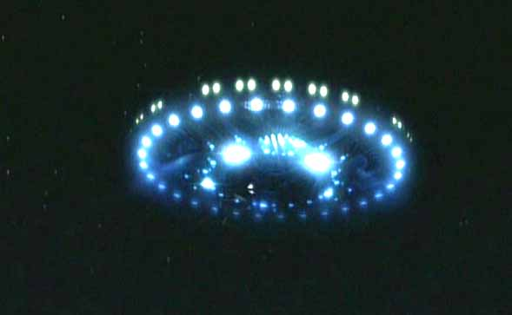
picture not from book

In the20th they answered his many questions and told they had 150obs. ships here- most small unmanned discs. Ten was 15mdia ships, placed on 2 small motherships of ca 330m, designed specifically for recording data and carrying scout ships aboard. But they had ships in greater number on the moon. And they described their ships can not be screened magnetically by bending the light around it - so to be optical invisible, as ex the Erra/Pleiaren-ships could as the Meier contactpeople from the Pleiades/Erra claimed. But they described equipment to prevent radar-reflections.

Here a very interesting extract on
SPACESHIP PROPULSION
from this 20radiocontact at night 20th july63
Question:
"We often read or hear of fantastic stops and starts, and sudden changes of direction. How can such tremendous "G" forces be withstood?"
Answer:
"Al-Kori speaking. Actually such spectacular demonstrations are more for show purposes than anything else. Certainly such feats cannot be duplicated by any of your own craft."
"With the propulsion techniques we use, namely gravitic and magnetic, propulsion is provided from fields generated by equipment inside the craft."
"Concerning magnetic propulsion: As you know, the planet Earth is surrounded by magnetic flux. It flows from south to north, since in reality the geographic South Pole is Magnetic North, as opposed to something called the North Magnetic Pole located in Hudson Bay."
"When entering this field, automatic detectors determine the flux intensity and the direction of flow in relation to the ship. There are also many more factors which are involved for this type of discussion."
"On Korendian ships, there are two sets of magnetic poles. One is vertical through the center of the ship. The other set of poles is on one of two rotating rings on the bottom of the ship."
"The vertical set of poles repels the Earth’s field with sufficient force to cancel the effects of gravity, much as centrifugal force, so as to suspend it in the air. For descending we simply weaken it. To ascend, we strengthen it."
"The poles on one of the rotating rings are used to travel in directions other than directly perpendicular to the field. These are automatically aligned by computer so that the Ring North faces Terran magnetic South, and vice versa. The poles are generated independently, and are variable independently or simultaneously, either in terms of strengthening or of weakening both together, or strengthening one and weakening the other."
"The second of the two rotating rings contains a revolving field, generated by a heavy current whipping around in coils in this ring. This field can be reversed instantly by simply changing the polarity of the current."
"About gravity propulsion we will say only this at this time. It relates to the resonance with atomic vibrations."

SPACESHIP DRIVE ALSO PROPELS OCCUPANTS:
"To return to your question, the interior of the ship is shielded by gravity screens which are an integral part of the ship, and affect everything within it. Thus when the ship accelerates, the entire area inside the grid accelerates with it simultaneously, as if the power were directly applied to every atom in the ship individually. In fact, that is exactly what happens."
"This is NOT an inertial negator. There is no known way of eliminating mass short of conversion into energy. But it does give the effect of the entire ship being a homogenous mutually accelerating mass, somewhat equivalent to falling out of an airplane. In this case you would be accelerating at 9,81m per second, per second, yet I doubt very sincerely that it would have any tendency to drive your eyeballs into the back of your head. This is because gravity affects each and every atom simultaneously, as does our drive mechanism."
"If it were not for the simultaneous acceleration of occupants and the ship, the occupants would feel a force which approaches a maximum value of 7,500 Gs. At this level, a man weighing 150 pounds would experience a pressure of 562 ½ tons! Obviously, this amount of pressure would not help one’s state of health!"
They then said that crashes of crafts were rare - they mentioned 6 crashes since year 1800. Formation flying was synchronized from a carrier usually and faults in the Earth's magnetic field were a problem.
The size of the ships in their federation was from 7,5cm to ca 4000km!!-This last made for explorations and also for evacuation of planets before totally disasters.
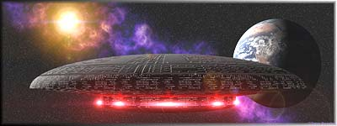

Their cosmic federation/alliance (21.Cont.-24th july-63)
-was formed in earthyear 1334.
- Had more than 5000planets in our galaxy as members.
- They discovered our earth ca 1959.
- They say the other planets here has life, but tell not exac.which.
- They say that our is the 3.high-siv.here on earth - as Lemuria and Atlantis was the proceeding - both destructed by wars.
The alliance has a world central committee elected from the representatives: two masters are elected from each planet and those elect the central committee, which are located on the Planet Arcturia

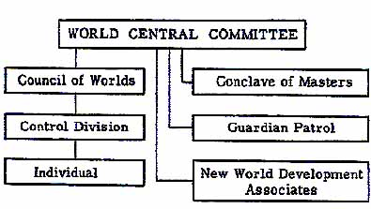
The ships under this alliance was donated to the cooperation and had crew from the same planet. There was a kind of friendly competition in getting new memberplanets to join the alliance, and esp Earth now.
The alliance naturally has a policeforce called the Guardian Patrol.
Their job=to protect the Alliance planets from hostile forces, and have free right to move to all planets and arrest possible criminals -which is very rare, as they claim not a single crime on the 610years.
This is because all things are in abundance on those planets and they do not use money - but use produced TIME as a measure - not converting this time to money, which can be misused by others. They say that if WE HERE got this system, 95%i of the crimes would be eliminated!!!
They meant that our United Nations would be a good start to make a world government -as also the Danish Wiseman Martinus already foresaw (in ca 1931) would happen in the future - after some time fellowing the BIG crises he foresaw coming "around the year 2000" as he expressed it. (M.had no formal education - only 6year in school and had a very deep cosmic experience in 1921- making him able to write many 1000pages in the fellowing decades on the theme LIFE's development in cosmos/eternity - link).

"Economic" system in federation: based on love+service (love in action)
In the next contact on 25juli63 the contact Daman-Rel on KORUNDOR told him of their economic system used in their federation.
They meant it was a human birthright to share the abundance and thus free:
- Free food, clothing and house/place to live (as luxury-homes here).
- Transport in spes.trains or like. But personal crafts were not.
- Communication- as small cellphonelike devises everyone had free.
- free energy or power
Their food was free acc.to a standard they had fixed. They had "synthetic meat" as " …we no longer butcher animals for eating. It is wasteful, and the meat is not 1/10th as nutritionally beneficial as the synthetics. Also, the synthetics are free of harmful elements… "
All of their production was automatic and thus no heavy manual labor. Quotation: "The only people really involved in industry at the present are the technicians and engineers required to keep the equipment in top condition. Maintenance of the actual machinery is by robots designed for the purpose, and all machines are, in turn, designed for ease of maintenance. The original factories are built almost entirely by robots under the control of computers programmed for that purpose."
They could easy convert lead to gold so gold had no special value. Their "cars" were magnetically propelled vehicles suspended over the roadways by magnetic repulsion.
All purchases in the alliance were registered in big computers. There were many private corporations and none was ruled or controlled by government.
They worked 6/20 of a day (>6.9h) 3days a week. (3/5 a week). 10holidays "paid" for in 100days worked.
All could select jobs themselves as long as possible after qualification.

THEIR SCHOOL SYSTEM AND EDUCATION (23cont in last july63)
- All education through tele-screen- transmitted to all the planets in the union from one learningcenter on a planet named Alitra. 15diff.channels- one per level. Equivalent 5h/day but only 2 "schooldays" out of 10.
Can use as much time as needed for passing tests/examination>individual learning-tempo. Some then twice as quick as others. Tests then made home as the learning else - on an internet-like system. Plus courses to be borrowed from libraries which are impressed directly into the brain/subcons by electr.way.
All "get paid" during all kind of studies.

Physical face-to-face contact#2 - at night in aug63
4 men of Korendor-origin but apparent as normal amr.men came in a white ’53 Plymouth Fury and picked him up and drove some time to where they had parked a kind of flying car of their own origin from Korundor. They said it also had outfit to eliminate gravitywaves and could go up to some few kilometres high and had also pressure-cabin and autopilot. He got a demo-trip in the craft and a lot of technical data on it and descriptions on how it worked in many details, which can be found in the e-book.
Last in this contact they repeated the warnings against the atom-race.
***
In the next radiocontact 1.5month later he said he could now make contact to them by sending out a special electronic signal, as they also could beam a special wake-up signal directly to his "sleeping mind" at night - so he could get up and start the normal radio-way.
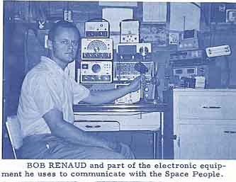
In radiocontact 26-nov63 they talked about the "history" of war on our battlefield-planet. They warned that a new big war would be nuclear -and total devastating, and talked for support of UN and warned to discredit UN. Then as now the warmongers in USA were active, and they warned against them. And they already said 40years +, how these warmongers thought how gullible the common people were - as they still do - because for more than half a century they have now lied and coverupped everything important to know and the REAL facts/connections. And the KORUNDOR people already then saw this danger and so they very strong gave warnings on this "let the government/powerpeople think for you".
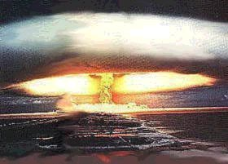
A couple of weeks later they was heard of again, but now late in the evening. This time they talked on the saucer/ufo-associations and the lack of co-operation/powerfighting in these. They meant that only cooperation was the answer. But it seems the Korundors - like the ET-group from Koldas, that worked parallel on information - was some kind of naive in their thinking on how strong Earth's "darkpowers"/opponents really was through the four decades of last century, regarding misinformation, cover-ups and ridiculing on this theme. Besides lulling people through backing/making silly, meaningless TV-entertainment. (Now nearly all the commercial tv-stations here in Scandinavia, also unfortunately sends those stupid, blunting, American-made series all times - besides "modern war-reports" as sport/football - again, sponsored by whom??)
They - the people from Korundor said: "Once the people are aroused and demand to know truth, then the way will open up to influence the leaders of your country (in political, religious and social areas) to take the right action to being about the desired conditions of peace, Brotherhood, and abundance."
Comment: yes, hopefully this will happen now gradually when we have got internet.
Another thing the said here is very much misunderstood here. They claim, as other incarnated wisemen here on earth (ex Martinus), that we must unite as a planet and make a world- government. This last is much misunderstood by many today, who believes that the darkpower/illuminati will succeed in this as a selfish play to get total control using us as slaves - well, comprehensible but.... They unfortunately don't see the spiritual plan and the evolution-way that planets fellow in a the BIG evolution. Yes - a worldgovernmnet will be made - but not ruled by these power/manipulation/bank-/khazar -people who now hidden behind steer the world today. They will be removed "as virus" by the REAL life-powers behind our planet as a living being - WHEN THEY HAVE OUTPLAYED THEIR ROLE HERE.In the same way as the virus' in our bodies will be removed and simultaneous strengthen our immune-defence. Be safe - EARTH also has an immune-defence against these parasite-powers which WILL BE removed when time is ripe.
The Korundor-people said on this through his radio:
"Eventually the United Nations will be made the controlling force in your world government, according to the principles of Alliance government. With the U.N. forces taking over international policing, the vast amounts of energy, which have been squandered on militarism, can be turned to peaceful purposes. Manpower, which was formerly employed in warmongering, can be redirected into peaceful activities. Medical and scientific research will be given priority. Food surpluses will be eliminated by two means: 1. Shipping surpluses to the underdeveloped countries on the stipulation that they, in turn, will contribute to society when they become independent. 2. Production according to the consumers needs, by efficient management of farmlands and other food-producing facilities, keeping only nominal surpluses for emergencies."
"In the more remote future, it is quite probable that your planet will unite with the Alliance, as your socioethical and scientific progress continues."

"They" can copy the body- from 3.physical contact
This is the first ET-copy-case I have red about from the 60ths: they had copied his physical body atom for atom, and a replace-man got the job "to drive it" (this is not mentioned here, but as I see it: the body must have been entered by the replacers' astralbody - rø). This copy should then take his place while Bob was "away out there". Of course this may seem far out if one doesn't understand men's spiritual composition. Have red about some similar cases from 2 researched/studied contactees from Sweden - Ante Jonsson and channie west (info on both on scandinavian on same site here) - who both writes in their books on cases like this. I have met Ante, and he is definitely not a liar!! But this is naturally hard to understand for the most, esp.for those who believe that the consciousness is only a by-product of the brain.

Visit on a secret base
Well, they had done this because they should visit one of their under-surface/inside earth bases and so they claim to have done. It is described a kind of mechanical doors down to it, but those must have been well hidden by a kind of force to have remained undiscovered.
Extract: "We (in the flying "car") quickly descended down through this form, and when we were below it some thirty feet, it swung closed above us with a whirring sound of electric motors. Orii-Val then pressed a button on the control board. A pair of doors opened in front of us and we glided through. We were now in a long tunnel of sorts, illuminated by a glowing strip of light on its ceiling. I was told this was over a mile long."
Down there were big, long tunnels with conveyors in middle. They came into a room with 6m high white-glowing ceiling and white-green walls. There Bob got a check-security card and they rode on some magnetic cars to watch different things there. He could fx talk to and see his double at his home.
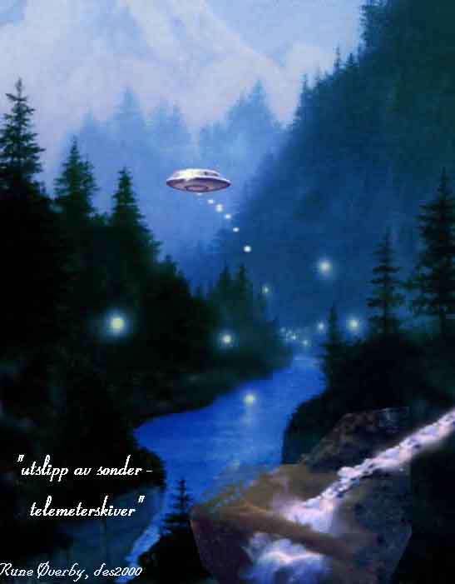
artpicture - "let go of tele-meter-sondes" - not from this book
There also was screens that connected the other bases as well as surveillance sondes around our planet - pluss comm.to their homeworld:
Extract: " This is the Main Console, and is this entire planet’s direct link with Korendor, Arcturus, and other Alliance worlds. All the recent communications with Masters on other worlds, that you have experienced, were established right here. This unit links planets to bases, to ships, and to other consoles for reaching individuals. When Master Kalen-Li called you from Korendor, his voice went through a similar unit on Korendor, was received here and your voice went the other way. "
There they also monitored all radio and TV signals that were sent out all around the earth. The entire base was done in a style so that the Korendor-people being based there should feel home: also fragrance-devices making feelings from woods on their homeplanet. The base had 6 levels/floors.
He also got a visit to the PowerStation on the base - a clean and quiet place as all power-creating worked on the difference of gravity on the rotors:
"All of the generators or motor-generated sets are run by gravity. Half of the rotor is shielded from gravity, the other half exposed. The difference in flux causes a torque, quickly setting up rotation. The speed is varied by governors and the percentage of shielding."
He was also shown an acclimation chamber where the Korendor-people could accustom to our planets conditions, as they had higher pressure, more oxygen and more G. And the most fantastic, lightfull living-rooms though with no visible lightsource - furniture as most beauty to think of.
There he also met one of the wisemen/master who had talked to him on radio, and not least the beauty Lin-Erri.
Short extract of what the master said: "By misusing the universal forces, you become their slaves and forfeit your mastery of them. Once this occurs, you are in deep trouble. Only a radical change of philosophy can reinstate the Right and the Good, and make you once more the sculptors of your destinies. You may think, for example, that you have mastered atomic power. My friend, you have NOT. It is ruling you, and you tremble under its shadow, afraid to move for fear it will annihilate you. "
After 7,5h there - they left the base.

Part 2-summary of the UFOcontacts of Bob Renaud from July 1961
link to part 1
(Realize that the effective ridiculing forces from the ignorant, adversary powers that have had monopoly on the medias since WW2, and so strangled all such information - now realize they no longer have this, and thus now try to disperse confusion though the www by joining different forums and there claiming THEY JUST ARE this and that particular "contactperson" - now "admitting it all was bluff"etc. Just like the dark/confusion-powers used the pensioners "Doug and Dave" some years, ago claiming THEY ALONE had made ALL the cropcircles, and the ignorant press people as usually believed it!!)

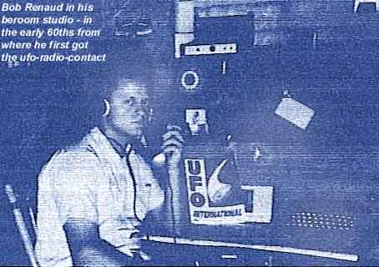
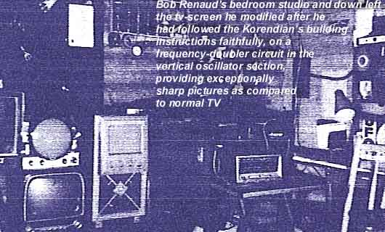
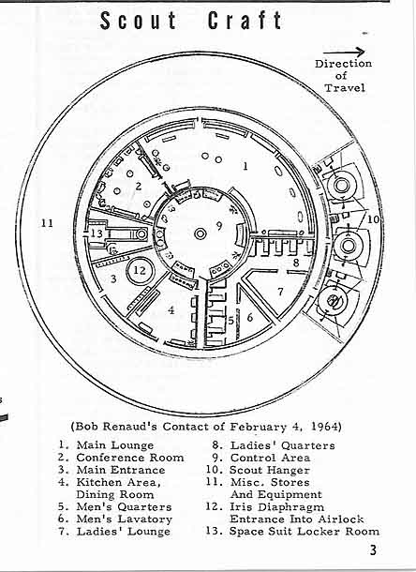
Opening-comment to this/such material: Of course one shall not suppose that anybody believe this -or similar contacts - only from any kind of pictures or claims - one must find a recognition INSIDE when reading this - studying such materials. So if a person will not be bothered reading or studying this or such - its waste of time. You are absolutely free to think you are only a pile of soil with a accidental "life" inside if you will - as the warmongers and materialists will have you to believe. Consequently - it is only through realizing, recognizing this surrounding material "reality" as only being a particular vibratory frequency-zone/"cosmic class room" - on a BIG scale, where a given frequency-design make this illusion of "reality" - that one can conceive such phenomena as teleportation and deep-space-travel through higher vibr.dimensions. In the view of the blind materialists of today, who identify themselves with the matter/body alone - of course such "theories" must be absurd!!

The physical ufo-contact in the early 60ths of Robert P. Renaud, UFO CONTACT FROM KORENDOR part 2 of summary
(5 colorpictures down is not from the book - it's only suitable illustrations)

The contacts through the year 1964
Bob said he HAD read about earlier contactstories, and had been searching for proofs, which he got when his own experience happened. He had now got the ability to feel when they called him. And the next contact was to an undersea base and again his "stand-in" took his place. Picked up this time by a 20m dia craft hovering ca 170m above the house - by an antigrav-beam, where to men from the ship up had first been beamed down the "elevator" to meet him. There was a magnetic force outside the 1,5m dia disk they stood on, so no need of rails.
He described the interior of the ship and again mentioned the 3dim pictures on walls. The room he came into was ca 12m dia w.curved ceiling. After a short trip he observed the ship being computer controlled down into a base below, into a room of ca 150m.wide. Also those conveyor-belts to stay/drive on. There he again also met the "young space-girl beauty" Lin-Erri.
He could now use a teleport-station there with different "end-stations" to their other earth-bases. After a quick med.check he was able to teleport with Lin-Erri to an under-sea base someplace under the Pacific Ocean (3,2km under ocean-bed)- outside of California:
" This was truly a unique experience --- unlike anything I had ever known before. When you first enter, a tingling sensation like an electric shock runs through from head to foot. Then suddenly there is a feeling that can only be described as disorientation and blankness, accompanied by an impression of sudden disintegration into weightless, massless vapor, like a ghost!
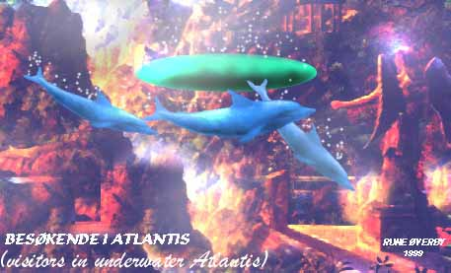
picture not from book - just a pure illustration: "visitations in underwater-ruins of Atlantis"- same for the 2below.
For an instant you cannot think. All you know is that you exist. Your brain is at this instant a mass of electrical impulses, which are being transmitted like radio. Our mind, without these physical senses, is self-existing, and is independent of the universe. It travels via the Ultraconscious to the body reassembled at the other end.
The tingling returns suddenly, then vanishes. You are through, and still alive and in one whole piece. This translation has taken one second! One second --- and 2,500 miles were just traversed!!
The man on the other end greeted us and led us to the main office…"
As usual he gives an extreme detailed description of the equipment in the base he can see - ex how they get oxygen and fresh air down there. And he get into the control room of their earth- crafts with a lot of panels, recorders, 3d-telescreens, monitors, and flight control units. Here they could also fellow the unmanned discs.
In those days in the early 60ths, there was no color-tv's, so he was impressed of all "in 3d+color." He saw one 90cm small, fly over LA + one over an AirForceBase, where it was deliberately controlled so it was seen and they could then pick up the soldiers reactions through equipment.
In a room there they overlooked "all earth" through those unmanned and manned discs, from where they got pictures and data back on big monitors on the walls. They could also remote-control all the ships if necessary.
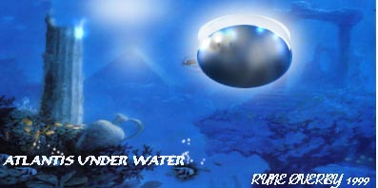
Oddly enough they had labelled most all eq. in English and not their home language Galingua. This must have been done in the intention learning our language for their people intending to be later or simultaneously out-placed in earth society. Ex.he saw a laserprojector - and remark: it will probably not be long before "those" are in sale, instead of the projectors now in use, which are surely also some copied ET-stuff (acc.to "leaking channels" as Dr Michael Wolf who told how a mil. group gave eq.to private firms who back- engineered them and patented it + on the coverup from StevenGreers new book)
He also got a demonstration of how they easy could teleport a ship-crewman into the base he just was on from one of the bigger ships over south-Africa on 2 seconds!! So all Bob experienced there was almost "too much" for him.
But he sensed: " These wonderful beings have not turned their inventions and discoveries against one another in hatred and war. Instead, they have applied their knowledge for man’s benefit, for his comfort, for his service. Because of this essentially humanitarian and philanthropic attitude, they have been the benefactors of many of nature’s wonderful forces that lie hidden from us - hidden behind a dark cloud of our own making --- a cloud composed of our hatred, our insincerity, our prejudice and greed. Look upward and see these shining discs in our skies.
Think about the wonderful people in them who have already been through times like our present predicament. Out of love and human decency they have overcome these trials, and now live in a world of true freedom and peace. When you can realize that we, too, could experience in our time this blissful life, then you have taken the first step toward helping to bring this wonderful way of life to all people of our own planet. "
*
He also was a technician himself and could see into some of their computers and saw something unlike what he was used to. But what is normal in today's computers also here on earth - which are (acc.to leaking sources as DrWolf) just taken/"copied" ideas from spacepeoples crafts/equipment of either "stolen" or crashed/downed materials. Even many technological break-throughs like the transistor, fiber optics, microwave, etc. have been undeniably proven to come from back-engineered technology from downed ET crashes. Top officials in all walks of life are now coming forward with this information. But here what Bob wrote on the computers he then saw " …the actual brain was composed of a myriad of little squares (todays IC/processors-rø.rem) of solid-state modules united apparently by mere contact, since there was no visible interconnecting wiring, nor was there room for any."
He also got a demonstration of a computer that he could a form of talk to, and with a form of "semi-will". He claimed they were into hangars of more than 3,5km length and those had no columns. The ceilings of glowing white "lights". In these big rooms were scoutcrafts of all kind from 10-30m, and technicians working on some.
Book also claims that the ship got through the ocean floor through a forcefield-door that holds the water back: "… When the ship reaches the surface of the ocean floor, a force-screen will open up and make a 200-foot diameter passage in the water up into the atmosphere. It is possible to move out every ship in this hangar in five minutes!"
*
The swedish contactperson Ante Jonsson also tells in his book from the early 90ths (link in swedish language) that he was taken to an undersea base where a forcefield hold the waters back. Of course such claims are nearly fairytales for normal, ignorant people of earth who have been deliberately misled and lied to for more than half a century from the authorities and the military. 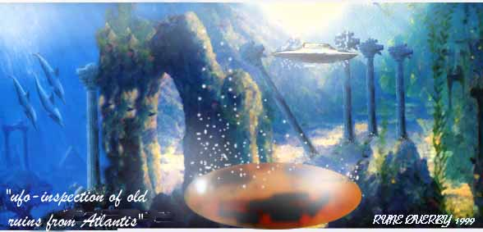
artpicture only as illustration - "dive down to the underwater-ruins of Atlantis"
So he saw a lot of diff.eq.there - fx: " On the right wall there was one long panel of unexplained function. It was being operated by three men and two girls. It appeared to be a sort of test and analysis device with probes in each stall(book tell it was 396stalls) to run the maintenance and repair checks on the craft hangared there."
Another claim is that they said they had developed methods to materialize bodies made for earth's conditions for "incarnating into" - just in the same way as Lobsang Rampa (link that opens in new window- here the doc on "renting-bodies") said was used in the far past for advanced ET's to come here in a hurry, as those bodies were conditioned to Earth's environment. One of them he met this way was the "president" of Korundor!
And he touched one of the REAL BIG PROBLEMS HERE: OUR VALUE-SYSTEM SO EASY TO MANIPULATE AND MISUSE FOR THE HIDDEN (big-banks-)power BEHIND. And this is JUST what those mis-using-powers-behind are afraid of being understood, discovered and accordingly abolished:

THE NEED FOR A NEW VALUE-SYSTEM ON EARTH
He spoke of many important things and he said:
"…This immediately brings into view a much needed change for your world. This is: A prompt change from your present economic system of capital --- to a SYSTEM INDEPENDENT OF MONEY, gold reserves, deficit financing, etc. We speak of the Universal Economics System mentioned to you in some of your earlier messages."
"You must be aware that many of your world problems are caused by inadequate economic conditions --- poverty, low productivity, poor education, and failure to develop natural and human resources, to name just a few."
"It is therefore advisable to eliminate these problems by eliminating their source: Money and the principle of barter on which it is based. In the field of science, your world has progressed by leaps and bounds, but you are chained to the inadequacy of a system of economics that is a thousand years obsolete!"
***
Some later quotation:
"… Actually, when we discuss with out economics experts the barter system used on Earth they find it hard to realize that a planet as advanced in many ways as Terra, can still believe in the archaic money-system economics you are now using. There are so many benefits to a moneyless economics system that we are surprised you have neglected it so long."
Together with the president came also a Korundor-wiseman named Altim who talked about how a planet they knew had been pulled into an atomic war. It had had a similar situation as earth - with the same "evils root": a moneysystem. The atomic war there had killed 91% of the inhabitants. 64% had died immediately, and 27% of the after-effects /radiation etc.
Just now that whole planet was a military state much worse than Soviet have ever been, they said. The Korundor-people were now trying to help that planet by many ways.
***
After this talk of the wisemen, Bob was taken home: They first teleported him directly to a small scoutship near his home - from which they took him down to some place near, by help of the antigrav-lift-beam.
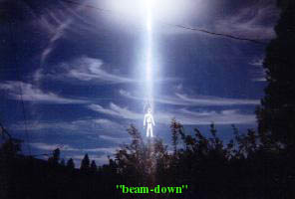
picture just an idea/not from the book
*
SCOUT SHIP DIAGRAM
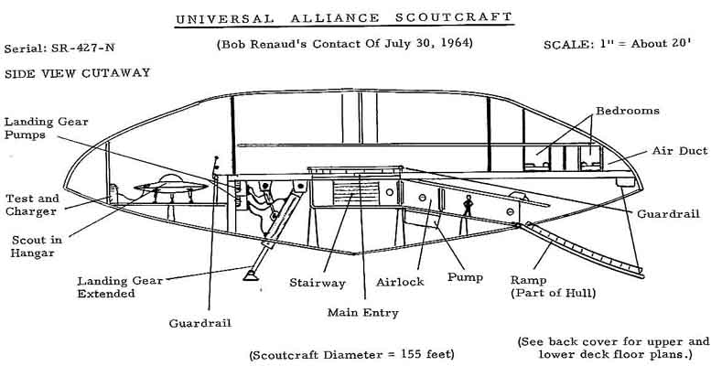
This diagram of the Scout Ship that returned Bob Renaud and Lin-Erri from the Undersea Base under the Pacific Ocean was drawn by Bob after his return to his home in Massachusetts. He was most impressed at what he had seen and witnessed on this long trip. Picture from the book.

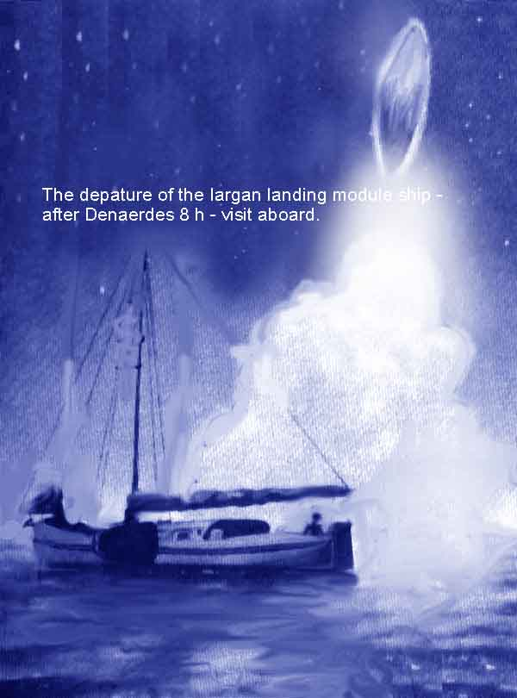
artpicture from another contact that happened in Holland in the 60ths - which is also made available because of the respected collecting-job of Wendell Stevens - all honour to him!! Is was when "stefan von der Erde" had these meetings with a "water-loving-race" from planet IARGA- whom he met when sailing with his family. From these contact he got a lot of intr.inf.
---------------------------

February 4-night contact - 5.faceToFaceContact
-Got radiomessage intending a contact as usual at night, so they came in a ship some over 60m in diam.which released a small ship, descending down and picking him up. They had nearly been watched of a passing car when they flew. So the bigger ship took them up.
Inside he remarked that the telescreens on the wall showed the landscape much lighter than seen by eye alone, and all of them covered all around the ship, including up/down
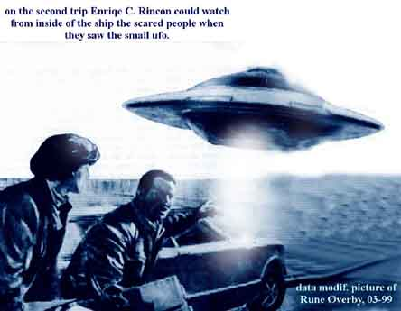
picture: "they" avoid frightening people as Rincon got a demonstration of from his cosmic friends when he was taken inside a ship and they flew near some people in a car being very scared. This happend in SouthAmerica in-73.
Blue pastel colour in the rooms, and grey carpets on the floor. A 2mdia column in the center. Crew of seven-incl. 2 women, all wearing a one-piece uniform.
Bob was now able to get a spacesuit on in the colour of polished silver. It was air-conditioned and contained breathing apparatus, a communications device, and a variety of meters and instruments for control of temperature, air pressure, humidity, radiation, etc.
Wearing it they could go outside of the craft, as the shoes of it had a adjusted magnetic attraction to the ships hull. He describes the difficulty of moving in non-gravity, and describes a view from space that we are now used to see from the space-shuttles. He also saw the cosmic dust as "fireflies": " Most of it you would call meteoric dust. It comes from many sources, among them comets, the wreckage of the fifth planet in your system, and the uncountable millions of tons of loose material floating about in space. It can present a hazard if in great enough quantity. Our ships have shielding force fields to deflect them. "
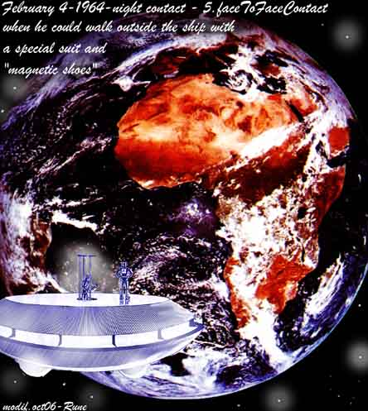

The problem of overpopulation,
In radiocontact at feb10-64, Lin-Erri spoke of the problem of overpopulation, and mentioned that India was an example of that. Said the ideal family was 2 children + the parents. She talked on necessity of sexual education and on today’s wellknown methods of avoiding pregnancy. And said:
" Now, assuming that your Earth had a world-wide program of sex education, and a safe and efficient means of controlling the conception rate, the next step would be to consider the improvement of the stock."
"One might first think of the mentally deficient and the criminally insane, whose characteristics could be hereditary. If all attempts to help them fail, then sterilization would be the humane way of preventing their defects from being carried on to another generation. "
And some lines below: "We here have developed this science to a point where we can determine even the colour of the eyes of a child to be born! Also, we have developed a method of changing the genetic patterns to eliminate deformities and produce superior strains. It is possible to produce a variety of conditions, such as resistance to disease and, occasionally, to instil certain specific aptitudes --- such as for music or science. "

Their Penal System.
The next radiocontact happened 4 days later, when Andre-Kael – a Universal Alliance of Planets Criminologist – spoke on the subject Penal System. And he said that some nations "capital punishment in form or for any reason, represents a retention of barbarian ways and indicates the inability of a civilization to deal effectively with its problems."
They saw the inhumanity and limitation in our present penal system, and saw the injustice in our jurysystem: "We are also opposed to the jury principle, leaving a man’s very life in the hands of people who have no knowledge of the facts except for what they hear from ‘witnesses’ who can easily be bought. When emotions and unreason rule, there is little opportunity for objectivity and justice."
And talked how the rich could use money to buy lawyers and judges. Their solution was not to use punishment. The lawbreakers on their worlds could either admit the wrongdoing or use another method; "Psychprobe".
The "criminals" lived a free life in a kind of region, isolated from the society else. Their methods seem to be very close to what the Danish wiseman Martinus wrote in his LIVETS BOG in ca 1931 on how our society on earth will - after his timeless views - solve this problem in the far (+500years) future. But here an excerpt from the way the Korundor- alliance did it:
" There are no cells, no guards, no walls --- nothing whatever to restrain the individual physically."
"Instead, he is required to register three times a day at the main building in the area; once upon rising, once at midday, and once before retiring for the night. If he fails to register, he knows that a search will automatically be undertaken and when he is found, he will be returned to continue his retention.
"While under detention the criminal may work at any of a variety of useful jobs. There are repair shops, manufacturing plants, printing or taping units, and a number of other facilities. There are recreation areas, dining areas, and what you would call PX’s."
"After his work day is completed he has full run of the base until Galun 18 (20 Galuns in a day), curfew time when he must register and retire for the night, to awaken at Galun 5. The work period is from Galun 6 to Galun 12 daily. Visiting hours are during the free time period from Galun 12 to Galun 18 daily.
"The criminal is paid for his work and has financial freedom within the facilities of the base. He would not be able to use his UnEc card ("work-receipt-card") off base, since the penal cards are red, and would be instantly detected among the gren ones used in ordinary life."
"Each private dorm is very comfortable, and includes bathing and toilet facilities, as well as radio and telescreen. There is a well stocked library in each dorm and a large main library in the recreational complex."
"This may seem like luxury but there are definite restraints, despite the apparent freedom. They are required to stay on base, and they know that if they try to leave they will be apprehended and returned within half a day. They cannot use thief UnEc off base. They may not travel from planet to planet. They may not visit home. And they MUST live according to schedule. Apparently these things constitute sufficient psychological ‘punishment’ to ally in these individuals any future plans for crime, for the system works very well."
"In a penal colony, a criminal also has a chance to further his education and work training if, for some reason, he did not get what he needed previously. Of the little crime that we have, 99% is due to these two factors: Inadequate education, and work training."
"Another choice open to a criminal is to undergo a voluntary assignment to one of the many planetary development units which are constantly bringing civilisation to the new worlds frequently being discovered."
"Here the criminal lives among non-criminals, the only distinction being the red card and the three registrations daily. Also he must remain on the planet, whereas the others may leave at will. He shares the same living quarters, recreational facilities, etc. Here, too, an education may be obtained when needed. Still, these people feel the psychological walls around them."
"The third alternative is to undergo corrective psychprobing to change the criminal tendency. Under this program, the individual must report once every day to the office in the city nearest him, where he will be probed to determine the effect of the corrective measures. Usually this will take about 20 to 25 days, after which he is free to resume his normal place in society. He is now distinguished by a yellow UnEc card. He can use this any place in the city of his choice, but nowhere else on his own or any other planet. His card is identified specifically with the certain city he chooses, and is so made that any attempt to alter it will render it VOID in large black letters. Furthermore, he may not leave the city or planet where he has agreed to remain. This is similar to your probation system."
"If the individual requests a psychprobe to determine his guilt or innocence, he is brought without delay to the nearest Psych Centre, put into a semi-conscious state and his conscious and subconscious centers are probed. We have learned that the brain patterns of criminals are very distinct from those of other people. A test for those distinctive patterns, which are formed by guilt feelings and aberrant mental functioning, is the first of two probes. If the person has patterns, which indicate the criminal tendencies, then the second probe is used. Through careful questioning, visual memories of the crime are brought fourth in the criminal’s mind as the experience is ‘relived’. The probe machine then translates the electromagnetic brain impulses into visible pictures on a telescreen, which correspond to the memory of the crime committed."
"If, by this method, guilt is determined, criminals may then choose one of three means of ‘punishment’, and in some cases must submit to corrective psychprobing as well. In rare instances, it requires surgical correction of brain damage to effect the required rehabilitative measures. As always, education is provided as needed. "
*
And crimes are not officially published on their planets, and the lawbreakers have no problem going into normal society again.
Here I will insert another cut from a physical contact to a BIG humanlooking alien-girl from one of the "overlooking-ETraces" - telling the Australian contactperson Michel (in -89) of the penal-system used in a far, far distant earth- civilization. This civ. had been colonized from space- the colony then existing in the east – some up to one million years+ ago:
‘As for murder, this too was rare, as you will see. Accused murderers were taken to a special room and left alone. Behind a curtain, a ‘mind-reader’ would be installed. This was a man who not only possessed a special telepathic gift but who also cultivated that gift in a constant endeavour, in one or another of the special universities. He would intercept the thoughts of the supposed murderer.
‘You are going to retort that it is possible, with training, to make one’s mind blank - but not for six hours at a stretch. Further, at various times when he or she might least expect it, certain predetermined sounds would be heard, obliging the ‘subject’ to break concentration.
‘As a precautionary measure, six different ‘mind-readers’ were used. The same procedure was applied to witnesses for the prosecution or defence, in another building some distance away. Not a word would be exchanged and, on the two following days, the procedure would be repeated, this time for eight hours.
‘On the fourth day, all the ‘mind-readers’ submitted their notes to a panel of three judges, who interviewed and cross-examined the accused and the witnesses. There were no lawyers or juries to impress. The judges had before them all the particulars of the case, and wanted to be absolutely sure of the guilt of the accused.’
(from http://galactic.no/rune/thaoeng2.html and the 2 pictures down is made to illustrate just that contact )
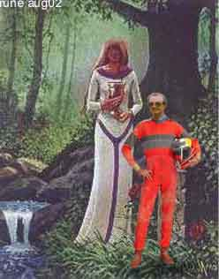
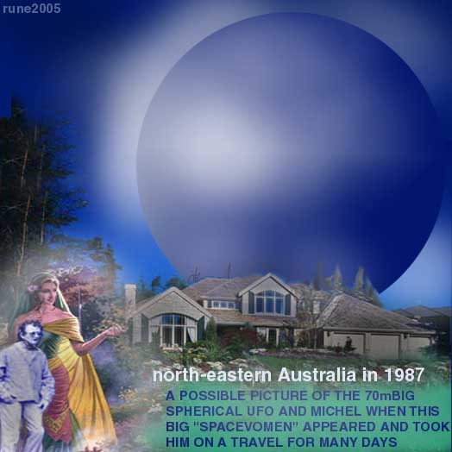

next part of The physical ufo-contact in the early 60ths of Robert P. Renaud, UFO CONTACT FROM KORENDOR:
Part 3-summary of the UFOcontacts of Bob Renaud from the 60-ths

Still in the year 1964 and late winter:

Contact on radio 21feb to Orii-Val
And now he talked about "sport" on their home-world – a lighter theme. They had no kind of football, but:
  - A form of tennis-played by 4people in 2 teams
  - A variation of basketball with foam ball w.some water inside, which shifts about in flight to give absolutely unpredictable trajectories to the ball. The nets are electronic hoops.
  - A kind of "air-pylon-race" with antigrav-jets and magnetic ships.
  - Kind of sports car-racing with "cars" without wheels. They also claim the have copied our form of drag-racing!! (what a wild idea, but for a siv.with enough recourses it may be ok…)
  - And: "We have other sports, too. Our water sports do include swimming, boat racing and water skiing. In our short winter we enjoy skiing, ice skating and ice boating."
***
In part 37 of book they tell how the information from the Space People was transferred to Bob - by "beaming" information to him via psychprinting. When he was ready to write the information seemed to just flow into his mind. Later they give him a post-hypnotic suggestion (while he was in an electronically induced hypnotic state) that whenever he contacted the Space People, he would remember every detail until he had written it down. After that his memory would revert to normal and details would gradually be forgotten.
The pleiadian(pleiaren) spacepeople (from –75 in Switzerland) seemed to have used a similar method for letting Meier writing down the contact-reports literal/ word-for-word. ("semjase-berichte"- which contains many hundred(-or thousands) pages). And some similar method used in the case of the Iarga-contact of Van Denaerde in Holland in the 60ths too.

4.march-64 and face-to-face-contact #6
Bob stood waiting under the stars after pre-instructions when one "star" came down – the scout ship. The pilot inside was the familiar Orii-Val who said they were going to "Outer Space." As he said, they built their scouts for travel in any medium, from deep water to deep space.,,
They rose to a kind of carrier-ship with a tubular hangar inside with a hundred feet (30m)in diameter and (later told) 550 feet (16,5km) in length! A good sized tubular scout carrier could be parked in that great shaft!
They said this was the ship from which he had got the first radio-contacts in –61. It showed up to be a big ship and many floors/levels.
In one of the many rooms he was shown "a copy machine" that took a 3d atomic "picture" of the body.
He wrote about this: "I took my place on the red circle on its floor and assumed the correct stance. Orii pressed a button. I felt what could only be described as a wave of energy pulse through me. It was so brief as to be almost unnoticeable. It felt sort of like an instantaneous but very mild electric shock.
"That’s it", Orii said, "you can come down now."
My curiosity aroused, I said to him:
"What was that all about?"
He explained that three things had been accomplished. First that I had been photographed in the usual manner, and second, my psychic make-up had been recorded! Third, and perhaps the most astonishing, he said that in that brief instant he had taken my atomic photograph!
"As you remember", he continued, "teleportation is merely the transmission to a receiver of a pattern of signals corresponding to your atomic structure, where raw material is built up into a body, an object, etc. This unit, instead of transmitting these signals, records them in a brief instant on a blank Pattern Block, which consists of a compressed atomic structure containing as many atoms as a ten-foot cubed block of the densest natural material. The signals impressed upon this block cause the atoms to align themselves in certain ways. When the aligning is completed, a Locking Pulse is sent through it to freeze them exactly as they are. The atomic photo is then completed. There is one taken for everyone that comes on this ship at any time, and that is so for every ship in our Korendian fleets.’
"The purpose is quite simple. If a person’s body should be damaged beyond normal medical treatment, by accident or otherwise, his body is annihilated and a new one is built up from the ‘picture’ in the Pattern Block, which he then occupies, and picks up where he left off. You might say it is a sort of suspended teleportation."
*
In another room he was observing as some people were teleported to Andromeda- galaxy some million light years away! He says he was told that all the control and communication inside/out-from this ship was controlled by computers + only ONE man alone: the Co-Captain, Quinn-Tatrill.
Also here were big screens + 1wall-to-wall showing all outside like real windows, as they also showed depth. The pictures were composed of many thousands of single-pictures composed together by computers and shown on the screens. Some also showed near-look/enlarged live-pictures of the moon and the sun – the last in shielded lights, where the sunspots were seen.
"…a special room was where all the control and in/out info from the telemeter-discs were gathered. On he right wall a segmented telescreen, divided into four parts, monitored the video transmissions from the discs. Only one of them was in use, showing a clear view of the Pentagon in Washington. I was told that it was also monitoring brain waves from inside the five-sided military command center. These patterns were being displayed on the output rack."
He also saw an earth-man that was teleported up inside this ship in the intention of tapping his sub-cons. - as he was working in a military inst.and they had to get the overview of all happenings regarding them, as they overlooked the dangerous development of the weapon race. (have not red if this man was awaken – but it’s written as he had volunteered:) "… He works at a military base, on Top Secret devices that we need to know about in order to further our research. When he is brought back to Earth, his memory of all this will be erased. We had to pick him up while he was on vacation in the mountains, in order to avoid suspicion."
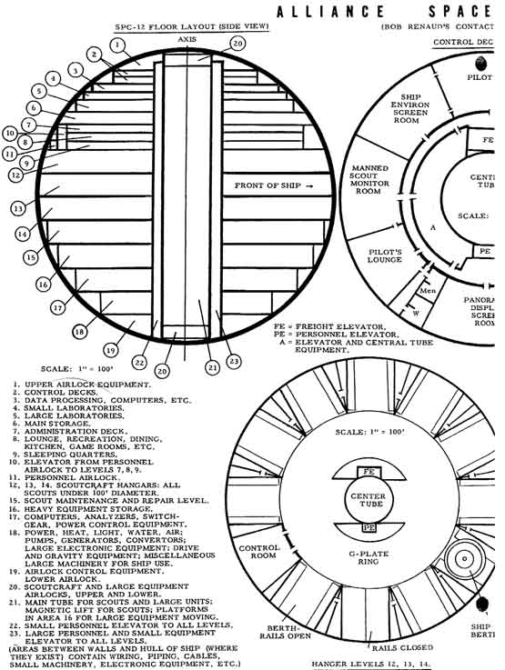
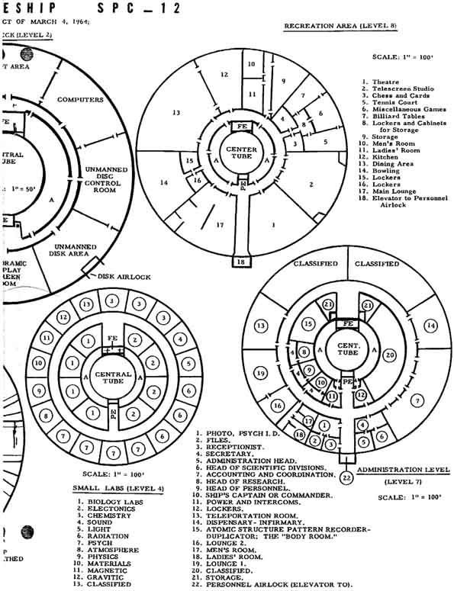
In this big ship there were 700private rooms – all with plenty of room/furniture. Last in this visit he was able to meet the other (+more) persons he had earlier listened to by radio – fx "the masters".
Nearly 50 years ago this must have sound like fairytales when he wrote such of the hightech he saw, but today in 2006, much of this is not so unbelievable technically seen, for those being high-tech oriented/updated.

--------------------------------------------*-----------------------------------------

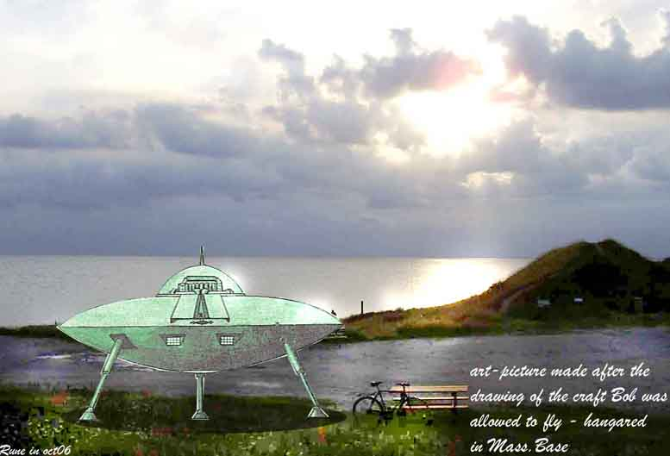

THE next contact the book refers happened many months later – 30.july-64
– 2-5in the morning, when they told him to be outside a minute later. Then they remotecontrolled from a bigger ship above - a small ship landing– inviting him inside. He did, and was guided by radiovoice to take off and "drive it" himself: but a little too quick – up to 800m in second! Of course they could have remote-controlled it back/up, but they did let him try to fly it live. At last he managed to maneuver it into the bigger, as he had also earlier tried to fly one under some instruction.
He says he only felt a light feeling of movement when the big ship accelerated away towards Washington for a special task: They "parked" 8000m above pentagon – and was invisible on radars. From this ship they sent down small "spy-balls":
" Our purpose here", Orii began, "is to plant three small psychoprobe monitors on the roof or the building, directly over three offices that we wish to observe. The three men are at work now, so our job is greatly simplified. Let’s go over to the disc board, and we’ll begin phase one."
The 5cm probe was set into the (concrete) roof by a small device that burnt a hole some into it, and after the probe was in place, it was sealed by the same laserbeam-eq.
On the screens they saw all: "…. I saw a tiny metal sphere neatly deposited into the hole, just below the surface of the roof. Then the Heat beam was projected and the roof melted in around the globe. It was no longer visible, and when the roofing material cooled it would be undetectable. I felt a deep sense of relief that nobody inside had suspected the carrying-on over their heads. The disc by now had returned to its berth in the ship, and the control panels (on the mothership) shut down automatically. "
"These probes", Orii elaborated, "are attuned to specific mental frequencies, and will disregard all others. They will monitor all brain activity on the conscious level, relaying it to our instruments in the base located out in the ocean near here. Their power source is the weak, but useable, radiations emitted by the building’s wiring. We placed them as close as possible to cables, for maximun sensitivity and power output for the transmitter."
It is distinct to see that the "overseers" took this overseeing –task serious as they here claim they had used ten thousand probes on only Washington! But from what I have red from other such "sources" – other races have an even more advanced high-tech – with no use for "physical probes" for doing this same job.
But those here were not so "behind" – as can be read here that those probes could also tap the electric impulses from the nerves in the brain from the eye, ears etc. of the men inside the buildings, so that the eq.in the ship could "translate it" to pictures(+sound) on a screen up there, or translates it directly into the brain of the spacemen - who "experienced" the same!!
And not only that –they had made a type of helmet that was coupled to the wearers brain via the probes "down there"– and the "ufo-men" then experienced what the man "down" saw, heard, felt etc. – and with two-way function. Here a cut on that:
" …needless to say, I accepted. Orii plugged its connectors into a panel and placed the helmet-like apparatus on my head. Abruptly, I was in a comfortable chair in a spacious office. Before me on a mahogany desk, was a copy of a manual on one of our bombers. A typewriter was nearby with an unfinished page of type in it. Assorted papers, pens, and a pair of phones completed the desk array.
Orri (the "spaceman in the ship with Bob) interrupted me momentarily by switching the gear to standby. He said:
"We’re going to give YOU control of his mind for a while. What YOU want him to do, he will do. Since you are an Earthman, you are not affected by the laws of non-interference as we are. I’m going to switch you over now."
So saying, he threw a switch from Monitor to Control. The headgear then returned to life, and I was back in the office. I noted that only when I directly willed it did I control him. He still reacted normally to his surroundings, however.
I turned my/his head to observe the room. It was quite comfortable for an office. The floor was covered by a carpet, which blended nicely with the cream-white walls. Several pictures hung on the wall, along with a number of documents that gave his name in full. Since to give it here would put him in jeopardy, I’ll say only that his first name was Joseph. It was very light in the room, the ceiling being one of those with wall-to-wall fluorescent fixtures. The door was at the right of his desk, with a chair on one side and a coat tree on the other. The light switch had a chrome plate on it, with several fingerprints clearly visible.
In the room were other chairs, a table, a bar and TV, a radio, and miscellaneous bookcases and cabinets. On one of the cabinets a picture of his family faced him. It showed his very lovely wife and two children, a boy and a girl.
A secretary came into the room. They conversed a moment about a visitor who was waiting to see him and then she left. Moments later, a tall, distinguished looking gentleman entered , carrying a briefcase. They greeted each other with a handshake and began to talk about matters of which I had no understanding. I took off the helmet then, figuring that what they had to say was none of my business.
Over the speaker, Joseph’s voice came clearly:
"You know, ED, I had the weirdest feeling a moment ago, as though I was being watched. Then I felt a distinct urge to make motions I ordinarily wouldn’t have done. I don’t know --- it was just an odd sensation, as if someone else were in the room here!" He said something about working too hard, and they both laughed. Joe sounded just a little uneasy, though
I shuddered to think of psychic atrocities this could be used for if it fell into the wrong hands! People could be forced to kill themselves or others. There could be no privacy. In fact, war could be precipitated by simply controlling various world leaders, and making them declare war. If this were impossible, then the military leaders could be made to begin the war without the leader’s consent. In this age of atomic weapons awaiting the push of some buttons, how easy it would be to begin the end of mankind! Thank God such power isn’t within our grasp. If it were, this Earth would truly be a worse hell than it is at present. "
(it is here to comment on the Norwegian contactperson Arve Jacobsen’s experiences onboard a big mothership he claimed to have been taken into in the early 70ths – where they among a lot of other experiences/adventures let him wear a some similar helmet – from where he describes a sensation of observing through another mans eyes on a distant and more primitive planet that they seemingly observed or flew over. Link to Norwegian report on that)
And here an excerpt of how they can zoom into the subcons.of a given people and find out all about them, and they use this information in fx selecting the right people for being contactpersons:
"……Orii turned a control labeled Magnification, and the scene was exactly as you might see through a zoom lens. The ground came up quickly, and soon we could pick out individual people on the street, what few there were. Orii said:
"Pick one of them."
I chose a taxi driver who had stopped temporarily for a break.
Orii then went over to another panel called the Remote Psychprobe. He switched it on and focused its beam on the man three miles below. Then he pushed a button marked Computer Analysis. From within the depths of the ship a whirring noise sounded that lasted about five seconds. During this time I noticed that the man was apparently aware of some unseen influence, as he stopped smoking and looked around curiously, as if trying to figure out what had attracted his attention. When the beam stopped, he started puffing on his cigarette again and then scratched his head in bewilderment
Orii had the typed sheet from the printout unit. Now he read it off to us.
"His name is Peter _____ (last name deleted here for privacy’s sake), he is 36 years old, lives in Washington, has a wife and three children, two boys and a girl. He drives a 1961 Chevrolet, white and red, two door hardtop style, on which he owes three payaments. He will be off duty at 06:00. He thinks Barry Goldwater is a nut "
***
About a month later he was again in physical contact with them, and was this time taken to the Massachusetts Base, where a conference was to be held by the people involved in controlling and coordinating ‘Project Terra’. A model of Earth was hanging in the conf.room.
‘Project Terra’:
- Scientific and sociological research.
- Education of the Terrans in the Universal Laws.
- Prevention of warfare, inevitably to become atomic-.
Else it was to influence the people on earth- from schools to government - of Universal Philosophy etc. Plus to display landings, and to inspire/support anti-atom movements. And back up an establishment of a powerful world government under the United Nations direction.
They also admit here that it is seemingly some different interpretation of the universal Laws of Non-Interference between the different "cosmic helpers" that are here – those here seem to go some longer than fx the Erra-pleiadians having contact to Meier, who seem to have been very careful, acc.to c-notes in interacting with common earth-people.
Bob was now shown a film of a scene from the war in VietNam where the us-army were torturing a young "enemy soldier" - and where the Korundors admitted having broken the law of non-interference: they landed and scared the us-torturists and freed the prisoner, took him with them and treated him, and brought him back to his very grateful parents.
They also measured that the us-army had atom-weapons onboard some of their airplanes, and how the us had fired at their crafts many times. Another film they showed him at the meeting was when a Korundor-man had been teleported down to a military –meeting in pentagon: (bob reports what he saw as a film in the conference:)
" …a few seconds later there was a view of the ship’s interior. A man was standing inside a teleportation cabinet, dressed in a space suit, and carrying in his hand a telescreen camera, about the size of a cigarette box, which included the recorder and transmitter. A moment later he vanished. The next view was of a large assembly of military men in a conference room. They were all gaping, wide-eyes and slack-jawed at the figure that had appeared on the platform in front of them."
The intruder then talked some short with them, and demonstrated the reality of this what they saw by making one of the generals there floating in the air – then the Korundor-man dematerialized himself back to the ship!!
---
if this is correctly refereed and true, it is no surprise why the military are afraid of this to be known: they would loose their jobs - there would be no need for them/the military, in a high-tech society with abundance of everything - nothing to fight for!!
*
here a statement from this conference that came to be true when looking at the happenings from today- 40years+ later, in spite of a lot of scaring rumors on the net:
" Then there are those who predict a shift in the Earth’s magnetic poles, and foresee incredible disasters as a result. Let us inform you that your magnetic poles have reversed eight times since the Earth began, once only a few hundred thousand years ago. The sun’s poles have shifted three times, the last only a few years ago, with no effect whatsoever to anything. By our calculations your magnetic poles are due to reverse themselves within ten years. This does not mean polar flip, and the effects will cause little for you to be concerned about" (in the norwegian edition of "Illustrert Vitenskap" #3/95 (illustrated science 3-95) had on the cover this sentence "the sun has lost its soutpole" (translated from "solen har mistet sin sydpol") this was from measurements of the suns missing magnetic south-pole done of the sonde ULYSSES at 13.sept-94, when it passed the – missing - south pole of the sun.)
The conference else took up the problem with the development of the cobalt-bombs on both sides of the iron-curtain.
Last in this part 3 of the summary I’ll refer from a radiocontact that happend a year later – 11nov-65 – with master Kalen-li Retan.
Short from that: " After thousands of years of despair and destruction, we feel that you are entitled to a better life, one free of fear and hate. Too long have your people been snared like helpless animals in the giant steel trap of war. Too long has the spectre of death and violence haunted you in your very dreams. Too long have you lived from minute to minute, expecting the next moment to bring the end of all things on Earth. Too long have your children grown up in an atmosphere of sadness. It is now time for a great change."
"We are at present engaged in direct encounters with dark forces which control your nations. As each day passes and they realize more fully that their days on this Earth are numbered, they show their colors more and more. They are in panic now, my brother. "
This was said more than 40years ago and the dark’s (and/incl.the powerpeople behind ‘s) own fright are now stronger than ever – that’s why they now orchestrate "terror attacks" in the hope that the world can be captured in their evil grip for more centuries. But this thoughts are in vain – the earthman is now in the process of being filled up and thereby "satisfied" with pain and sorrows, and begins to wake up their inner true LIFE-ESSENCE and ability to recognize the real TRUTH.
END

More on the Korendor talks where "ArKay" told of their homeworld and else gave advises for earth in 1988
remark: this is NOT channeled information

Planet KORENDOR
As the axis is not so much inclined as for earth, there are less pronounced seasons than here. 6dg north-south of eq.is not liveable; 6-20dg:too varm, but one can live there, but most tropical rainforests. Only few cities so long south.
Temperate zone: 20-75dg.where 98%live- and 60% live north of equator
Surface of K= earth's X 7,5 and 53.7% is land.(i e 4xE's landareas) and 5% of it is cultivated and only every other year seeding/harvest for not soil exhaustion.
They use no form of animal-products, but fruit in abundance. Have many types of them, but just apples they only found on earth and imported "home". Have also seafarms for seaweed=source for fiber/+protein.

FORESTS
In a far past time (1000y ago) they used forests/wood as buildingmaterial+ burning it for energy - ruthless exploitation leading to a near-eco-catastrophe -
but not now; therefore many enormous big forests -upto one mill.sq.miles- 2592000km2.
After the wood-burningperiod which made so much pollution- they used sunpowerstations in the eq.zone for a time (and they still exist there he says). And so they developed fusion energy.

TYPOGRAPHY- no big mountains because of the high gravity - max 2700m high. A mountainplanet like earth is rare in cosmos they say. But many big lakes and rivers as ex the Nile on K. And the waters are used for relaxation, but they do not fish of ethical standpoints. They are shaken of people doing such things as hunting here.
There are also some enormous caverns on K.- so big they could house big earthcities inside - and they admit they don't know how these are formed. Also a 140km dia meteor impact crater exist on K.- 7km deep.

THE KORENDOR PLANET - THE CITIES:
Their maincity or capital on Korendor is named Vrell - pronounced "virell."
- Has many parks and gardens since you are always near one of them.
- Almost absence of traffic on streetlevel - only some electric cars - most people are walking when not riding underground or overhead transit tubes linking most buildings.
- Most cities on K.is constr.as "wheels" of concentric rings of buildings at the hub of each wheel. Ca.25rings pr.system. Those wheels are in turn part of bigger wheels and centre in this big wheel is the capital complex where the planetary gov.is.
- Outside the city is a forest/meadows ring - ca 21km wide with wild animals not afraid of people.
- Outside that ring is the houses for people and past that the farmland with fruit trees of many hundred kinds. And automatic farming + harvesting.
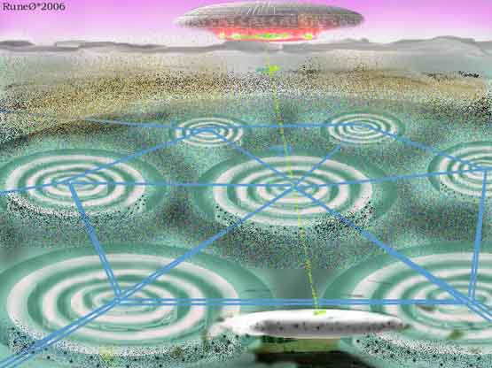
an idea of a Korendor-city and a big mothership of kilometers in diameter hanging above - not from the book and not to be taken as a correct or exact interpretation from the Korendor-material - buy the e-book and evalutate yourself!!
- CITY SPACEPORT is located 8km beyond the forestbelt Northeast: parking-area for 1000s of ships there of various designs: also some old winged and triangles. Most discshaped from some metres up to 800m+ in size. There are "air-columns" for in/out-traffic. The old winged museum type plane is hydrogendriven. A flight-museum of 15km2 with history of flight back to the first 800years back and 35000 crafts from many of the Alliance' planets! He says that many of those museumsplanes there are still much more advanced than our most moderns here!
- HOTELS and restaurants for visitors from other planets are there many of - all made so that the visitors shall feel at home and flourish - also with the type of food the visitors are used to - but of course not slaughtered meat. A part of the capital is related to the alliance-related operations and there is an alliance museum there with more than 8million visitors a year. A lot of institutions devoted to music and art exist there.
- THE ALLIANCE WORLD CENTRE: show life and things from the 740.000 planets in the alliance on pictures, datafiles etc. Holography and hightech shows life and conditions. They claim they also had added earth in the collection there -as they operated help/surveillance -bases here and he says people there were very interested in earth.
- They underline that FOR NORMAL EARTH PEOPLE KORENDOR IS NOT A LIVABLE PLANET - as earth is not suitable for their korendorbodies.(talk 16.oct88) One of the reasons is the gravityconditions. They give the example of deepseafish not "made" for living in shallow lakes.

POPULATION
- The planet KORENDOR have 8000000000 (8xe9) - 8billion -people living there.
- They said "human is not the shape of the body, but the essence of the spirit".
- They too feel joy, laugh, sorrow and sometimes also anger and hatred. They also thus have a dark side they admit. (it shows they are still "polarised" or still some kind of unbalanced - it is first in the last levels of evolution where yet incarnating into physical bodies, one get free of all kind of negativity - and then able to materialise bodies at pure will-manifestation acc.to cosmology of the real initiated - rø-remark). They admit they are not prefect, but say they can give advises as they have walked the same way beforehand.
- They say that "some planets have permitted the dark side to control their lives", and that's why the Korendors are here on earth now to help against these dark ones.
- Culture: the capital have a lot of artists in many forms and show their work in galleries.
- WORLD CENTRE - photos and advanced info showing life etc on some of the 740000 planets in the alliance. Though not a member yet - also earth is represented as they have their bases here.
- Last in that talk they said they did in the past try to modify the weather there - but found out that is was best to let the nature steer that ifself.
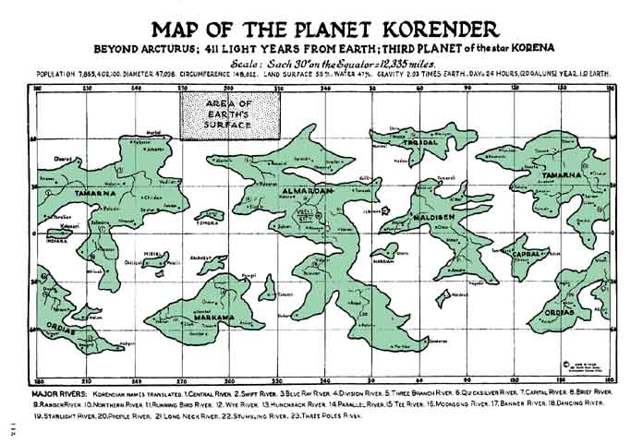
FOR BETTER MAP - buy the e-book on the case ca 20usDollars. A book, which can be found on http://www.ufophotoarchives.com - site of Wendell Stevens who's honour it is that much of this "old" information is now accessible again.

And for the following one can agree or disagree in what "they" mean - but here he said:
-on energy-supply in the transition to new tech on earth:
They meant that fusion (hydrogen) atom-power-stations were to recommend for us. Not fission as used today. Hydropower in limited use. (They themselves had gravity-control- equipment -why didn't they give us them??? - probably afraid of misuse-R.Ø.rem)
DRIVES FOR SPACECRAFTS: - magnetic, but most used is gravitycontrol.
Magnetic: as a linear motor where ship= "rotor" and planetary field= the "stator".
But most used is as said above just gravity control, where they for "roto-engines" can partial shield half of the rotor for grav.pull. The imbalance causes motion. Else on tech as earlier described in part 1.
- on telepathy is said that many cosmic races out-there use ONLY this ability, but those are usually group-connected having no singular traits and no privacy. The Alliance uses it to some degrees, also teaching their children to use it in some way.
- For information purposes etc they use bio-electronic implants- linking all citizens as a personal telephone in brain: make conferences, learn and research. Also so connecting to the ships computers and common computers. Plus personal ID. All use is free of course. Here we are afraid of those implants because we see the danger that those in power or else will misuse them.
- TELEPORTATION: earlier they used a system sending the body as a atomscanning-picture which was copied on the receiver -place - but often this body was not adapted to that place, so now they let a computer build up a suitable body adapted. They seem to use the implants to "synchronise" it all. The datapicture/"file" can also be stored to make a copy to possibly incarnating into later - or for shorter periods they can store the "empty body waiting for its owner". The body-data-files for the different people using the system is then stored on the places where they use to teleport/"travel" most - identified by the implant-code - and so the system is much less dependent of transferring big amounts of "body-building-data".
- All visits on Korendor must be done only through a system where the suitable bodies are teleported on the way described above and the suitable body then composed there. So their form and appearance on Korendor would be different from how they appeared - fx on their earth-bases. (insert picture)
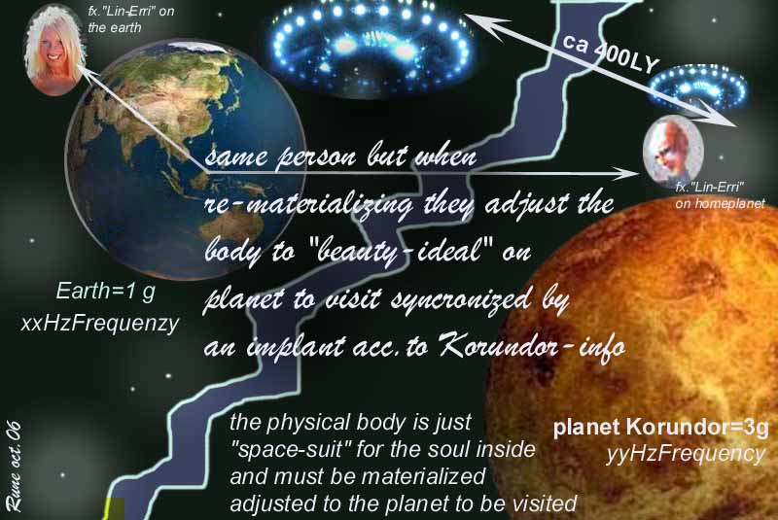

Some data for and their sun KORENA acc. to the material:
*Sun/star called KORENA
*411 lightyear away
*magnitude 7,386
*diameter 1,693 x our sun
*masse for sun there 4,694 x e27 tons
*12 planetets around their sun
*one year there is.4.53 earth-years
*day in earth-hours 24h-19min-31sec
*diameter for planet Korendor: 21,847 miles v. Ekv.(=2,74x earth)
*axis-inclining 11,9633gr (i.m. less marked seasons than here)
*masse: 24,0843 x earth
*volum 20,6909 x earth
*density 1,164 x earth
*population 7,9 billion
*capitals name is "Vrell" with a pop.of 37 millions in 2001
*landareas 53,7%
*saltwater was 91% of waterarea
*atmos: 76, 9% nitrogen - 21,7% oksygen - 1,5% other gases
*middeltemp 27,3 grC.
*airpressure 2,36 x earths
**
-they warn against our use of fossils fuels and the pollution of our planet, and the fellowing greenhouse-effect, and this last have our scientists now understood. The Korendors warns - as THEY themselves did the same to their planet in the far past - with catastrophic results.

MORAL DECAY They also warn us against this - but know it is a level! They know that those who have abolished god in their lives will come to defeat. Morally decadence. They talk as what they call the OMEGANS are here to destroy the moral codes and ethics. "We will do our part by ridding you of the OMEGAN influence, but we cannot bring you back from moral chaos. This must come from within each and all of you. …We will give you the light you seek, but in the end it is you that must pilot the ship toward the safety and security of your home port."
And …"the purpose of the Alliance is to eliminate the Omegan influence from your world. Once we have attained that goal we will withdraw to act as observers".
They say they only are here to protect us against these dark-influencing forces they call the Omegans, whom they also say inspired the development of the atom-weapons. But it is also said in this material that the same Omegans try to prevent another major war - only making the small wars going on continuously, all over earth where it is possible.
"Our many centuries of peace have rendered us quite frankly unprepared for the military way of life that has been forced upon us within the last thirty years by Kalran and Omegan initiatives against the Alliance"
(regarding the notion "omegans" ; the different ET- visitors through their contactpersons have all warned in their ways against such "dark influencing forces". But they call them by different names and sketches. And it is up to the particular person/reader to find out about what and whom those "forces" are. R.Ø.remark).
DISSATISFACTION. The Korendors admit (late-88) that they try to create a dissatisfaction in the dictatorships / so-called communist-countries. They assert that they inspired the glasnost -era in soviet in the late 80ths.
JOINING THE UNIVERSAL WORLD ALLIANCE UWA demands:
- first level is "protectorate"- a prospective member until it meets the criteria for advancement:
- that means certain sociological conditions must be reached
- adoption of UNIVERSAL ECONOMIC SYSTEM (measuring workingtime alone instead of use of money – a PERSONAL measure-unit that cannot be traded, and have the same value for all and everywhere in the Alliance.)
- form a planetary super-government: nations can exist, but is united into this one.
- Before becoming full member of the alliance one can have "protectorate" :
It means having full use of the high-tech in the alliance, whom have the control of it: fx through access to space, but no spacecrafts of Earth jurisdiction, and getting no technical data for the spacecrafts one manage.
- Once a world meets the criteria for elevation, then they can be "Associate members": and then the particular planet have no opposition to any of the rules of the Alliance. On this level the only exception is having no voting in the Alliance, and no communication-possibilities through implants, and restricted access to the databanks of the alliance. This is usually a brief stop. But some have resistance to let the alliance control certain "local planet matters" – yes, exactly as the accustom-phase that new members of EU in Europe have to pass.. (we see the process in small scale here)
- A common beginner problem is that the alliance do not permit the planets to have their own military force. And that new ones will not subdue its old ego and way of thinking + and dealing to the alliance’ eco-system. Plus stubbornness and planetary pride.
- All 740000 planets in the alliance went through this procedure and the steps through "childhood" and "youth" levels, becoming "adults" in the alliance - with the following duties and pleasures with the adventure of seeing all as vital and indispensable facets of the giant diamond the alliance is.
- It seems like what is called the "Council of Elder Masters" had recommended special help for our earth.
- Again they underline that although they can communicate, they are absolutely not allowed to give any material proofs of their existence here. (same as all "contact-planets" say)

BENEFITS OF BEING A UWA-MEMBER is getting:
- Also means as fusion power tech- to get free of fossil fuel etc.
- Ability to make anti-matter –power for spacecrafts.
- New tech in the medical field- but they themselves (ETs) have no sickness-problems, as such things is mastered in the ALLIANCE.
- Getting computer- tech that are intelligent and reasoning. Getting super-conductors.
Planet-covering communicating system based on personal freq/implant, which opens up and linking to info about "everything"; this from computers on may be all the planets in the alliance. Including history of the galaxy thousands of years back.
- Cultural and artistic ideas.

more on the radio/physical COMMUNICATION FROM ARKAY OF "Korendor"

  part 1
  part 2
  part 3
  part 4
  part 6
  part 7
  scandinavian
  soundtalk in mp3/ norwegian on the case - partly bad sound
  on 2.may-89:
  "..we offer no promises to descend from the heavens in a multitude of ships to save mankind from their own errors and undoing".
  And …"our task here is not go gather a select few to be evacuated out of danger, but rather to work in your society to eliminate the problems that might cause such a catastrophe".
  THEIR RELIGIOUS INSIGHTS- AND –LIFE.
  In communication in may-89 they touch the religious theme and say they deliberately avoided this in the initial contacts in the early 60ths. But when the new-age came in the 70ths this was "opened up".
  On Korendor they have not formalised religions, and no churches – no different sects as here on earth. But they gather to focus on God in joyfilled gatherings with praying songs and fellowing rel. ecstasy. Their beliefs is close the "the new-age philosophy" and they know that life reincarnates.
  On God and the spiritual levels and laws:
  - God a all-encompassing being=sum of all existing.
  - Envision "him" as an eternal spiritual being: "the infinite one" – without specific form and substance.
  - That "he" provides for those who seek help and guidance. Say they have no other rational explanation for the joy of life they feel inside when they contemplate and pray to "Him". But regarding prayer; "we prefer solitude and quiet in our daily communion with Him. In all Korendian homes there is a small room away from the traffic areas that is for the specific purpose of prayer". AND LATER: "..when we communicate with God, we open our hearts and speak to Him intimately and with deep emotion, much as one might talk with a cherished companion".
  - They had not had any Jesus, Mohammed or Buddha –like persons in their history – because they had not drifted away from God in their known history.
  - "it is our belief that God in His infinite wisdom will not force Himself on anyone. Free will elevates humans above the lower life forms. To maintain free will, we cannot have irrefutable proof of the existence of God…" (or proof of the "spiritual nature of all" for that matter. (R.Ø.remark).
  - "our faith is alive within us, a beautiful and reassuring part of our beings" - and "we do not parade our faith for all to see and approve". No Korendian will make a grand show of his or her faith "
  - "our way is a deep, soul-felt intensely personal relationship with God and an ingrained commitment to live by His eternal laws".
  - "…we know from the ASCENDED MASTERS that there are in fact a number of spiritual levels or planes leading, so these Masters have taught us, to the highest level wherein one finds a true unison with God, indeed becoming a part of "Him".
  - Regarding the question of heaven: "the etheric realm is where a persons spiritual soul resides after physical death. It is the lowest of the several levels, and is seen by people who have undergone "near-death" or "out-of-body" experiences. Knowing that the incredible beauty related by these people is just first plane, it is beyond imagining to envision the higher levels, and impossible to contemplate that ultimate Heaven". (this has been extensive covered by all the spiritual books that has emerged since this contact happend soon nearly 20y ago. rø-rem)
  - "we know that life of evil receives punishment in the spiritual planes in the form of denial of the right to elevate to the higher levels. ….being barred from progressing upward be as close to Hell as I care to conceive."
  - "if that individual knowing that he or she will be eternally refused access to higher planes, desires with sincere repentance to be reborn to make amends, such a thing is permitted. This in no way refutes my earlier statement. The return in NOT A PENALTY. Rather, it is a second chance, an opportunity for redemption, and is freely chosen by the person.
  - "The location of this rebirth and the circumstances are selected by the Ascended Masters to be appropriate as an object lesson to the person, usually involving a life adversely affected by his or her evil history, and the need to rectify those wrongs in order to attain the forgiveness that will remove the barriers to advancement in the etheric, realms.
  - "I point out again that this is a purely voluntary action. None of them, no matter how malevolent they may have been in life, are required to go back against their will. If they elect not to do so, they are removed to a place in the first plane, away from the rest, and this is their home for as long as they remain un-contrite, even unto the end of eternity. A true hell indeed ".
  - "for as long as people are foolish enough to delude themselves that their self-serving, Godless society is the destiny of humankind, then God will be content to stand aside and allow them to discover from painful experience how utterly wrong they are.
  - "it is height of ignorance to assert that mankind will evolve beyond the universal tenets that govern all that exists. God’s laws are a part of His nature. They are not arbitrary. They are because He is, and what they are is because of what He is."
  - "…unfortunately for the race that thinks itself beyond those laws, they cannot be disobeyed or ignored without consequence. God’s way is order, and the antithesis of order is chaos. When a race decides to abandon the order of the universal laws, it inevitably feels the onset of disorder, degeneration and in the end, self-destruction. These are what you call "the wages of sin".
  - "Your race is at a critical stage of its existence, my Terran friends. In your quest to become the masters of your own destinies without the guidance or help of God, you have invited the forces of chaos into your lives and your society. God does not impose upon the free will of humans. Our failures are ours alone. Our successes are ours with God’s presence in our lives.
  FAR, FAR HISTORY OF Korendor
  - their planet "began" 1,51x e9 k-years ago=6,84x e9earthyears ago (6,8milliarder/billion)- then their sun condensed. As the proto-planet cooled, the vast quantities of hydrogen and oxygen in the atm.reacted to form water vapour, which over several mill.years condensed to form oceans and lakes.
  - First traces of life came ca 20mill.years ago in the tropical oceans as monocellular organisms – both plant and animal.
  - Within a mill.years had plant life developed to allow it to spread into land areas. The high radiation from their sun gave mutations and many new plants of that.
  - The early amoebic life came, that rapid changed – so within 2mill.years the seas were full of sealife – from fish to primitive human types. (whether those was developed "naturally" or "planted" is not mentioned. -R.Ø.remark)
  - Half a mill.years ago a division occured when the human branch divided into a land line and a sealine – to a form of waterman.
  - "first man" appeared on K. 400.000y ago.
  - There were never large landanimals on K.-all are smaller than humans- because of the higher gravity they say. As for the early humans here they fought for territory and partner – lived in families up to 8-10children. They could communicate on primitive telepathy, as also animals can as "instinct".
  - After centuries living in local caves, they began making own dwellings as nomads. Gathering of a number of tribes made them to settle down – often then with thousands of people. Those with more intelligence began ruling the villages under certain laws that the others accepted to escape the confusion of anarchy.
  - After some time different sciences came as they began to understand – ex. Astronomy. Chemistry and physics developed a few millenia later – making metals possible.
  - So came after some time the mechanical era. As there were no big animals on K.-all heavy work had to be done with manpower.
  - They then discovered the use of the wheel, and so came the mechanical era which lasted to ca 1500 k-years ago (ca7000earthyears). So they could travel over longer distances and found other tribes that they shared their discoveries with, and soon primitive roads were built and then a kind of mail service to transport written messages.
  - Manual labor was replaced by power from wind, water and combustion.
  - With a creation of planetary community, it was found advisable to unite every city under one central body of law. The first K-world gov.was then made, and leaders elected by popular vote.
  - Then science discovered electrical energy. The whole planet was electrified in ca20k-years/90e-years. Soon later came electronics.
  - They here claim that every planets course of cultural and technological evolution is the same - as there is little room for variation.
  - on Korendor, radio/tv stations are publicly owned, and so they have no soap-operas and sportprograms as we are dulled on here. They have accordingly no advertising on radio/tv
  more on history of Korendor: THE COSMIC DUST CLOUD
  This had their astronomers warned about, but in vain. But it came and the days became as nights, and temperature fell extreme- freezing all. Civilisation was destroyed. 30 m of ice and snow buried their world, and Korendor died.
  For 17 k-years (ca70earth-years!!) some few stayed underground, and so survived in deep natural caves where core-heat was making it possible to survive. But then suddenly the dust was gone, and the light and warmth came back and melted the ice. But on the surface there were "death" everywhere. Of 2 billion(2xe9-ie; milliarder) only 40000 survived. Of the water-man-race only 800 survived. It took 400k-years (1700 e-y) to rebuild Korendor.
  FIRST SPACE AGE – came 1000 k-years ago (x4,3earth-years). For 2900 earth-years ago the first k-skip left their world for going into space. "Korenhal" is nearest planet there – #4 and when coming there they discovered it was already populated!! (They apparently had a honest leadership telling the truth, and not as here on earth where "they" tell us what is appropriate to maintain their power and what to fit into the religious doctrines to maintain power over money and religion/"faith".(R.Ø.remark).
  They on "Korenhal" had also been through the cold dust-dead, but had managed it better as they were more used to coldness, being a colder planet. The Korendors learned much from them – their nighbours, and was beyond in technology/space-travel. This other neighbour planet had been trough a worldwar ca 20years after the dust period. That decimated their population, and paralyzed their civilisation.
  Now trade was established between the sister-planets.
  picture not from book
  Ca 1500earth-years ago some 500 from the Korendor –planet set out for deeper space-exploration – but with no much hope to return. They were "lost regarding communication with them" when they were ca ¼ lightyear out into space. This ship could travel at speeds near the lightspeed, and had set out to reach out a planet from where they had got radiosignals through many far past years. It is written as this was earth and the pre- high- civilisations Lemuria and Atlantis which existed here in the far past had apparantly leaked signals .
  He also touches this in one of the last communications – from –89. Here are told that the ship from Korendor that was on a far journey into cosmos came here after having used 500years in spacetravel with their then primitive 3Dtech!!
  They claim that they brought with them the universal language "galingua" here: "…the infusion of Galingua into Terran languages was one of their influences on early cultures ".
  On just that language they say that unlike english, it is a very structured and unambiguous language. Every letter has one sound only. Verbs are delined by a single set of rules without variation. Nouns fellow a similar precise pattern and plurals have but one format. Grammar is thus simple and direct. The purpose of Galingua is a language common to every world.
  The book claim that when the Korendor people now (again) came to earth in the late 50ths, they say they had found long-buried records in tibet of the far, far visitors from their own people to Earth!
  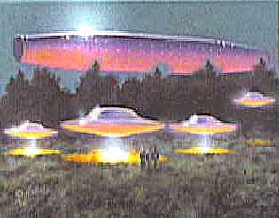
  More on their early-and further spacetrips
  They say that when the Korendors went into interstellar trips, they found civilisations on all stages of development; from stone-age to super hightech ones. For ca 300 earthyears ago(it is easy to mix k-years with our earth-years in the txt) they formed a relationship with 30civilisations "near them". And soon they discovered it was possible to travel in "subspace" as they call it here – where the earlier trips over years could now be done in seconds!
  Beyond their wildest dreams! But tell they lost ships when learning this - they admit. They claim to have experimented for ca 15years (probably their years – more than 60 earth-years) with this technique.
  And so at last they could set out for more far spacejourneys – making contact to new kind of people – but also discovering that not all of their cohabitants in the universe shared their views and ways.
  Fx.he tells they were met with weapons when they were coming into a planet in the ORION-region, and were attacked with thermal weapons - but the Korendors didn’t loose any ships. After that they avoided that region of space.
  After 50years of this spacetravel their contactweb were of thousands of planets.
  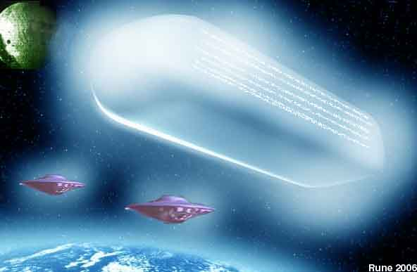
  THE GALACTIC ERA
  With this new tech they could explore a radius of many K-LY(=thousands of light-years) and so comprehending the infinity-and –number of life-variations. All magnificence.
  The universal eco-system was introduced in that era – and within a decade most of the planets in their "trade-routes" had introduced it. But this new regions of their exchange-activity with so many other planets was a heavy load on K’s nature-resources he admit, so he warn against this when we in the future get so many "new cosmic/galactic markets".
  Quotation: "our probes into the heart of our galaxy continued, and we tended to focus in a rather narrow "beam" of travel toward the core. As we neared that awesome place, we quickly discovered the sparsity of new worlds and civilisations, we fanned outward from our established paths and literally found thousands of worlds… with new races of beings of a diversity that truly left us in awe of gods ability to adapt life…"
  UWA – UNITED WORLD ALLIANCE
  – about this was also mentioned in the first radio-messages from this contact-group from Korendor:
  - formed 655 y-ago (1334 AC) from a meeting on Vrell city on Korendor.
  - They worked to do/be:
  - A light in the darkness
  - Guide for the lost
  - Shelter for the homeless
  - Friend for the friendless
  - Doctor for the ill
  - Father to the young
  - Companion for the aged
  - An aid to the strong
  - A guardian for the weak
  After one of the Korendor –people in –89 had seen NEW-YORK from the street-levels – and all the malice there - he commented that "the human race has perhaps thirty years (>2019) of life left before perishing in orgy of amoral self-destruction".
  JULY-89
  This was one of the last communications to ArKay from Korendor – and here he said that first k-mission here in newer time was from the year 462 AD till the year 970 AD - when landing in the Tibetan mountains. He say they had developed well in radioastronomy in 456 AD, and had got in signals in their past that seemingly was from earlier high-tech civilisations on earth.
  They had selected 500 volunteers for the supposedly oneway trip.
  The ship was buildt with drives of ramjet hydrogen engines – taking in the interstellar hydrogen and other materials, ionizing it in nuclear chambers – using it as reaction mass for thrust. It rotated making artificial gravity.
  Yes he tells they came to our far earth after centuries in space, but when they at last arrived they found no high-tech siv.here –and knew they had to be loyal to the law of non-interference, as a new developing culture was to begin again on this blue planet earth/Terra.
  In the text it is also claimed that when they entered our sunsystem they were observed by unmanned probe-crafts, that they later found belonging to (another) Federation-base on the asteroid we today call Ceres.
  June 18-in year 970AD they landed in the highmountains of Tibet, after orbiting and mapping most of earth. The region had natural caverns as a good basecamp.
  Then they converted the largest of the caverns to main headquarter. But the low airpressure compared to homeworld was the mainproblem, so after sealing the caverns, they made airlocks to them with much higher pressure inside.
  They claim that in a 5-year period they had constructed a very comfortable facility inside, and they made new, artificial tunnels. They claim to have been observed by other cosmic visitors under this first years on earth – but those took no further contact. Later they found that they were of the "Confederation" - the other group of united planets in a league with more strinct laws of absolute no interference on other planets - except for naturaldisasters.
  During the next 100years the settlement underground in Tibet grew to 15000people, and spread from the original site.
  Some local earth-people discovered them, and some also remained with "the gods". By the year 1150 it was really a earth colony, and ca 1000people of each sex traveled out on earth in the task to learn all about the people.
  In the underground there were later 80000people who had also constructed a fleet of crafts to begin the exploration of the outside world.(*remember those were far ahead of the tech-level we still have here in the "known"/prevailing society here.)
  Those made detailed maps of the outside earth, in the time of the middle age – the dark age! They were shaken to see the ruling class terrorise the lower, being less worth than animals.
  "Our dreams for your people were rapidly being dashed".
  Then they established communities in Peru, Siberia, Sahara and what is now called Wyoming - and waited for the dark age to end. By the 14th century all of the origianl Korendors had passed over - but the successors was now 3millions in number! But then came the "Black death", which spread quick also among the earth-Korendors. The ability to carry oxygen in the blood was damaged. And he say that within 2days nearly all were dead. Only the children of mixed races fared better.
  All this was found in the holy mountain in Tibet, where in a sanctuary there ancient records were written about this. Also maps leading to other places in the world where more was found about this.
  "little remains now of our presence on Earth".
Visiting their moon base
Elor (one of the spacepeople) announced that they would land at Plato Crater, their Moon space port. The ship passed over the rugged terrain of the Moon, and they noted an occasional ground vehicle on the rough ground, flashing signals of greeting. They came to an immense ring area of Plato. An iris in the covering opened and they descended into a huge hangar. Vast rows of ships were in the expansive chamber. They glided over them and settled in an area as large as a football field, all inside and under cover, pressurized and warmed, and having increased gravity – about 90% of that of Earth, with about 16% natural gravity outside.
They went down eight floors by elevator, then down a corridor to the entry room to the ramp and stairway and out without stopping. The great new ship on its massive tripod landing gear curved out of sight in all directions; the polished hull now pitted and dull. Astra indicated that it was her first time on the Moon, so they enjoyed it together. A small car pulled up. It was driven by Master Kalen-Li, who was already there to greet them. He drove to the far end of the hangar where a door opened into a long tunnel. Astra noted that one of the guards there was from the New England Base; She had known him (Keri-Aldek) as an old schoolmate on Korendor.
Then through a door and up a ramp to a level hundreds of feet higher and into a garage with many similar vehicles. Then into a reception room where they were given badges by a young lady. A security guard came in and they followed him through a corridor, then took an elevator to the top floor, and into a large room where they were welcomed into Lunar Control. The guard noted the two (Bob and Astra - his girlfriend from one of their earthbases) holding hands, and excused himself, leaving them to wonder at the scene - the myriads of marvelous equipments for all their Moon Operations. Apparently all of the employees spoke English, for Renaud heard no Korendian. Later he heard Kalen-Li say something in Galinguan
Next, they went into a beautiful room called the Observation Deck. Around the outer rim was a 10-foot high window, looking out on the Moon surface. The sun was low on he western horizon, casting strange shadows on the floor of the crater. From their elevated level they could see most of the floor of Plato. It is about 700 miles from the north pole. In the southern star filled sky, Earth shown down on them - an azure ball of subdued radiance in the sunlight. They watched it in perfect peace. (Renaud is a true poet, but this is only a summary of his full report.)
Into the car again and they retraced their route to the "tube room" where many of those odd vehicles were stored - short tubelike carriers for several passengers with an entrance at the side. They were propelled along tunnel-tubes by "ring magnets" in the tubes. A crane brought one of the carriers to the loading platform. They, with Orii-Val, Kalen-Li and others got in and were moved into the tubular tunnel. They knew when they were moving by the lights above them. The vehicles had rollers recessed into the casing, but traveled as on air, being supported by the propulsive power, having about an inch of clearance all around. In transit the tube would be evacuated and sealed to reduce friction, even of the air. Their destination was the crater of Hipparchus (Base 2) with the optical and electric telescopes, nearly 1,000 miles to the south.
At their destination, the car was unloaded and the group were all introduced to three men, the commander, the controller, and the security officer of the base. They proceeded to the upper levels and the wonderful telescopes above…
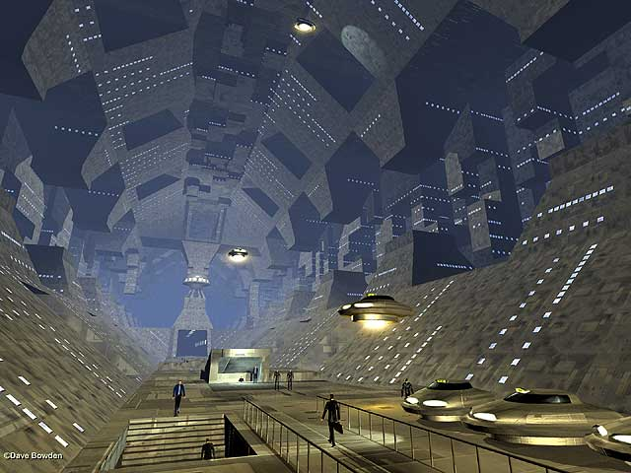
picture not from book or the story else
******************************************
here extract from his adventures on his 2.moon-base-visit on Friday 28 July 1967. (- well, you think it seems unbeliveable, but why should he invite such wild stories, he knew would be ridiculed, if he actually didnt went thru it?? - rø)
Here they are underground in the base and was to take a trip on some hover-scooter like vehicle:
"….next, by car to a sort of garage and repair shop, where there were many single-person vehicles like motor scooters without wheels, resting on a flat plate on the bottom. They then dressed for outdoor travel in light-weight space suits, complete with air-tanks and recirculating purifiers. Bob donned his suit and in two minutes had fastened the sealing strips. The light helmet had a large visor allowing a wide range of view. Altogether it may have weighed ten pounds, plus six pounds for the power and air pack. Earth or Moon weight? Orii-Val switched on the air conditioner for Bob and activated the suit communicator. His voice would operate the necessary controls. The men’s suits were grey and red; Lin-Erri had one of light blue and Astra’s was a bluish-pink.
Each selected a scooter and sat down on it. There were three switches, which were closed in sequence. The first started the stabilizing gyroscope; the second activated the floatation grid, which caused the scooter and rider to rise and hover about six inches from the floor. The third switch activated the propulsion, which was controlled by a foot pedal, making it simpler than driving a car. I believe it had handlebars for guiding though it may have simply tilted for curves.
They moved toward a small elevator, which rose with them, until they were about ten feet below the surface, stopped, and an iris opened above them. Then they rose until the platform was flush with the ground level and, as they left, it dropped out of sight and the iris closed. It was so well camouflaged that it could scarcely be detected.
It was Bob’s first time "out in the open". The sun was in the lower eastern sky and the shadows were pure black. He climbed off his scooter and stood on the surface of the Moon, It crunched under his feet like fine sharp gravel. The low gravity enabled him to stand with no effort at all. He picked up a big rock, which should have weighed over ten pounds and threw it upwards some feet and it descended slowly, as in a slow motion picture. It landed a number of feet away, bounced of another rock some ten feet and landed in a small puff of dust, which settled back promptly, but he could feel no trace of atmosphere. It would not be breathable, but might be capable of carrying dust some distance.
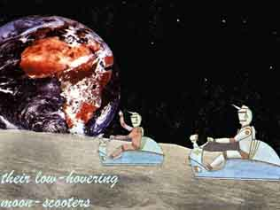
The party saw a rather large meteoroid hit the ground and hurried to the spot. It was only 3 or 4 inches in diameter, but it had blasted a crater about fourteen feet wide and several feet deep at the center. It showed 6 to 8 inches of granular stones and pebbles; then the ground became hard and dense and was solid rock at a depth of about two feet. There were many large and small craters; some were elongated gouges, indicating a low trajectory.
The horizon seemed very close. Earth was visible hanging about half way to zenith in the southern sky, for Plato Crater is about 700 miles from the north pole. It looked like a bluish half-moon, glowing brilliantly in the sunlight. On the dark side one could almost see the lights of the largest cities, like specks of fire in the darkness. Flashes of light signified a large electrical storm….."
Some later when they entered a large underground cavern, which harbored a kind of ur-old-underground-city:
"…they stopped at the mouth of a large tunnel and entered, using their laser lights in the dark interior. They went as far as they could on their "sleds" and walked about three minutes more, coming to a large cavern in which, eons before, a small town had been built. It had been preserved perfectly though its age must have been in millions of years. We cautiously navigated the narrow stairway to the "ground level" thirty feet below the tunnel entrance, and headed down what appeared to be the main street.
The buildings were remarkably well preserved, with only an occasional crack, missing masonry, or crumbling mortar to be seen. There was nothing ornate about the architecture; everything was simple and quite plain, without embellishments. It seemed as though this place had some very businesslike purpose, rather than being merely a settlement. Master Kalen-Li (one of the Korundor-men at the moonbase) began a commentary on our surroundings.
"This establishment has been determined to be a sort of base, a headquarters for a race of aliens who arrived on the Moon millions of years ago. They were treated as gods by the backward natives of the Moon, who constructed this section as a temple to use during their stay. Due to its underground location, it is the only remnant of a mighty atomic war which broke out between the aliens and another group of highly advanced primitive natives who had their main city in the area that is now the Crater Copernicus. This race took offense at the ingress of the aliens into their domain, and demanded their withdrawal or face annihilation. The aliens refused to leave and defied the Lunarians to do anything about it, without themselves being obliterated."
"Things reached a stalemate, and remained so for some ten years (Earth Time), during which time both sides stockpiled great reserves of weapons of ever-increasing power, and sophistication. Finally, the Lunarians made a sudden mass attack on the alien base outside on the surface, almost destroying it. They did not know of this under-surface headquarters or it would not be here today. From various points surrounding the main Lunarian city, missiles were launched at it, each one bearing Lithium bombs. They met in midair and exploded simultaneously, in the most awesome blast one can conceive. The lunar city was instantaneously vaporized, and the explosion blasted out the crater that exists there today as Copernicus. It had another effect much more deadly however."
"Our computers have placed the odds at over fifty million to one, after much computation on available data. Nevertheless, the blast acted as a trigger, which ignited the very atmosphere that surrounded the Moon. In a short blistering flame, the very atoms of the air were converted into pure energy, of an intensity too staggering to estimate."
"This wall of fury spread like a huge ripple from the center of the blast, and in less than a minute it had completely encompassed the Moon in its wake was total devastation. All organic forms had been seared to ash, without exception. Plants and animals alike had been reduced to almost nothingness. The buildings, the vehicles, and all he rest of man’s artifacts were vaporized or simply pulverized into dust by a shock wane which defies description; a heat into millions of degrees, and radiation levels in the billions of roentgens."
"It was over in a few moments. The surface of the Moon had been stripped of its life and constructions. In their place was a bleak, arid wasteland, slowly cooling in the absolute cold of vacuous space. This town is all that remained. It escaped the wall of fire that wiped out the rest on the surface. However the radiation killed everyone and everything in this cavern instantly, and the air rushed out into the now-airless outside. All was still for a while. Then the effects of the blast began to rock the Moon."
"Earthquakes, volcanoes, and internal shifts predominated in shaping the surface into what is seen today. Long since dead now, the surface still bears the scars of the greatest tragedy of all time. One may find residual radiation from that catastrophe, in the rocks and soil, as a reminder of the futility of war."
"I might add that all that I have said has been determined from records found in this city, which record even the final moments of life, and the ‘hell on Earth’ that ended it so suddenly."
End extract

On this moonbase visit it also happend a conflict with a small group from "planet Kalran" that had teleported themselves into the base from bigger ships and intending to do some kind of sabotage there - these Kalrans appartenly woutd "remove the cosmic police" so they can do what they want on Earth

BAD GUYS IN THE VEGA STAR-SYSTEM?
IN those Korundor-contacts there is a claim (in book2/moontrip) that I interpret as there has been - and possibly still exist - military/force-thinking civilisations in the Vega-system, belonging to a similar-thinking alliance from the surrounding planets/systems out there - acc.to the text some below.
The Billy Meier-contacts also mentioned contacts to just planets in Vega:
Fx in the 60.contact on Thursday July 29, 1976 - Billy was introduced to "Menera". She had a strange looking ship, and was said to be from the planet DERON in Vega System, and should fill in for Semjase until the end of that year. Menera was described as a dark/black, and very pretty. Dark skin, very brown, 10 cm shorter than Semjase. Billy asked to know if she was connected to the "Hottentotts" of Africa. Her forefathers, she said, came to Earth and mated with the HUNS. They came together with the Africans and created the "Hottentots".
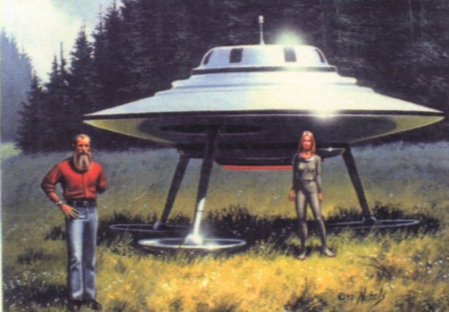
art of Jim Nichols of a meeting between Meier and Semjase from Erra in Taygeta / behind Pleiades in the mid 70ths
Meier was later told of the power hungry "Ishwish" leaders that ruled with cruel power in those far ages(more than 230000years back) in the Lyra/Vega- planets - which eventually started a civil uprising. The war from that was said to last for four centuries and over 60% of the population was destroyed - three worlds of the Lyra system were dissolved! No one in the Lyra and Vega systems escaped this great war from 230,000 years ago was told in the contacts.
So the Vegans have evidently - as many/most incarnating in this galaxy on this consciousness- level/dimension - been very warlike - but the question is whether they still are? Are there still some pocets of the "old thinking"...?
Because if one shall believe what the Korundor book 2-Part Four, tells - there still did exist a powerstruggle between the Korendor-alliance and the alliance of Vega-planets in the 60ths - but the question is if it still goes on? So here is what the korendor-people answered to the question: "Who are the Kalrans?"
The Korondor -man "Kalen" said about this:
"The Kalrans are inhabitants of the planet Kalran, fifth planet of the star Vega. Their planet developed along lines almost identical to ours, but with an emphasis on military power. Once they had achieved space travels they colonized the remaining suitable planets of the Vegan system. They established an impregnable fortress in that system, which the infant Alliance could not hope to tackle. The Alliance members decided upon a complete isolation of Kalran, economically, culturally and scientifically. We feel now that this may have been our greatest error.
"The Kalrans, left to their own devices, expanded their power and capabilities.
Developing an awesome military force second to none in this part of the galaxy.
Stilt, they made no attempt to disturb outside planets, and we in turn, continued
our policy of isolation. An occasional patrol vessel kept check on their activities,
but for several hundred years, the Kalrans filled in relative coexistence with the
Alliance, each ignoring the other.
"The Alliance had expanded to over 200 planets in nearby sectors of space. Our
discovery teams drove ever farther into space, locating and enlisting new worlds
into our group. It was upon one such a mission that we discovered that our head-
in-the-sand policy had backfired.
"Probing into space around the Kalran system, we chanced upon a previously
uncharted system of four worlds. Our instruments showed life, so we sent
ambassadorial ships to the major city of one of them, to extend our friendship
and our offer. We were met by Kalran warships. The embassy ships were
destroyed. We retreat and attempted to make sense out of this unexpected
development. Patrols had shown no expansion by Kalran forces, yet they had
taken over this system, a serious compromise of security obviously existed, since these warriors had slipped out from under our noses and occupied an
entire planetary system,
We headed back to Alliance HQ with the disturbing news. We were paced to the
edge of the system by three Kalran warcrafts, which then turned and headed
back to their base,
This was many decades ago. We were unable to stop the spread of Kalran
influence, as their science was a match for ours and their methods were
completely ruthless. They continued to harass our shipping and passenger crafts,
make sneak attacks upon Alliance planets, and in general make blasted nuisances of themselves.
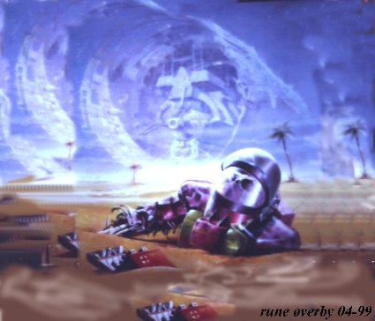
pictures up/down: wars and hatred have seemingly ruled this galaxy in the past - but the result will at last be as the picture down tells: deep inner pain and a dark conscience


"To this very day, they remain the major "darkforce" in the known galaxy. They
control over 150 systems in a tight net that is impossible to penetrate. Over the
last several decades, it appeared that they had decided to stop annexing
systems, and instead concentrate on spreading their influence by less violent
means. Of so we thought, until today. Their presence here in this system
confounds us, yet confirms a concept that one of our theorists had proposed - that
the Kalrans had in fact joined forces with another group, or several other groups,
to the end of creating an empire equal or superior to the Alliance in size and
influence.
"If this is indeed true, and it would seem that there is in fact no other assumption
to be made, then we may find ourselves, willingly or not, mandated to stop them
by force. Here we have the edge, for the present as we have developed highly
sophisticated military capabilities. We have psychprobes that can affect an entire
populace simultaneously, disrupters capable of pulverizing the very moon we
stand on!'
He continued listing the weapons that had been developed as a
fault of the dangers that the Kalran Empire posed. They were fearsome indeed.
"These are hideous weapons. And we hope beyond hope never to use them, but,
for the safety of the alliance, it may be-come necessary, Earth may be the crux. If
we allow them to take over hare, we will have no choice except war. If we stop
their advances here, they may very well choose to five and let live. It remains to
be seen.
"It appears that our destination is at hand…"
***
The different alliances seem to have some different philosophies and ideas on how to best help Earth. And just like the politicians - they fight to market their own ideas, and simultaneous abuse the "others views" - but this denotes an unfinished structure of their society! (Well, the Erra pleiadins fx open admit they are abs not perfect...)
Another speculation is if the NAZI-germany in/before WW2 had direct contact to the here mentioned "Kalrans" and their negative(claimed here dark) alliance, and that JUST THOSE supported WW2/Hitler-germany with ideas to make their secret super high-tech and advanced planes in ww2.
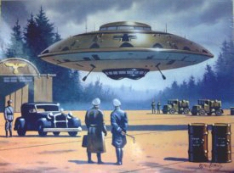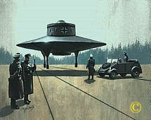
Because when reading the contact-reports/"semjase-berichte" - and esp. the newer material from Meiers writings - one get an impression of a strong, partly negative, condemning, "military" style and character: fx blaming all other contactpersons to be "lüger und betrüger" and/or downgrading and ridiculing their value. Well, one can joke that it was not a chance that the Erra-people chose just german as their primary contact-language - with their warlike past, and their tradition on "obeying orders". (It should also be mentioned that the so-called contactperson Alex Collier - claim that the renegadegroup of the (Erra)- pleiadians called the Giza-intelligence, had contact to the pre/under ww2-german-nazi's - watch f x part 6 of "UFO contact Alex Collier interviewed by Rick Keefe" on youtube. -And it is best to search for "Alex Collier" in the search-window on youtube - because the adresses may change)
But back to the speculations on the german pre-ww2-connection with former manipulative ETs. Well the Germans have seemingly learned their lesson: remark how just THEY WERE MOST OPPOSEING to the US warcampaign in 2003! So there is no reason to judge anybody - neither earthly nor interplanetary nations - all have had their karmic task to do and meet here, and all must learn through self-practice - the cosmic law #1: treat all other people and lifeforms as you- YOURSELF - wish to be treated. But tolerate all others level of understanding and being - it's their own "problem" and limitation. The galaxy is developing as all other living beings do - and IT also changes toward REAL humanity and LOVE. So the lesson for all here - either star-nation-federations intending to help us- or ordinary people - the lesson is forgiveness and learn understanding and tolerance for others views!!
*
Else it is common to read that there has been and possibly still is - pockets of dark planets on some of the planets in Orion, and that just those (+ the greys) in cooperation with secret parts of the us-military/coverup-men behind, are staging most of the socalled abduction/ufo-terror-cases - in the purpose from keeping people away from all kind of extra-terrestrilal thoughts and ideas. According to Stephen Greer and his new book from 2006, most of those cases is deliberate and pure thought-impressions /mindcontrol from the same dark gang - the Cabal's high tech. Another man having leaked much of the information on this Cabal is Dr.Michael Wolf - no dead - as most are of those that talked more that "they behind" wanted. (link)
In on of the last communication from the early 90ths that I red from this, they said - supposedly still via radio - that their ALLIANCE was never engaged in abduction. They knew some races did it on earth in the purpose of tracking their evt own old roots here - and researching on our/their DNA - but the Alliance considered it ok as long as the abductees were not harmed.
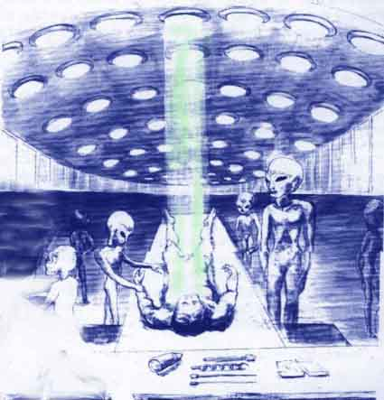
picture: typical terror ET-abduction ideas that "the dark agenda(powerpeople behind) try to imprint into peoples brains acc.to Dr.Greer - which claim to have much inside information on this from mil/gov.sources.

Acc.to selfclaimed sirian contactperson Sheldon Nidle, the conflicts in our galaxy has now been mostly solved in the last decade - and now its only on our earth the combat still exist - to saturate the last conflicts, pain and "spiritual darkness", so that all "from earth" at last turn to their inner being of REAL LOVE, FORGIVENESS AND UNDERSTANDING.

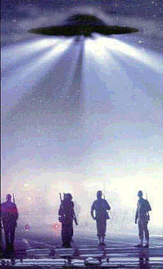
The Korendor-Case watched by the coverup-people
Like many other contactcases studied/investigated, also this case Korendor-case includes closely monitoring /surveillanc from the "hidden power behind" (military/intelligence/the shadow government-people) – who obviously interrupted his mail. Same happened to the mail of another "dangerous" contactman mentioned above - Eduard "Billy" Meier (the semjasecontacts) in Switzerland in the 70ths. Where "they" had forced the local postoffice to let "them" filter his mail and such sanction the return-films of ships etc he had taken - from the development-laboratory and like. Once they disclosed this clearly seen on the film he got back – it was mirrored, seen on the filmlayer. So "they" had kept the originals and he only got copies back, but they had been careless enough to make mirrored ones. In the same way they changed the pictures of his contactwomen and used this systematic against him many years later.
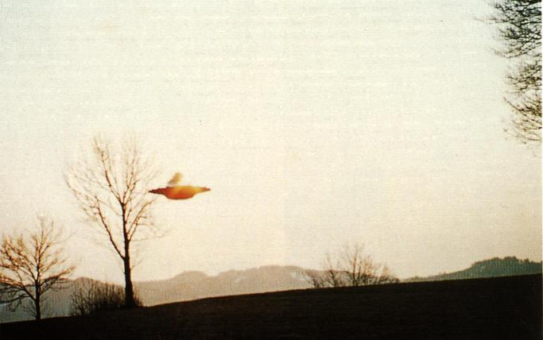
one of Meiers 1500 superpictures of pleiadian/pleiaren ships - most of his dias now stolen - but he still has ca 500 left of the originals acc.to his website.
In the case of Renaud here, they had as said, apparently looked through (scrutinized) his mail: when he later wrote and printed a book on his contacts by help of John Dean, they discovered, after it had been printed, that someone had changed astronomical information in it. This apparently done in the intention to disproving him later – to claim him a liar, and so ridiculing him and so make readers distrusting all the other he had written. Just as they use to do in such cases – with good help of the stupid, egoistic press-people – only seeking superficiality and ridiculing sensations, and not understanding anything of cosmic/spiritual evolution.
Ca.20 years ago FATE-magazine had an article on this Korundor case written by Allen Griese. He thought as most others, it all was pure science-fiction. But after meeting Renaud in –67, he didn’t longer believe he was a hoaxer as he wrote "..if Renaud was engaged in fraud, it was obviously an unrewarding task".
Yes, it is unlogic to think that people should invent such stories when they KNOW that the result is intense ridiculing, being hunted, abusing, disparagement. And he wouldn't have any money for his information, so there is no logic motives on why he should invent such a story if it was not real and experienced.
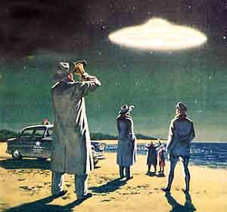
the cover of far past publication of FATE MAGAZINE that wrote of the case in the 80ths by Allen Griese.
So Grise visited Renaud at his home and found, as the contactee's writings claimed, a basement room full of electronic equipment, including the television set and the shortwave radio over which the communications supposedly were effected.
Grise, an engineer by profession, and ham-radio buff by avocation, found that everything seemed to make sense. The circuits were all appropriate to extend the receiving range. "In other words, if he was getting messages from an aerial source, he had the equipment with which to receive them.
More remarkable, however, were the books Renaud was writing on Korendorian life and philosophy. There were a dozen or so of them, all single spaced an, each 500 to 600 pages long. There were, so far as Grise could discern from studying their contents, no typographical errors. But that was not all:
"When he wrote these books," Grise recalls, 'it was like his hands belonged to someone else: He'd sit there in front of his typewriter and pay no attention to what was coming out of him. He could be on the phone or talking with me, and all the
while his hands are going, producing all this perfectly-typed, clearly-written stuff on alien philosophy. It was just unbelievable."
Grise was perplexed by Renaud's attitude: "He showed no signs whatever of wanting to promote himself", he says. "There was no show biz, no snake oil. He didn't even seem much interested in talking. He 'd answer questions, but he wouldn't offer anything. He was hesitant to entertain visitors and he sold nothing, made no money. He said the whole business was imposed on him; he hadn't gone after it".
"Renaud has a large collection of tapes allegedly on his space communications: Grise listened to some of them and heard what was supposed to be the voice of the primary contact-woman Lin-Erri. He recalls, "These were good-quality, reel-to-reel recordings. The womens voice had a kind of hesitancy in speech patterns suggesting a foreign person doing well in English. It had s a singsong, melodious quality ."
When Grise asked if he could meet the extraterrestrials in whom, despite a deep natural cynicism about such matters, he was almost ready to believe it: Renaud said he could request a meeting but could not guarantee that the Korendorians would agree to one...
Soon afterwards Renaud broke off their brief association and told him to not to call or visit anymore. He likely understood it was no meaning in trying to convince anyone not ready or spiritually ripe.

Some data for planet KORUNDOR and their sun KORENA acc. to the material:
*Sun/star called KORENA
*411 lightyear away
*magnitude 7,386
*diameter 1,693 x our sun
*masse for sun there 4,694 x e27 tons
*12 planetets around their sun
*one year there is.4.53 earth-years
*day in earth-hours 24h-19min-31sec
*diameter for planet korundor: 21,847 miles v. Ekv.(=2,74x earth)
*axis-inclining 11,9633gr (also less marked seasons than here)
*masse: 24,0843 x earth
*volum 20,6909 x earth
*dencity 1,164 x earth
*population 7,9 billion
*capitals name is "Vrell" with a pop.of på 37 millions in 2001
*landareas 53,7%
*saltwater was 91% of waterarea
*atmos: 76, 9% nitrogen - 21,7% oksygen - 1,5% other gases
*middeltemp 27,3 grC.
*airpressure 2,36 x earths

