The 1982 Clearwater Hearings
Introduction
When the FBI raided Scientology's headquarters in Washington D.C. and Los Angeles, they uncovered boxes and boxes of damning evidence clearly showing how the management of Scientology was breaking the law on a daily basis.
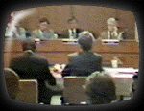

Included in those documents was "Operation Normandy" which was the blue-print for the cult's take-over of the city of Clearwater.
The Clearwater City Commission invited attorney Michael Flynn to come before the city to present witnesses and evidence about the criminal nature of this destructive group.
Scientology was to be given equal time to respond to the charges.
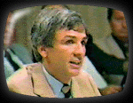
For one full week, the citizens of Clearwater watched the hearings live on the local cable system. The entire hearing is now on-line.
Day One - May 5, 1982
Opening Statement from Michael Flynn
Testimony from Edward Walters
Michael Flynn Explains Some Documents
Ron DeWolf

Day Two - May 6, 1982
Ron DeWolf (Conclusion)
Lori Taverna
Casey Kelly

Day Three - May 7, 1982
Rosie Pace
David Ray
Ernest and Adelle Hartwell
George Meister

Day Four - May 8, 1982
Lavenda Van Schaick
Janie Peterson
Sharon McKee
Scott Mayer
Robert Dardino
Paulette Cooper
Dr. John Clark
Brown McKee

Day Five - May 10, 1982
Scientology's Response
Michael Flynn's Summation

The 1982 Clearwater Hearings
Day 1 - May 5, 1982
Opening Statements
The hearings begin with an opening statement from attorney Michael Flynn. Drama is added to the moment as Scientology's Attorney Paul Johnson rises in the auditorium, demanding to be heard.

The 1982 Clearwater Hearings
Day 1 - May 5, 1982
Edward Walters
As the first witness, Walters covers a lot of ground, giving an overview of the corruption that the city council will hear about for several days

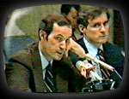
The 1982 Clearwater Hearings
Day 1 - May 5, 1982
Michael Flynn Explains Some Documents
Flynn goes over some Scientology documents as he enters them into evidence.

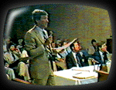
The 1982 Clearwater Hearings
Day 1 - May 5, 1982
Ron DeWolf
Ron DeWolf (L. Ron Hubbard Jr.) was the son of Hubbard and worked very closely with his father during the growth of Scientology in the 1950's. He had a very rocky relationship with his dad and ultimately wound up testifying against him in court.

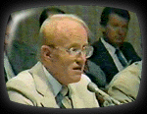
The 1982 Clearwater Hearings
Day 2 - May 6, 1982
Ron DeWolf
1982
Day Two of DeWolf's Testimony

The 1982 Clearwater Hearings
Day 2 - May 6, 1982
Lori Taverna
Lori Tells the council about the many abuses she witnessed in Scientology including medical neglect of staff members and their children.

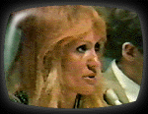
The 1982 Clearwater Hearings
Day 2 - May 6, 1982
Casey Kelly
During the three years, Kelly spent at FLAG, he handled Scientology's finances and recruitment.

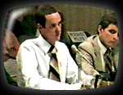
The 1982 Clearwater Hearings
Day 3 - May 7, 1982
Rosie Pace
Rosie is the sister of Lori Taverna. She spent eight months at FLAG and tells about her experiences in Clearwater.

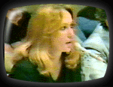
The 1982 Clearwater Hearings
Day 3 - May 7, 1982
David Ray
David gives a blow by blow account of what is was like to join the Sea Org and discover the harsh realities of life among the "elite crew" of Scientology.

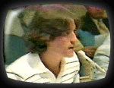
The 1982 Clearwater Hearings
Day 3 - May 7, 1982
Ernest and Adelle Hartwell
The Hartwells were not Scientologists yet they wound up working alongside L. Ron Hubbard at Golden Era Studios. They were witness to the insanity that came with the Sea Org but without the indoctrination.
These two ballroom dancers thought they were coming to Clearwater to be with their daughter but instead found themselves in a hidden, desert compound.

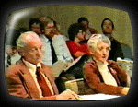
The 1982 Clearwater Hearings
Day 3 - May 7, 1982
George Meister
George Meister was told his daughter Susan committed suicide while a member of the Sea Org onboard the ship, The Apollo. When the grieving father asked questions he was shocked by Scientology's actions.

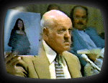
The 1982 Clearwater Hearings
Day 4 - May 8, 1982
Lavenda Van Schaick
Lavenda testifies about the living conditions of children and contends that hepatitis swept through the Clearwater base in 1977.


The 1982 Clearwater Hearings
Day 4 - May 8, 1982
Janie Peterson
Janie was a member of the Guardian's Office. She explains how community programs such as Narconon and Applied Scholastics are really PR tools.

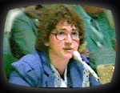
The 1982 Clearwater Hearings
Day 4 - May 8, 1982
Sharon McKee
Sharon worked in Michael Flynn's law office and testifies briefly about unusual activities at the Flynn office.

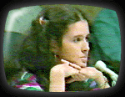

The 1982 Clearwater Hearings
Day 4 - May 8, 1982
Scott Mayer
Scott talks about why Hubbard decided to settle in Clearwater and what actions the group took to take over the city.

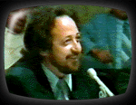
The 1982 Clearwater Hearings
Day 4 - May 8, 1982
Robert Dardino
Robert burgled medical and legal offices on the orders on Scientology.

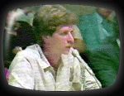

The 1982 Clearwater Hearings
Day 4 - May 8, 1982
Paulette Cooper
The author of "The Scandal of Scientology," Paulette Cooper became the number one target of this ruthless organization before anyone knew just how vicious they really were.
Scientology devised a plan called "Operation Freakout" to destroy her and they almost succeeded. If it had not been for the FBI raids, her name may never have been cleared and the truth never exposed.

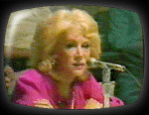

The 1982 Clearwater Hearings
Day 4 - May 8, 1982
Dr. John Clark
A Harvard professor, Dr. Clark was a major target for Scientology as he was a respected psychiatrist speaking out about the destructive nature of cults.
Scientology set out to destroy him with lawsuits, slander and dirty tricks.

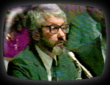

The 1982 Clearwater Hearings
Day 4 - May 8, 1982
Brown McKee
Brown McKee had spent 24 years in Scientology by the time of these hearings.
He was a mission holder in Connecticut and was present at the infamous 1982 meeting in which mission holders were strong-armed into accepting new terms...or else.

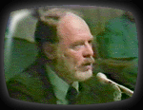

The 1982 Clearwater Hearings
Day 5 - May 10, 1982
Scientology's Response
Attorney Paul Johnson appears for the church. One week earlier, he had demanded to be allowed to speak. Once he had his chance, he refused to respond to any of the charges leveled in the hearings.

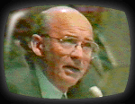
The 1982 Clearwater Hearings
Day 5 - May 10, 1982
Michael Flynn Sumnation
Michael Flynn wraps up the testimony as the hearings come to a close.
