Clarity America 497 $

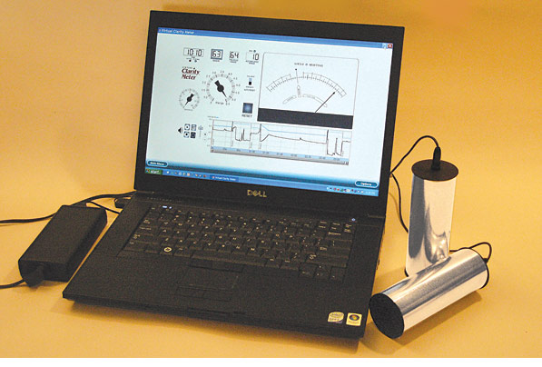

<http://clearingtech.net/2011/01/virtualclaritymeter/>

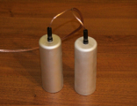

<https://theta-meter.com/>

Ability 4ª 958 £

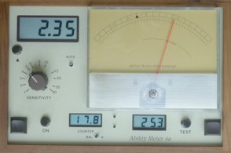

<http://www.abilitymeters.com/>

Latas: 50€

<http://meyl-instruments.de/produkte/solo-dose_en.htm>

Mindwalker 2A 595€ Mindwalker 3A 332 €

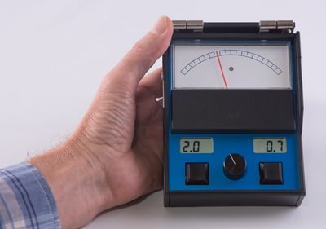 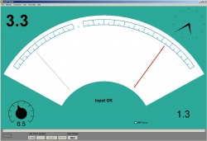

<https://mindwalker.weebly.com/>