PALEOGLOBE:
http://www.scotese.com/Default.htm
http://www.palaeos.com/Default.htm

Huidige platen:

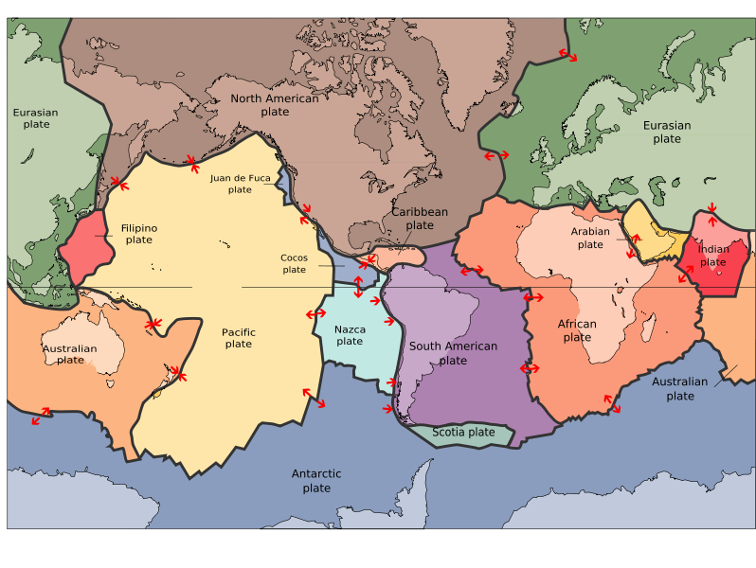

De Oer-Aarde

Forming the First Continents
Earth is about 4.5 billion years old. The oldest rocks are about 3.9 billion years old. Microfossils have been found in 3.5 billion year old rocks. At that time the earth's atmosphere was mostly CO2.
The development of anaerobic bacterial photosynthesis and blue-green algae lowered the level of CO2 in the atmosphere and released O2. This had a" reverse greenhouse effect" on the earth's energy balance, leading to widespread glaciation between 2.5 and 2.0 billion years ago. Oxygen levels stabilized below current level around 1.6 billion years ago, then resumed a slow rise - paving the way for new life forms dependent upon oxygen.
The initial land masses were hundreds of micro continents and island arcs. The first continental grouping is thought to have appeared about 3 billion years ago. Called Ur, it consisted of relatively small pieces of present day Africa, India, Australia and Antarctica.
By 2.5 billion years ago about 25% of the current continental crust had formed. These most ancient land masses, or shields, are shown in green on this sketch. (In their current locations, not where they formed.)  These lands moved continuously as ocean beds formed and spread. When larger bodies of land impacted with smaller bits, they were added to their margins. Collisions with larger land masses raised mountains and unleashed flows of magma which welded the colliding pieces together. | 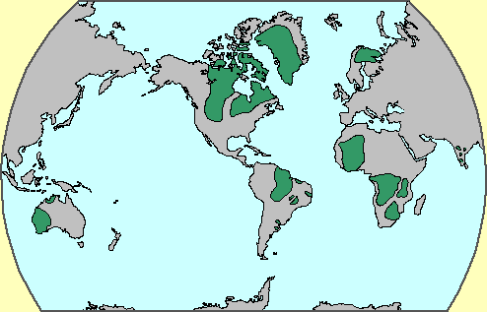

Ur (continent)

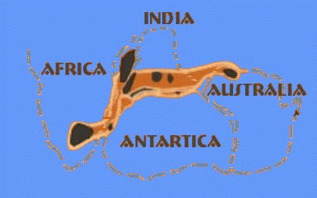
Ur is the name of the first known continent that probably formed 3 billion years ago in the early Archean Eon. Ur joined with the continents Nena and Atlantica about one billion years ago to form the supercontinent Rodinia. Ur survived for a long time, until it was first torn apart when the supercontinent Pangaea broke apart about 208 million years ago into Laurasia and Gondwana. It now forms parts of Africa, Australia, India, and Madagascar. In the early period of its existence, it was probably the only continent on Earth, and is so considered by some to be a supercontinent, even though it was probably smaller than Australia is now.

History of Ur
- ~3 billion years ago, Ur formed as the only continent on Earth.
- ~1 billion years ago, Ur was a part of the major supercontinent Rodinia.
- ~300 million years ago, Ur was a part of the major supercontinent Pangea.
- ~208 million years ago, Ur was torn apart into parts of Laurasia and Gondwana.
- ~65 million years ago, the African part of Ur was torn apart as part of India.
- ~Present, Ur is part of Australia and Madagascar.

Vaalbara
The name "Vaalbara" is given to Earth's theorized first supercontinent. According to radiometric data of the encompassing cratons that constituted Vaalbara, it is believed to have existed 3.3 billion years ago (3.3 Ga) and possibly as far back as 3.6 Ga. Evidence includes geochronological and palaeomagnetic studies between the two Archaean cratons (protocontinents) called the Kaapvaal craton (the Kaapvaal province of South Africa) and the Pilbara craton (the Pilbara province of western Australia).
Further evidence is the structural sequence similarities of the greenstone belts and gneiss belts of these two cratons. These same Archaean greenstone belts are now spread out across the margins of the Superior craton of Canada and are also spread out across the cratons of the former Gondwana and Laurasia continents. The subsequent drift paths of the Kaapvaal and Pilbara cratons after 2.8 Ga gives further evidence that they were once connected.
It is not certain when Vaalbara began to break up, but geochronological and palaeomagnetic evidence show that the two cratons had a rotational 30-degree latitudinal separation at 2.78 to 2.77 Ga, implying that they were no longer contiguous after ~2.8 Ga.

Kenorland
Kenorland was one of the earliest supercontinents on Earth. It is believed to have formed during the Neoarchaean Era ~2.7 billion years ago (2.7 Ga) by the accretion of Neoarchaean cratons and the formation of new continental crust. Kenorland comprised what later became Laurentia (the core of today's North America and Greenland), Baltica (today's Scandinavia and Baltic), Western Australia and Kalahari. Swarms of volcanic dikes and their paleomagnetic orientation as well as the existence of similar stratigraphic sequences permit this reconstruction. The core of Kenorland, the Baltic/Fennoscandian Shield, traces its origins back to over 3.1 Ga. The Yilgarn Craton (present-day Western Australia) contains zircon crystals in its crust that date back to 4.4 Ga.

Formation of Kenorland
Kenorland was formed around 2.7 billion years ago (2.7 Ga) as a result of a series of accretion events and the formation of new continental crust (Halla, 2005).
According to an in-depth analyses by Barley and others (2005), 2.78 billion years ago submarine magmatism culminated with the eruption of extensive suites of mantle plume derived komatiites at 2.72 to 2.70 Ga. Extensive hydrothermal activity, produced volcanic massive sulfide mineralization and banded iron formation (BIF) deposition in anoxic arc-related basins. Arc and plume magmatism were followed by orogenic deformation, granitoid emplacement (by 2.68 Ga), stabilization of continental lithosphere and collision with the other cratons to form the Kenorland continent. The formation of Kenorland and possible collision of the Zimbabwe and Kaapvaal cratons at 2.6 Ga provides evidence that Late Archean cratons started to aggregate into larger continents at that time. Importantly granitoid–greenstone terranes and high-grade gneiss belts in the Gawler Craton, Antarctica, India, and China provide evidence for a second cycle of convergent margin tectonics and collision of cratons between 2.6 and 2.42 Ga. The Gawler Craton contains 2.56 to 2.5 Ga ultramafic to felsic volcanic rocks (including 2.51 Ga plume-derived komatiites), metasedimentary rocks, and granitoids with compositions that are typical of Archean granitoid–greenstone terranes interpreted to have formed at convergent continental margins. Central India and possibly eastern North China have similar histories from 2.6 Ga culminating with orogeny between 2.5 and 2.42 Ga corresponding to the aggregation and stabilization of Indian cratons within a larger continent. The Pilbara and Kaapvaal cratons are the only cratons with relatively complete and well-dated 2.6 to 2.4 Ga supracrustal rock records.
The accretion events are recorded in the greenstone belts of the Yilgarn Craton as metamorphosed basalt belts and granitic domes accreted around the high grade metamorphic core of the Western Gneiss Terrane, which includes elements of up to 3.2 Ga in age and some older portions, for example the Narryer Gneiss Terrane.

Breakup of Kenorland
Paleomagnetic studies show Kenorland was in generally low latitudes until tectonic magma-plume rifting began to occur between 2.48 Ga and 2.45 Ga. At 2.45 Ga the Baltic Shield was over the equator and was joined to Laurentia (the Canadian Shield), and formed a unity with both the Kola and Karelia craton. The protracted breakup of Kenorland during the Late Neoarchaean and early Paleoproterozoic Era 2.48 to 2.10 Ga, during the Siderian and Rhyacian periods, is manifested by mafic dikes and sedimentary rift-basins and rift-margins on many continents. On early Earth, this type of bimodal deep mantle plume rifting was common in Archaean and Neoarchaean crust and continent formation.
The geological time period surrounding the breakup of Kenorland is thought by many geologists to be the beginning of the transition point from the Hadean to Early Archean deep-mantle-plume method of continent formation (before the final formation of the Earth's inner core), to the subsequent two-layer core-mantle plate tectonics convection theory . However, with the findings of the earlier continent Ur and the ca. 3.1 Ga supercontinent Vaalbara, this transition period may have occurred much earlier.
The Kola and Karelia cratons began to drift apart ~2.45 Ga, and by 2.4 Ga the Kola craton was located at ~15 degrees latitude and the Karelia craton was located at ~30 degrees latitude. Paleomagnetic evidence shows that at 2.45 Ga the Yilgarn craton (now the bulk of Western Australia) was not connected to Fennoscandia-Laurentia and was located at ~70 degrees latitude. This implies that at 2.45 Ga there was no longer a supercontinent and by 2.4 Ga an ocean existed between the Kola and Karelia cratons. Also, there is speculation based on the rift margin spatial arrangements of Laurentia, that at some time during the breakup, the Slave and Superior cratons were not part of the supercontinent Kenorland, but, by then may have been two different Neoarchaean landmasses (supercratons) on opposite ends of a very large Kenorland. This is based on how drifting assemblies of various constituent pieces should flow reasonably together toward the amalgamation of the new subsequent continent. The Slave and Superior cratons now constitute the northwest and southeast portions of the Canadian Shield, respectively.
The breakup of Kenorland was contemporary with the Huronian glaciation which persisted for up to 60 million years. The banded iron formations (BIF) show their greatest extent at this period, thus indicating a massive increase in oxygen build-up from an estimated 0.1% of the atmosphere to 1%. The rise in oxygen levels caused the virtual disappearance of the greenhouse gas methane (oxidized into carbon dioxide and water). The simultaneous breakup of Kenorland generally increased continental rainfall everywhere, thus increasing erosion and further reducing the other greenhouse gas carbon dioxide. With the reduction in greenhouse gases, and with solar output being less than 85% its current power, this led to a runaway Snowball Earth scenario, where average temperatures planet-wide plummeted to below freezing. Despite the anoxia indicated by the BIF, photosynthesis continued, stabilizing climates at new levels during the second part of the Proterozoic Era.

Yilgarn Craton
The Yilgarn Craton is a large craton which constitutes the bulk of the Western Australian land mass. It is bounded by a mixture of sedimentary basins and Proterozoic fold and thrust belts. Zircon grains in the Jack Hills, Narryer Gneiss Terrane have been dated at ~4.27 Ga, with one detrital zircon dated as old as 4.4 Ga.
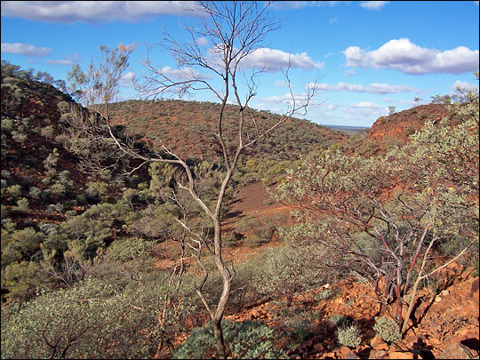 Narryer
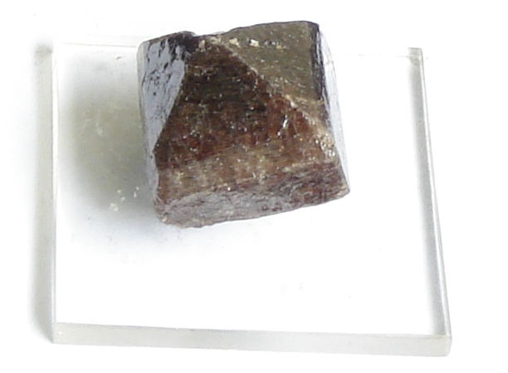 Zircon
] 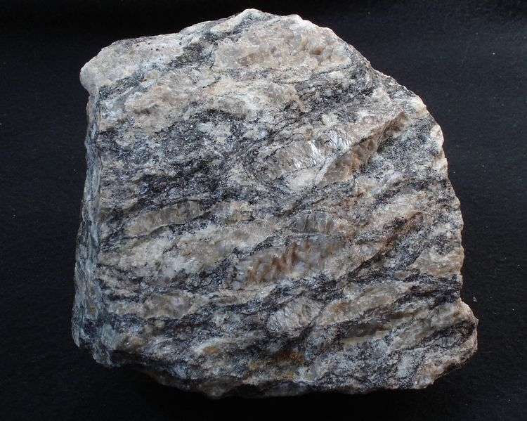 Gneiss

Geology
The Yilgarn Craton appears to have been assembled between ~2.94 and 2.63 Ga by the accretion of a multitude of formerly present blocks or terranes of existing continental crust, most of which formed between 3.2 Ga and 2.8 Ga. This accretion event is recorded by widespread granite and granodiorite intrusions, which comprise over 70% of the Yilgarn craton; voluminous tholeiitic basalt and komatiite volcanism^{[1]}; regional metamorphism and deformation as well as the emplacement of the vast majority of the craton's endowment in gold mineralisation. The accretion events occurred in several phases, probably by accretion of continental fragments separated by pauses in subduction, with renewed activity occurring episodically.
Geomorphologically the craton is primarily composed of approximately 2.8 billion year old (~2.8 Ga) granite-gneiss metamorphic terrain (the Southwestern Province and Western Gneiss Belt), and three granite-greenstone terrains (the North-East Goldfields, the Southern Cross and the greenschist metamorphic Murchison Provinces). Some greenstone belts and granites are as old as 3.1-2.9 Ga, and some are younger, at ~2.75-2.65 Ga.
The craton is one of the distinct physiographic provinces of the West Australian Shield physiographic division, comprised of the Stirling-Mt. Barren Block, Darling Hills, and Recherche Shelf sections.
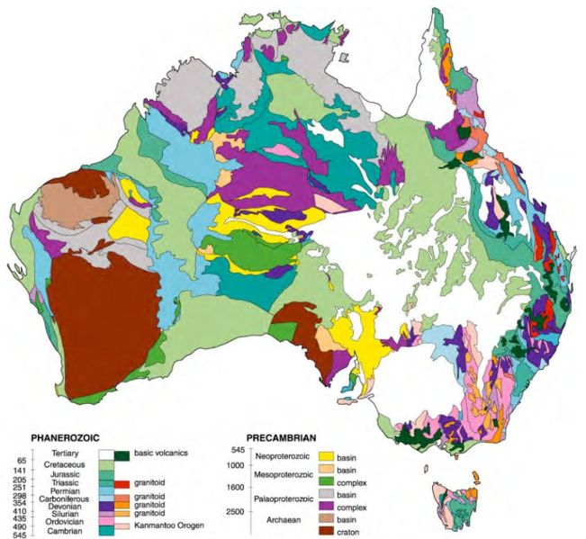

Proterozoic eon
Paleoproterozoic era |  |  |  | Mesoproterozoic era |  |  | Neoproterozoic era
Siderian | Rhyacian | Orosirian | Statherian | Calymmian | Ectasian | Stenian | Tonian | Cryogenian | Ediacaran

Paleoproterozoic
The Paleoproterozoic is the first of the three sub-divisions (eras) of the Proterozoic occurring between 2500 Ma and 1600 Ma (million years ago). This is when the continents first stabilized. This is also when Cyanobacteria evolved, a type of bacteria which uses the biochemical process of photosynthesis to produce energy and oxygen.
Before the significant increase in atmospheric oxygen almost all life that existed was anaerobic, that is, the metabolism of life depended on a form of cellular respiration that did not require oxygen. Free oxygen in large amounts is poisonous to most anaerobic bacteria, and at this time most life on Earth vanished. The only life that remained was either resistant to the oxidizing and poisonous effects of oxygen, or spent its life-cycle in an oxygen-free environment. This main event is called the Oxygen Catastrophe. Also the first Grypania fossils and the first Eukaryotes appeared during this time.

Siderian
The Siderian (IPA: /saɪˈdɪəriən/, Greek: sideros, meaning "iron") is the first geologic period in the Paleoproterozoic Era and lasted from 2500 Ma to 2300 Ma (million years ago). Instead of being based on stratigraphy, these dates are defined chronometrically.
Abundance of banded iron formations (BIFs) peaked early this period. BIFs were formed as anaerobic algae produced waste oxygen that combined with iron, forming magnetite (Fe₃O₄, an iron oxide). This process cleared iron from the oceans, presumably turning greenish seas clear. Eventually, without an oxygen sink in the oceans, the process created the oxygen-rich atmosphere of today. This event is known as the Oxygen Catastrophe.
The Huronian glaciation began in the Siderian 2400 Ma and ended in the late Rhyacian 2100 Ma.

Huronian glaciation
The Huronian glaciation extended from 2400 mya to 2100 mya, during the Siderian and Rhyacian periods of the Paleoproterozoic era. It was one of the most severe ice ages in geologic history and some geologists believe that it was very similar to the Snowball earth ice age that happened in the neoproterozoic era.

Rhyacian
The Rhyacian (IPA: /raɪˈeɪsiən/, Greek: Ρυαξ (rhyax), meaning "stream of lava") is the second geologic period in the Paleoproterozoic Era and lasted from 2300 Ma to 2050 Ma (million years ago). Instead of being based on stratigraphy, these dates are defined chronometrically.
The Bushveld Complex and other similar intrusions formed during this period.
Huronian glaciation period ended in late Rhyacian 2100 Ma.
The first known Eukaryotes began to evolve in the Rhyacian period.

Orosirian
The Orosirian (IPA: /ˌɒroʊˈsɪəriən/, Greek: orosira, meaning "mountain range") is the third geologic period in the Paleoproterozoic Era and lasted from 2050 Ma to 1800 Ma (million years ago). Instead of being based on stratigraphy, these dates are defined chronometrically.
Latter half of the period was an episode of intensive orogeny on virtually all continents.
Probably during this period Earth's atmosphere changed to oxygen-rich due to photosynthesis of cyanobacteria.
Two of the largest known impact events on Earth occurred during the Orosirian. At the very beginning of the period, 2023 Ma, a large asteroid collision created the Vredefort impact structure.
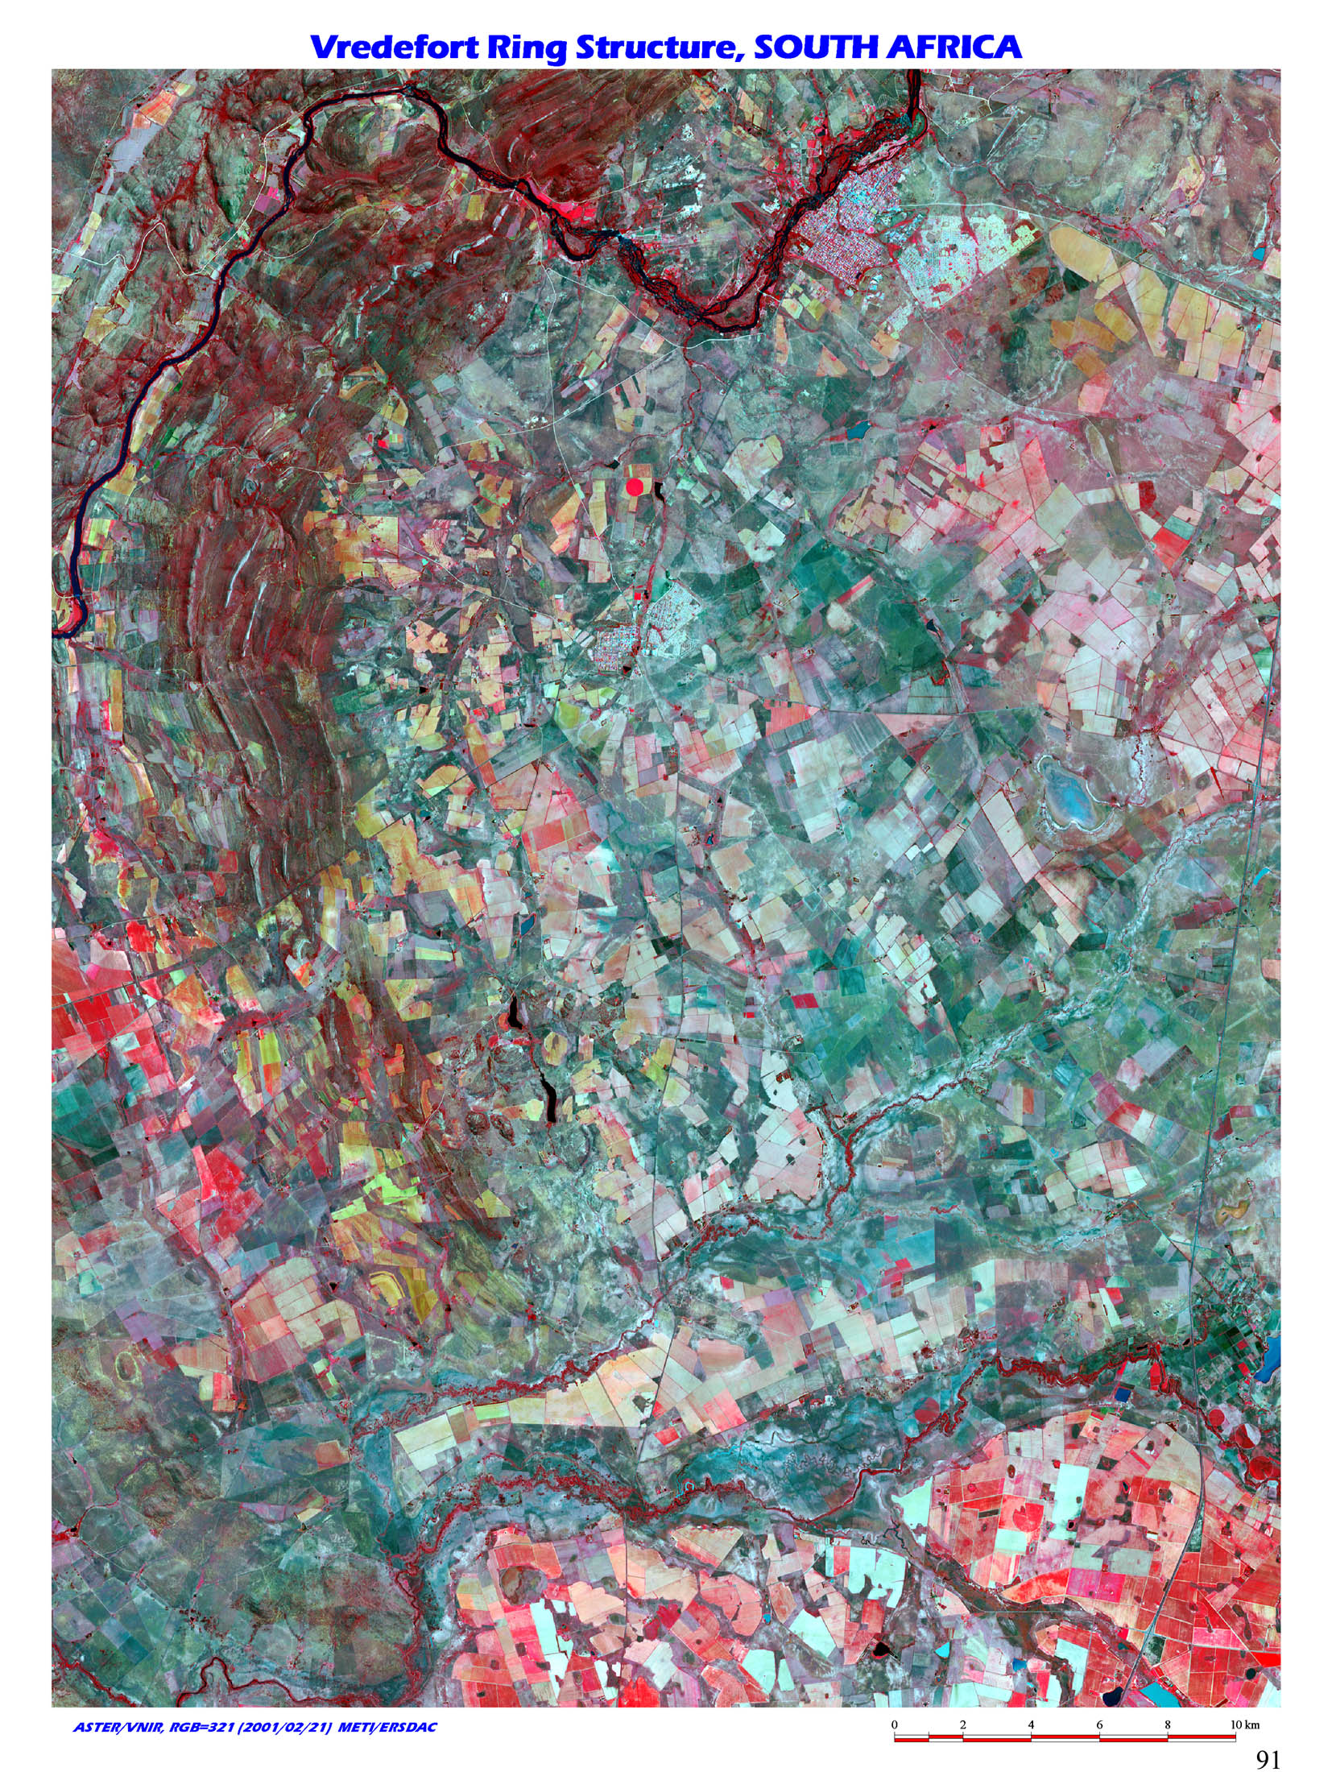
The event that created the Sudbury Basin (Ontario, Canada) structure occurred near the end of the period, 1850 Ma.
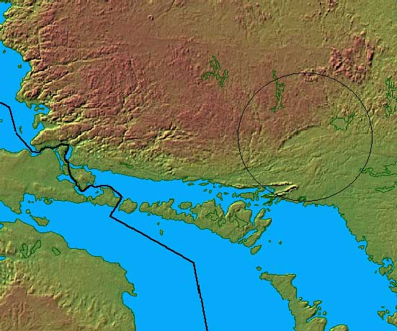
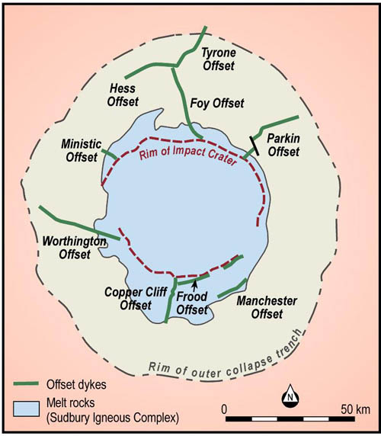

Statherian
The Statherian (IPA: /stəˈθɪəriən/, Greek: statheros, meaning "stable, firm") is the final geologic period in the Paleoproterozoic Era and lasted from 1800 Ma to 1600 Ma (million years ago). Instead of being based on stratigraphy, these dates are defined chronometrically.
During this period the first complex single-celled life appeared.
The period is characterized on most continents by either new platforms or final cratonization of fold belts.
The supercontinent Columbia formed at the beginning of this period.

Columbia (supercontinent)
Columbia (also known as Nuna and, more recently, Hudsonland or Hudsonia) is the name of one of the Earth's posited supercontinents, which existed approximately 1.8 to 1.5 billion years (Ga) ago in the Paleoproterozoic Era. It consisted of the proto-cratons that made up the former continents of Laurentia, Baltica, Ukraine, Amazonia, Australia, and possibly Siberia, North China and Kalahari as well. The existence of Columbia is based upon paleomagnetic data.^{[1]}

Contents
- 1 Size and location
- 2 Assembly
- 3 Fragmentation
- 4 See also
- 5 References

Size and location
Columbia is estimated to have been about 12,900 kilometres (8,000 miles) from North to South, and about 4,800 km (3,000 miles) across at its widest part. The east coast of India was attached to western North America, with southern Australia against western Canada. Most of South America rotated so that the western edge of modern-day Brazil lined up with eastern North America, forming a continental margin that extended into the southern edge of Scandinavia.^{[2]}

Fragmentation
Columbia began to fragment about 1.6 Ga ago, associated with continental rifting along the western margin of Laurentia (Belt-Purcell Supergroup), eastern India (Mahanadi and the Godavari),^{[5]} southern margin of Baltica (Telemark Supergroup), southeastern margin of Siberia (Riphean aulacogens), northwestern margin of South Africa (Kalahari Copper Belt), and northern margin of the North China Block (Zhaertai-Bayan Obo Belt).^{[4]} The fragmentation corresponded with widespread anorogenic magmatic activity, forming anorthosite-mangerite-charnockite-granite (AMCG) suites in North America, Baltica, Amazonia and North China, and continued until the final breakup of the supercontinent at about 1.3-1.2 Ga, marked by the emplacement of the 1.27 Ga MacKenzie and 1.24 Ga Sudbury mafic dike swarms in North America. The rifted fragments formed the supercontinent Rodinia about 500 million years later.

Proterozoic eon
Paleoproterozoic era |  |  |  | Mesoproterozoic era |  |  | Neoproterozoic era
Siderian | Rhyacian | Orosirian | Statherian | Calymmian | Ectasian | Stenian | Tonian | Cryogenian | Ediacaran

Mesoproterozoic
The Mesoproterozoic Era is a geologic era that occurred between 1600 Ma and 1000 Ma (million years ago).
The major events of this era are the formation of the Rodinia supercontinent, the breakup of the Columbia supercontinent, and the evolution of sexual reproduction.

Calymmian
The Calymmian (from Greek calymma, "cover") is the first geologic period in the Mesoproterozoic Era and lasted from 1600 Ma to 1400 Ma (million years ago). Instead of being based on stratigraphy, these dates are defined chronometrically.
The period is characterised by expansion of existing platform covers, or by new platforms on recently cratonized basements.
The supercontinent Columbia broke up during the Calymmian some 1500 Ma.

Ectasian
The Ectasian (from Greek ectasis, "extension") is the second geologic period in the Mesoproterozoic era and lasted from 1400 Ma ago to 1200 Ma (million years ago). Instead of being based on stratigraphy, these dates are defined chronometrically.
Name derives from continued expansion of platform covers during this period.
Evidence of a eukaryotic red algae, Bangiomorpha pubescens, has been identified from ca. 1200 Ma old rocks in the Hunting Formation (Somerset Island, Canada). This is the oldest known sexually reproducing organism and therefore the earliest known complex multicellular organism. [1]
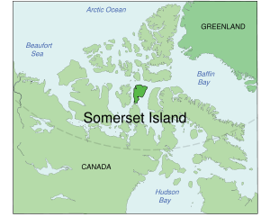

Stenian
The Stenian (from Greek stenos, "narrow") is the final geologic period in the Mesoproterozoic Era and lasted from 1200 Ma to 1000 Ma (million years ago). Instead of being based on stratigraphy, these dates are defined chronometrically.
Name derives from narrow polymetamorphic belts formed over this period.
The supercontinent Rodinia assembled during the Stenian.

Rodinia

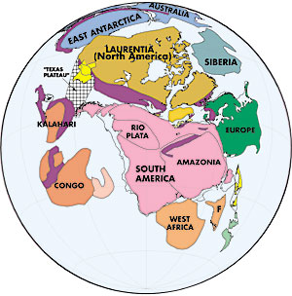
In geology, Rodinia (from the Russian родина, or "motherland") refers to one of the oldest known supercontinents, which contained most or all of Earth's then-current landmass. Paleomagnetic evidence provides clues to the paleolatitude of individual formations, but not to their longitude, which geologists have pieced together by comparing similar strata, often now widely dispersed.

Contents
- 1 Lifetime
- 2 Formation
- 3 Paleogeography
- 4 Separation
- 5 See also
- 6 External links
- 7 References

Lifetime
Geologic evidence suggests that Rodinia formed and broke apart in the Neoproterozoic, probably existing as a single continent from 1 billion years ago until it began to rift into eight smaller continents about 800 million years ago.^{[1]} It is thought to have been largely responsible for the cold climate of the Neoproterozoic era.

Formation
Rodinia began forming about 1.3 billion years ago from three or four pre-existing continents, an event known as the Grenville orogeny.^{[2]} The absence of fossils of hard-shelled organisms and reliable paleomagnetic data make the movements of continents earlier in the Precambrian, prior to this event, uncertain. (See Columbia for one possible reconstruction of an earlier supercontinent.)
The arrangement of Rodinia has been hypothesized using paleomagnetic data from the Seychelles islands and India and the Grenville mountain belts, which were formed by the Grenville orogeny and span multiple modern continents, as references.^{[1][2]}
Although the details are disputed by paleogeographers, the continental cratons that formed Rodinia appear to have clustered around Laurentia (proto-North America), which constituted Rodinia's core.
It appears that the east coast of Laurentia lay adjacent to the west coast of South America, while a conjoined Australia and Antarctica seem to have lain against the proto-North American west coast. A third craton, what would become north-central Africa, was caught in between these two colliding masses.^{[3]}.
Other cratons such as the Kalahari (southern Africa), the Congo (west-central Africa), and the San Francisco (southeastern South America), appear to have been separate from the rest of Rodinia.

Paleogeography
Rodinia's landmass was probably centered south of the equator.^{[4]} Because Earth was at that time experiencing the Cryogenian period of glaciation, and temperatures were at least as cool as today, substantial areas of Rodinia may have been covered by glaciers or the southern polar ice cap. The interior of the continent, being so distant from the temperature-moderating effects of the ocean, was probably seasonally extremely cold (see continental climate). It was surrounded by the superocean geologists are calling Mirovia (from mir, the Russian word for "globe").
Cold temperatures may have been exaggerated during the early stages of continental rifting. Geothermal heating peaks in crust about to be rifted; and since warmer rocks are less dense, the crustal rocks rise up relative to their surroundings. This rising creates areas of higher altitude, where the air is cooler and ice is less likely to melt with changes in season, and it may explain the evidence of abundant glaciation in the Ediacaran period.^{[5]}
The eventual rifting of the continents created new oceans, and seafloor spreading, which produces warmer less-dense rock, probably increased sea level by displacing ocean water. The result was a greater number of shallower oceans.
The evaporation from these oceans may have increased rainfall, which, in turn, increased the weathering of exposed rock. By inputting δ¹⁸O data into computer models, it has been shown that in conjunction with quick-weathering volcanic rock, this increased rainfall may have reduced greenhouse gas levels to below the threshold required to trigger the period of extreme glaciation known as Snowball Earth.^{[6]}
All of this tectonic activity also introduced into the marine environment biologically important nutrients, which may have played an important role in the development of the earliest animals.
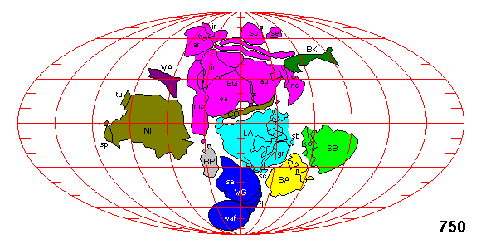

Separation
In contrast to Rodinia's formation, the movements of continental masses during and since its breakup are fairly well understood. Evidence of extensive lava flows and volcanic eruptions around the Precambrian-Cambrian boundary, especially in North America, suggest that Rodinia began to rift apart no later than 750 million years ago.^{[5]} Other continents, including Baltica and Amazonia, rifted off Laurentia 600 to 550 million years ago, opening the Iapetus Ocean between them. The separation also led to the birth of Panthalassic Ocean (or Paleo-Pacific).^{[1]}
The eight continents that made up Rodinia later re-assembled into another global supercontinent called Pannotia and, after that, once more as Pangaea.

Late Precambrian Supercontinent and Ice House World
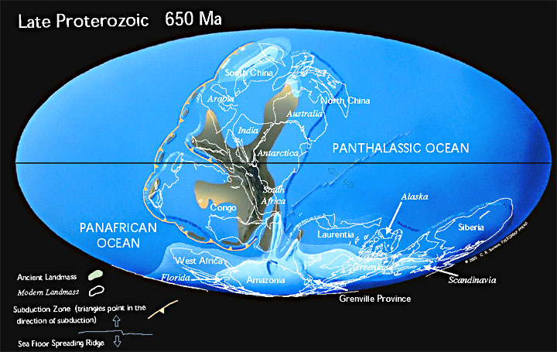
This map illustrates the break-up of the supercontinent, Rodinia, which formed 1100 million years ago. The Late Precambrian was an "Ice House" World, much like the present-day.

Proterozoic eon
Paleoproterozoic era |  |  |  | Mesoproterozoic era |  |  | Neoproterozoic era
Siderian | Rhyacian | Orosirian | Statherian | Calymmian | Ectasian | Stenian | Tonian | Cryogenian | Ediacaran

Neoproterozoic
The Neoproterozoic Era is the unit of geologic time from 1,000 to 542 +/- 0.3 million years ago.^{[1]} The terminal Era of the formal Proterozoic Eon (or the informal "Precambrian"), it is further subdivided into the Tonian, Cryogenian, and Ediacaran Periods. The most severe glaciation known in the geologic record occurred during the Cryogenian, when ice sheets reached the equator and formed a possible "Snowball Earth"; and the earliest fossils of multicellular life are found in the Ediacaran, including the earliest animals.

Contents
- 1 Paleogeology
- 2 Paleobiology
- 3 Terminal period
- 4 Notes
- 5 References

Paleogeology
Geologically, the Neoproterozoic is thought to comprise a time of complex continental motion as a supercontinent called Rodinia broke up into perhaps as many as eight pieces. Possibly as a consequence of continental rifting, several massive worldwide glaciations occurred during the Era including the Sturtian and Marinoan glaciations, the most severe the Earth has ever known. These are believed to have been so severe as to bring icecaps to the equator, leading to a state known as the "Snowball Earth".
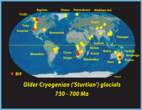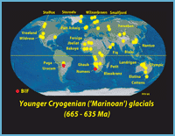
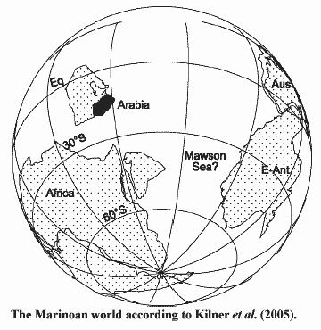

Paleobiology
The idea of the Neoproterozoic Era came on the scene relatively recently — after about 1960. Nineteenth century paleontologists set the start of multicelled life at the first appearance of hard-shelled animals called trilobites and archeocyathids. This set the beginning of the Cambrian period. In the early 20th century, paleontologists started finding fossils of multicellular animals that predated the Cambrian boundary. A complex fauna was found in South West Africa in the 1920s but was misdated. Another was found in South Australia in the 1940s but was not thoroughly examined until the late 1950s. Other possible early fossils were found in Russia, England, Canada, and elsewhere (see Ediacaran biota). Some were determined to be pseudofossils, but others were revealed to be members of rather complex biotas that are still poorly understood. At least 25 regions worldwide yielded metazoan fossils prior to the classical Cambrian boundary.^{[2]}
A few of the early animals appear possibly to be ancestors of modern animals. Most fall into ambiguous groups of frond-like animals(?); discoids that might be holdfasts for stalked animals(?) ("medusoids"); mattress-like forms; small calcaerous tubes; and armored animals of unknown provenance. These were most commonly known as Vendian biota until the formal naming of the Period, and are currently known as Ediacaran biota. Most were soft bodied. The relationships, if any, to modern forms are obscure. Some paleontologists relate many or most of these forms to modern animals. Others acknowledge a few possible or even likely relationships but feel that most of the Ediacaran forms are representatives of (an) unknown animal type(s).

Terminal period
The nomenclature for the terminal period of the Neoproterozoic has been unstable. Russian geologists referred to the last period of the Neoproterozoic as the Vendian, and the Chinese called it the Sinian, and most Australians and North Americans used the name Ediacaran. However, in 2004, the International Union of Geological Sciences ratified the Ediacaran age to be a geological age of the Neoproterozoic, ranging from 630 +5/-30 to 542 +/- 0.3 million years ago.^{[1]} The Ediacaran boundaries are the only Precambrian boundaries defined by biologic Global Boundary Stratotype Section and Points, rather than the absolute Global Standard Stratigraphic Ages.

Tonian
The Tonian (from Greek tonas, "stretch") is the first geologic period in the Neoproterozoic Era and lasted from 1000 Ma to 850 Ma (million years ago). Instead of being based on stratigraphy, these dates are defined by the ICS based on radiometric chronometry.
Events leading to the breakup of supercontinent Rodinia started in this period.
The first radiation of acritarchs occurred during the Tonian.

Cryogenian
The Cryogenian Period (from Greek cryos "ice" and genesis "birth") is a geologic period from 850 million to 630 million years ago. The greatest ice ages known to have occurred on Earth, the Sturtian and Marinoan glaciations, may have covered the entire planet in ice during this period. It was the second geologic period of the Neoproterozoic Era, preceded by the Tonian Period and followed by the Ediacaran, which marked the first development of multicellular life.
The name refers to the very cold global climate of the Cryogenian: characteristic glacial deposits indicate that Earth suffered the most severe ice ages in its history during this period. Glaciers extended and contracted in a series of rhythmic pulses, possibly reaching as far as the equator.^{[1]} It is generally considered to be divisible into at least two major worldwide glaciations. The Sturtian glaciation persisted from 750 million years ago to 700 Ma, and the Marinoan/Varanger glaciation terminated at circa 635 Ma. The deposits of glacial tillite also occur in places that were at low latitudes during the Cryogenian, a phenomenon which led to the hypothesis of deeply-frozen planetary oceans called "Snowball Earth".^{[2]}
During the Cryogenian, the supercontinent Rodinia broke up, and the supercontinent Pannotia began to form.

Pannotia

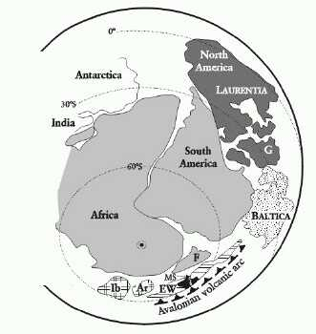
Pannotia, first described by Ian W. D. Dalziel in 1997, is a hypothetical supercontinent that existed from the Pan-African orogeny about 600 million years ago to the end of the Precambrian about 540 million years ago. It is also known as the Vendian supercontinent.^{[1]}

Contents
- 1 Formation
- 2 Geography and lifespan
- 3 See also
- 4 External links
- 5 References

Formation
About 750 million years ago (750 Ma), the previous supercontinent Rodinia rifted apart into three continents: Proto-Laurasia (which broke apart and eventually re-formed as Laurasia), the continental craton of Congo, and Proto-Gondwana (all of Gondwana except the Congo craton and Atlantica).
Proto-Laurasia rotated southward toward the South Pole. Proto-Gondwana rotated counterclockwise. The Congo craton came between Proto-Gondwana and Proto-Laurasia about 600 Ma. This formed Pannotia. With so much landmass around the poles, evidence suggests that there were more glaciers during this time than at any other time in geologic history.^{[2]}

Geography and lifespan
Pannotia looked like a V that faced northeast. Inside the V was an ocean that opened up during the break-up of Rodinia, the Panthalassic Ocean, an ocean that became the early Pacific Ocean. There was a mid-ocean ridge in the middle of the Panthalassic Ocean. Outside of the V was a very large ancient ocean called the Panafrican Ocean that may have surrounded Pannotia, equivalent to the future Panthalassic Ocean.
Pannotia was short-lived. The collisions that formed Pannotia were glancing collisions, and the continents composing Pannotia already had active rifting. By about 540 Ma, or only about 60 million years after Pannotia formed, Pannotia disintegrated into four continents: Laurentia, Baltica, Siberia and Gondwana. Later, altered landmasses would recombine to form the most recent supercontinent, Pangaea.^{[3]}
Another term for the supercontinent that is thought to have existed at the end of Neoproterozoic time is "Greater Gondwanaland", suggested by Stern in 1994. This term recognizes that the supercontinent of Gondwana, which formed at the end of the Neoproterozoic, was once part of the much larger end-Neoproterozoic supercontinent.

Proto-Laurasia
Proto-Laurasia ("first Laurasia") was an ancient supercontinent. It has been part of two major supercontinents - Rodinia, and Pannotia. In Rodinia, South China, Baltica, and Siberia were connected to Laurentia (North America) on the eastern side of the craton. Laurentia (future North America) was rotated clockwise from today. Its western side (today's western North America) was facing north, the future Arctic shore was facing the east. Proto-Laurasia had neighboring, connected continents - Amazonia to the south, West Africa to the southwest, Congo to the west, and Antarctica/Australia to the north. Rodinia broke up into Proto-Laurasia and Proto-Gondwana. One of the rifts gave rise to the Panthalassic Ocean to the north. Proto-Laurasia broke (temporarily) into four independent continents -- South China, Baltica, Siberia, and Laurentia.
The continental fragments (Baltica, Siberia, and Laurentia, but not South China) assembled back together to form the next supercontinent, Pannotia. Pannotia was shaped like a "V", facing northeast Map of Pannotia. The southeast portion of the supercontinent was Proto-Laurasia, which was positioned near the South Pole and as shown in the map was covered with glaciers (along with Amazonia and West Africa). When Pannotia rifted in the Late Proterozoic Eon, Pannotia rotated in a westward direction. Proto-Laurasia rifted away from Proto-Gondwana and slowly drifted across the Panthalassic Ocean. The rifting spawned a new ocean between the continents, the Proto-Tethys Ocean. Just before the beginning of the Paleozoic Era (545 million years ago), Proto-Laurasia itself rifted again into three continents - Laurentia, Baltica, and Siberia. The rifting also spawned two new oceans between them - the Iapetus Ocean, which was situated between Laurentia and Baltica, and the Khanty Ocean - which was situated between Baltica, and Siberia. These two oceans expanded in the Cambrian Period. Millions of years later, these three continents would come back together again, creating Laurasia, for the assembly of the most recent continent of Pangaea. And again, Laurasia broke into North America (formerly Laurentia ) and Eurasia (Baltica and Siberia connected, with additional cratons).

Gondwanda / Pannotia (circa 550 Million Years Ago)
About 600 to 550 million years ago, most of the world's large land masses came together again, this time in the southern hemisphere. A new supercontinent, Gondwana (shown at right) was formed. (The South Pole was near the "A" in "Africa").  A volcanic arc formed offshore of both Africa and South America. Called Avalonia, this string of islands would eventually contribute land to New England, other east coast US states, Canada, Ireland, England, Wales, Morocco, Portual, Spain, France, Belgium, Holland and Germany. | 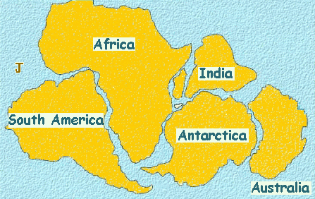

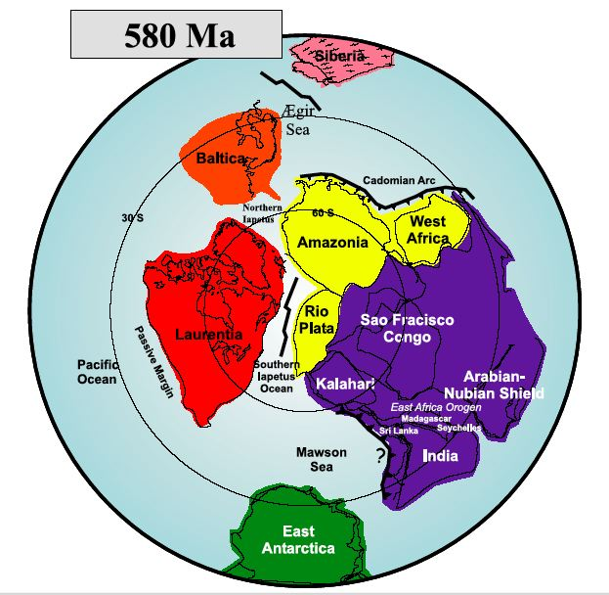
Pannotia

Ediacaran
The Ediacaran Period (IPA: /ˌiːdiˈækərən/, named after the Ediacara Hills of South Australia) is the last geological period of the Neoproterozoic Era, just preceding the Cambrian Period of the Paleozoic Era. Its status as an official geological period was ratified in March 2004 by the International Union of Geological Sciences (IUGS) and announced on May 13, 2004, the first new geological period declared in 120 years.^{[1][2]} The type section is in the Flinders Ranges in South Australia. It overlaps, but is shorter than the Vendian period, a name that was earlier proposed in Russia.

Contents
- 1 Base of the Ediacaran
- 2 Dating
- 3 Biota
- 4 See also
- 5 References
- 6 External links

Base of the Ediacaran
Although the Ediacaran Period does contain soft bodied fossils, it is unusual in comparison to later periods because its beginning is not defined by a change in the fossil record. Rather, the beginning is defined at the base of a chemically distinctive carbonate layer, referred to as a "cap carbonate", because it caps glacial deposits and indicates a sudden climatic change at the end of an ice age. This bed is characterized by an unusual depletion of ¹³C, and is considered by many scientists to be of global extent, although this is controversial.

Dating
No dating has been possible at the type section of the Ediacaran Period in South Australia. Therefore the age range of 635 to 542 million years before the present is based on correlations to other countries where dating has been possible. The base age of approximately 635 million years ago is based on U-Pb (uranium-lead) isochron dating from Namibia.^{[3]} Applying this age to the base of the Ediacaran assumes that individual cap carbonates are synchronous around the world and that the correct cap carbonate layers have been correlated between Australian and Namibia. This is controversial because an age of about 580 million years has been obtained in association with glacial rocks in Tasmania which some scientists tentatively correlate with those just beneath the Ediacaran rocks of the Flinders Ranges.^{[4]} The age of the top is the same as the widely recognised age for the base of the Cambrian Period.^{[2]}

Biota
The animal fossil record from this period is sparse, possibly because animals had yet to evolve hard shells, which make for easier fossilization. The Ediacaran biota include the oldest definite multicellular organisms with tissues, and the most common types resemble segmented worms, fronds, disks, or immobile bags. They bear little resemblance to modern lifeforms, and their relationship even with the later lifeforms of the Cambrian explosion is difficult to interpret. More than 100 genera have been described, and well known forms include Arkarua, Charnia, Dickinsonia, Ediacaria, Marywadea, Onega, Pteridinium, and Yorgia.
4567.17 +/- 0.7 Ma: Hadean
3800 Ma: Archean - Eoarchean
3600 +/- 0 Ma: - Paleoarchean
3200 +/- 0 Ma: - Mesoarchean
2800 +/- 0 Ma: - Neoarchean
2500 +/- 0 Ma: Proterozoic - Paleoproterozoic - Siderian
2300 +/- 0 Ma: - - Rhyacian
2050 +/- 0 Ma: - - Orosirian
1800 +/- 0 Ma: - - Statherian
1600 +/- 0 Ma: - Mesoproterozoic - Calymmian
1400 +/- 0 Ma: - - Ectasian
1200 +/- 0 Ma: - - Stenian
1000 +/- 0 Ma: - Neoproterozoic - Tonian
850 +/- 0 Ma: - - Cryogenian
630 +5/-30 Ma: - - Ediacaran

Op naar deel 2!

